# Mass Shooting Prediction Using Time Series

Hruthik Vinnakota, Jugal Kishore Ruvva, Rajeev Yenugula, and Shilpa Bai

Department of Data Analytics, San Jose State University

DATA 270: Data Analytics Process

Dr. Eduardo Chan

May 19, 2023

# Abstract

Mass shootings have surged in recent years, causing over 15,000 deaths in 2023 alone. However, little is known about the underlying dynamics of the phenomenon, which hinders effective prevention and intervention efforts. Therefore, this research project aims to investigate the patterns, trends, and seasonality in the occurrence of mass shootings over time and develop predictive models to forecast future incidents. Previous studies have identified temporal patterns and social/geographical factors associated with mass shootings in the United States, but few have focused on forecasting. While previous research has focused on gun laws and firearm purchase patterns, this study concentrates on forecasting and aims to provide valuable insights for prevention and intervention efforts. This research project employs four different time series models, namely SARIMA, VAR, Prophet, and LSTM, to explore the temporal patterns of mass shootings and potential drivers in the United States from 2004 to 2022 and explore patterns and potential drivers. The study found that mass shootings display a solid seasonal and periodic pattern, with notable peaks in the summer and fall every year, including a peak after the recent period of low activity during the pandemic. The models also show varying degrees of accuracy and interpretability, with all models outperforming the benchmark models in predicting the future trend of mass shootings and LSTM outperforming all others. The models provide valuable insights into the phenomenon's temporal patterns and potential drivers, helping law enforcement agencies and crime research institutions to forecast crime rates and assist in resource allocation.

# Mass Shooting Prediction Using Time Series

**Project Background and Executive Summary**

Mass shootings have sadly become a regular occurrence in the United States and become a frequent problem with serious societal consequences. These incidents have a catastrophic impact on the public having a long-lasting influence on the households, neighbors, and communities of the victims. A significant number of people lost their lives while many others were injured as a result of mass shootings that occurred across the United States. Many factors, such as mental illness, social isolation, and easy access to weapons, have been connected to the likelihood of mass shootings. In order to forecast future mass shooting incidents, data-driven methods have been applied to evaluate trends in recent decades whereas utilizing several machine learning models to comprehend the patterns and tendencies of mass shootings has gained more and more traction. Additionally, time series analysis has shown to be a useful method for determining the temporal trends and movements of mass shootings and for creating predictive models that can foretell future occurrences. Using a dataset of prior shootings, the goal of this research is to apply time series forecasting techniques to estimate the chance of mass shootings in the United States. Moreover, the suggested model would make use of a number of methodologies, an open-source time series forecasting tool that has grown in popularity in recent years because of its easy accessibility and consistency. The results of this research could influence treatments and strategies to stop and lessen mass shootings, thereby enhancing public safety.

From the websites of mother jones and gun violence archive, where the data was collected through various sources such as news reports, police records, and other publicly available data throughout the United States. Preprocessing will be done on the dataset to make it ready for analysis and to retrieve important features for the forecasting model. The suggested model will then be assessed using a variety of metrics, such as mean absolute error (MAE) and mean squared error (MSE). The objective of this project is to deliver a trustworthy tool for mass shooting likelihood prediction to law enforcement authorities and other essential organizations. Mass shootings can be predicted so that proactive steps can be taken to lessen their effects and avoid additional casualties.

The project will involve feature engineering, exploratory data analysis, model creation, and evaluation in addition to preprocessing and cleaning of the data and use a variety of machine learning techniques, including ARIMA, SARIMA, LSTM, VAR, and Prophet to analyze the data and develop the predictive model. These models will be employed to find the temporal trends and patterns in the dataset in order to build the predictive model.

In order to identify the temporal patterns and trends in time series data, the widely used time series analysis model ARIMA combines autoregression, moving averages, and differencing techniques whereas both stationary and non-stationary time series can be modeled. In order to produce predictions based on historical data, ARIMA models are widely employed in finance, economics, and other professions.

A recurrent neural network (RNN) variant called LSTM is ideally suited for representing sequential data. Here, LSTM models can learn long-term relationships in time series data by using memory cells that hold information about the prior inputs. The AR model is expanded to include numerous time series using the statistical model known as VAR. By representing the different time series as a set of equations, VAR models are able to capture the dependency between various time series. VAR models are frequently used to represent complicated systems with numerous variables in macroeconomic prediction, economics, and other fields.

Prophet is a time series forecasting model and is intended to be quick and accessible. The foundation of Prophet is a decomposable time series model with periodic, pattern, and event elements. Prophetic models are capable of coping with random errors, aberrations, and variations in trend or irregularity. Moreover, in many fields, prophet models have been found to perform better than conventional time series models. Figure 1 illustrates the basic flow diagram.

**Figure 1**

*Flow Diagram*

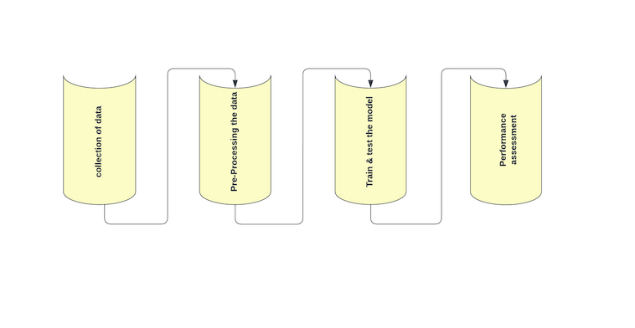

## Project Requirements

This research project requirement would be to analyze and forecast data that is gathered over time using a statistical technique called time series analysis. Its primary goal is to detect trends, patterns, periodicity, and seasonality in data.

This project will implement supervised learning algorithms such as Vector Autoregression (VAR), Seasonal Autoregressive Integrated Moving Average (SARIMA), Prophet, and Long short-term memory. The choice of model will depend on the characteristics of the data and the problem at hand. For example, models such as ARIMA and SARIMA are suitable for time series data with a clear trend and seasonality, while models like LSTM are effective for data with long-term dependencies. To ensure optimal performance, models need to be trained on an appropriate portion of the available data, and hyperparameters need to be tuned to minimize error and prevent overfitting. Features can help to reduce the manual effort required for feature engineering, which can be time-consuming and complex. Overall, the features can provide valuable insights and improve the accuracy of time series analysis using ML.

A multivariate regression model called vector autoregression simulates the relationship between a group of features as a function of both their own lagged values and the lagged values of other variables in the system. The order of the VAR model specifies the maximum number of lags that are included in the model. The parameters of the VAR model are estimated using a maximum likelihood approach. This model for mass shooting analysis is to explore the dynamics between different features that can affect mass shootings. These features may include, for example, mental health policies and services availability, and socioeconomic factors.

SARIMA is a valuable tool for modeling and forecasting seasonal time series data, including monthly or quarterly issues occurring for mass shootings in public places. It is an extension of the more basic ARIMA (Autoregressive Integrated Moving Average) model, which is used to model time series data that is not seasonal. The data's trend and seasonality can both be captured by SARIMA models, which may also be utilized to produce forecasts for upcoming intervals. Moreover, it helps with inventory control, resource planning, and demand forecasting for goods.

Prophet is a time series forecasting tool created by Facebook that analyzes and predicts time series data using an additive model. The trend, seasonality, and features are all combined in the additive model. The trend component represents the long-term changes in the data, and it can be modeled using a piecewise linear or logistic regression model. The seasonality component represents the periodic fluctuations in the data, and it can be modeled using the Fourier series. To estimate the model's parameters, Prophet uses a Bayesian technique. The model is trained on historical data to identify patterns and trends in the frequency and severity of mass shootings. Prophet would then use this information to make predictions about future mass shooting incidents. It can also be used to identify the factors that contribute to the frequency and severity of mass shootings.

Time series modeling and prediction are frequently done using LSTM (Long Short-Term Memory), a sort of neural network. It is very helpful for describing data sequences with enduring dependencies. An LSTM model creates a succession of output predictions in a time series modeling environment from a sequence of input data. Any length of input sequence can be used, and the model can be trained to anticipate a specific number of subsequent time steps. Because of its unique structure, the LSTM model is able to identify both short- and long-term dependencies in the data.

To use an LSTM model for mass shootings analysis, historical data on the date, location, and the number of victims for each mass shooting incident is collected and preprocessed. It can consider a wide range of factors, such as time of day, day of the week, location, weather conditions, gun laws, and socio-economic factors, to make predictions about future mass shooting incidents. These factors can be included as input features in the model, and the model can be trained to identify the most important factors that contribute to mass shootings.

The primary purpose of time series analysis on mass shootings is to gain insights into the patterns and trends of mass shootings over time and to use this information to make predictions about future incidents. By examining the historical data, factors can be identified that contribute to the frequency and severity of mass shootings. For example, the analysis may reveal that mass shootings are more likely to occur in certain locations, at certain times of the day or year, or under certain socio-economic conditions. To prevent or lessen the effects of upcoming mass shootings, policy decisions, and resource allocation might be based on the knowledge gathered from time series analysis. For instance, policymakers may use the knowledge gathered from the analysis to create legislation restricting access to firearms, enhance mental health care, and boost the presence of law enforcement in high-risk locations. Overall, the time series analysis on mass shootings is to understand the patterns and trends of these incidents over time and to use this information to prevent or mitigate their impact in the future.

There are numerous datasets available for mass shootings in the United States. One often

used dataset is the Mother Jones Database, which is a crowd-sourced database of mass shootings that occurred from 1982 to the present. The dataset includes details such as the time, place, number of fatalities and injuries, the weapons employed, and other pertinent information. The Gun Violence Archive is a different crowd-sourced dataset that compiles data on all different forms of gun violence episodes in the US, including mass shootings. The dataset is updated daily and contains information on the location, date, and number of victims. Another frequently used dataset with details on mass shootings from 1966 to 2016 is the Stanford Mass Shootings in America dataset. The dataset includes information on the date, location, number of fatalities and injuries, and other relevant details. Other sources of data include news articles and police reports. However, it is important to ensure the accuracy and completeness of the data when using these sources. Figure 2 illustrates gun violence archive site.

Also, using Python programming language, all the machine learning models will be generated utilizing the qualities specified before as inputs. The accuracy, mean absolute error (MAE), and root means squared error (RMSE) given by the Python library will be used to compare the models in order to ascertain how close each point in a cluster is to the points in the clusters surrounding it.

Figure 2

*The Sample Dataset of Mass Shootings 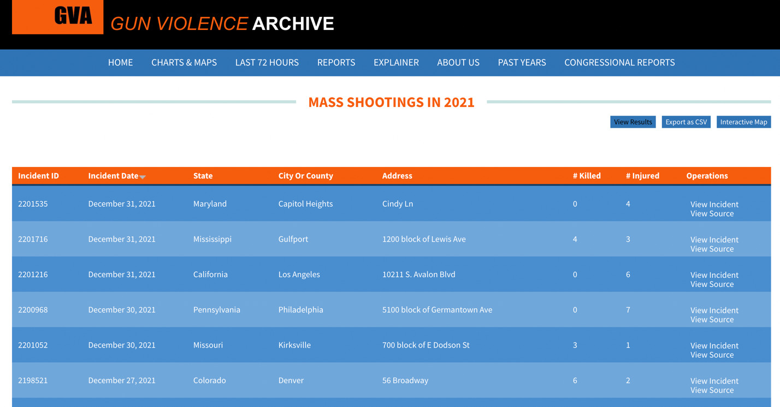Note.* The dataset of mass shootings is provided by the Research and Data Collection Organization. (2013, August). *Gun Violence Archive.* **https://www.gunviolencearchive.org/**

Feature engineering involves extracting relevant and meaningful features from raw time series data. This process includes handling missing values and outliers, detecting trends, seasonality, and other patterns in the data, and transforming the data into a stationary time series, which is essential for some models such as SARIMA and VAR. In addition, feature engineering can also involve domain-specific knowledge to identify features that are relevant to the problem being solved.

Evaluating the performance of a time series model is essential to understand its effectiveness in predicting future values. The mean absolute error (MAE), root mean squared error (RMSE), and correctness are a few metrics that can be used to assess a time series model. A measure of the model's capacity to accurately classify the data is accurate, whereas MAE and RMSE are indicators of the model's prediction error. Comparing a time series model with benchmark models is a common practice to understand the model's effectiveness in predicting future values.

Project Deliverables

Project deliverables table with the deliverables and due date is shown in below table 1.

Table 1

*Detailed Table Listing all Project Deliverables.*

| **Deliverable** | **Description** | **Due Date** |
| --- | --- | --- |
| Concept of the project | The document is organized into sub- sections that start with the suggested research problem, background data, suggested models, and literature review of the research including a sample data set and reference publications. | 20 February 2023 |
| Data comprehension | The document with collecting real-time data from the website to match the time series components with the EDA process and finally confirms the data quality. | 25 February 2023 |
| Extraction of Data | The document with detecting and retrieving the features needed for time series analysis, clearing the data of duplicates, and dividing a dataset into train and test data. | 11 March 2023 |
| Work Breakdown Structure (WBS) | The tasks that need to be completed by project team in a systematic order, together with their beginning and ending dates, roles, and descriptions of team members' responsibilities, in order to create the necessary deliverables and accomplish the objectives of the research. | 18 March 2023 |
| Data Set Analysis | A data collection that is ready to be used in the modeling phase after preliminary analysis of the data. | 25 March 2023 |
| Fabrication of Models | Model construction, training, and evaluation of model metrics utilizing hyperparameter tuning that the proposed models with the evaluation procedures. | 01 March 2023 |
| Conclusion | Using a hypothetical system and model can provide a wealth of knowledge and insights, as well as contribute to society and have an impact. | 29 April 2023 |
| Research Presentation | Final project report will be presented in a PowerPoint presentation. | 15 May 2023 |

## Technology and Solution Survey

This research problem aims to analyze the time series data of mass shootings using different time series models. Earlier studies have primarily focused on identifying the patterns and characteristics of mass shootings, however, there is a lack of research forecasting the occurrence of such events.

To address this problem, this project draws inspiration from the paper "Crime Forecasting: A Theoretical Approach" by R et al. (2022). The paper proposes a theoretical approach for forecasting crime rates using time series analysis. This approach is adapted to analyze the time series data of mass shootings and predicting future occurrences. They collected the dataset that contains Boston city criminal records and predicted using the machine learning algorithms such as Decision Tree, Extra Tree Classifier, KNN, AdaBoost, Random Forest, Light Gradient Boosting, and Gradient Boosting and performed the time series forecasting using ARIMA, and SARIMA. The results show that SARIMA outperformed ARIMA, as it fits properly with the data and is good at predicting extreme values.

Liu and Wiebe (2019) presented a time-series analysis of firearm purchasing after mass shooting events in the United States. The authors aimed to investigate whether mass shooting events influence firearm purchasing behavior and to what extent. The authors hypothesized that mass shootings would increase firearm purchases due to fears of stricter gun control laws. The authors analyze the time-series data on firearm purchase background checks and mass shooting events from 1998 to 2018 to identify any significant changes in the purchasing patterns after these events.

The authors obtained the data from the National Instant Criminal Background Check System (NICS), used to conduct background checks on individuals purchasing firearms from federally licensed dealers. The authors pre-processed the data by removing any duplicates and irrelevant information. Then, a time-series analysis was performed using a Box-Jenkins autoregressive integrated moving average (ARIMA) model to identify any significant changes in firearm purchasing behavior after mass shooting events. Used a difference-in-differences (DID) model to examine the impact of the type of firearm involved in the shooting on firearm purchasing behavior.

The results showed that there was a significant increase in firearm purchasing after mass shooting events. The authors found that mass shooting events led to a 66% increase in firearm purchasing, which translates to an additional 3,464 firearms sold per day. The authors also found that the surge in firearm purchasing lasted for about two weeks after the mass shooting events. In conclusion, Liu and Wiebe's study demonstrated the effectiveness of time-series analysis in understanding the relationship between mass shooting events and firearm purchasing behavior.

It is found that time series analysis significantly impacts other fields like stocks. Uppala et al. (2022) presented a comparative study of ARIMA, SARIMA, and LSTM models for profit prediction in time series forecasting. Even though the paper's objective differs from what this research project is accomplishing, it is considered intriguing by the implementation of time series models. The authors aimed to predict a company's future profits using these models and compare their performances.

The authors proposed using time series forecasting models to accomplish this task. ARIMA, SARIMA, and LSTM models were selected for their popularity in time series forecasting. The authors pre-processed the data by removing any outliers and missing values. Then, split the data into training and testing sets. The authors trained the ARIMA, SARIMA, and LSTM models on the training set and tested their performances on the testing set. Root mean square error (RMSE) and mean absolute error (MAE) were used as performance metrics to evaluate the models. The results showed that the LSTM model outperformed the ARIMA and SARIMA models in profit prediction. The LSTM model achieved an RMSE of 1.24 and an MAE of 0.88, while the ARIMA model achieved an RMSE of 1.54 and an MAE of 1.16, and the SARIMA model achieved an RMSE of 1.48 and an MAE of 1.12.

Pindiga et al. (2022) proposed using ARIMA and Facebook's Prophet model for stock index forecasting in the paper titled "Time-Series Forecasting: Predicting Stock Index Using ARIMA and Facebook's Prophet Model." This recommendation was made in response to the previous paper's finding of LSTM outperforming ARIMA and SARIMA. Preprocessed the data by removing missing values and normalizing the time series. The authors then use the ARIMA and Prophet models to forecast the stock index.

The performance of the models is evaluated using metrics such as mean absolute error (MAE), mean absolute percentage error (MAPE), and root mean squared error (RMSE). Based on the findings, it was observed that the Prophet model demonstrated superior forecasting accuracy compared to the ARIMA model for the data the authors examined. Therefore, this research paper uses the ARIMA and Prophet models to determine their respective performances.

To see how these models perform compared to other different models, this research paper chooses the widely used LSTM model. Ning et al. (2021) sought to compare the performances of ARIMA, LSTM, and Prophet models against one another in a paper titled "A Comparative Machine Learning Study for Time Series Oil Production Forecasting: ARIMA, LSTM, and Prophet." The authors analyzed monthly oil production data from January 2008 to December 2019 by applying the Box-Cox transformation to the data to make it more normally distributed. For ARIMA and Prophet, the authors tuned the hyperparameters using a grid search, while LSTM used a grid search with cross-validation. The authors found that all three models performed well in forecasting oil production, with Prophet showing the highest accuracy, followed by LSTM and ARIMA. Various performance metrics, such as mean absolute percentage error (MAPE), mean squared error (MSE), and root mean squared error (RMSE), were used to compare the model's accuracy. The authors acknowledge the study's limitations, such as using a single dataset, and suggest future research to investigate the generalizability of findings.

A comprehensive exploration was conducted on the LSTM method, which exhibits promising potential, and found that Lindemann et al. (2021) surveyed long short-term memory networks for time series prediction. The paper provided an overview of the LSTM network, its architecture, and how it differs from other recurrent neural networks. The paper involved an extensive review of recent research studies that used LSTM networks for time series prediction. The paper focused on the different preprocessing techniques, the architecture of the LSTM network, the optimization techniques used to train the network, and the performance measures used to evaluate the network.

The paper also presented some recent applications of LSTM networks in different domains. The survey results showed that LSTM networks had been successfully applied in various fields for time series prediction. The paper identified some of the limitations of LSTM networks, such as computational cost and its tendency to overfit when not adequately regularized.

Van Houdt et al. (2020) present a review of the Long Short-Term Memory (LSTM) model, which is a type of Recurrent Neural Network (RNN) that is designed to learn long-term dependencies in time series data. The authors provide an overview of the structure and functionality of the LSTM model, including its gating mechanism and memory cell, and compare it to other RNN models. The paper then examines the training and optimization of LSTMs, including regularization techniques, hyperparameter tuning, and optimization algorithms. The authors highlight some of the challenges and limitations of the LSTM model, such as the tendency to overfit on small datasets and difficulties with training on very long sequences.

Bashir and Wei (2018) addressed the issue of unevenly spaced time series data in the paper titled "Handling missing data in multivariate time series using a vector autoregressive model-imputation (VAR-IM) algorithm." The proposed can impute missing data in multivariate time series while preserving the temporal correlation between variables. The study used a VAR model to capture the temporal dependence between variables.

The authors first identified the order of the VAR model using the Akaike information criterion (AIC) and then estimated the model's parameters using the maximum likelihood method. Next, the authors used the estimated model to impute missing values in the time series. The imputation process involved iteratively updating the missing values until convergence. The authors evaluated the performance of the proposed method using simulation studies and real-world datasets. The VAR-IM algorithm outperformed other imputation methods, such as mean imputation and multiple imputations, regarding imputation accuracy and preservation of temporal correlation between variables. This research paper implements these techniques to fill in the data if it is not evenly spaced monthly, weekly, or yearly.

Khan et al. (2020) presented a study on modeling and forecasting new cases, deaths, and recoveries of COVID-19 in Pakistan using a Vector Autoregressive (VAR) model. The authors aimed to develop a model that can accurately forecast the trend of COVID-19 cases in Pakistan, considering the dynamic relationships between new cases, deaths, and recoveries. The authors proposed a VAR model to capture the interdependencies between these variables. Furthermore, data pre-processing, such as data cleaning, normalization, and stationarity testing, was done. The authors then estimated the VAR model parameters using the maximum likelihood method and evaluated the model's performance using various statistical measures. Used the model to forecast the number of new cases, deaths, and recoveries in Pakistan for 30 days (daily basis).

The proposed VAR model accurately captured the dynamic interdependencies between new cases, deaths, and recoveries and accurately forecasted these variables with 95% confidence. The authors acknowledged the limitations of the study, such as the assumption of linearity and the need for regular updating of the model parameters as new data becomes available.

## Literature Survey of Existing Research

The article in Los Angeles Times by Densley and Jillain (2019, September 1) discusses the increase in mass shootings in America, focusing on the recent mass shooting in the U.S. The article highlights the need for more comprehensive data collection and reporting on mass shootings and calls for policymakers to address the problem. There is also a suggestion that Americans should focus on preventing mass shootings by tackling the fundamental factors behind the violence, such as mental health problems and gun violence. Finally, the article acknowledges the difficulty of finding solutions to the problem of mass shootings but argues that it is necessary to take action to prevent further tragedies.

The research by Leonard and Aguas (2018) examines the historical trends of mass murder incidents in the US, including the frequency, type, and location of incidents (p. 9). There is a discussion about the demographic and behavioral characteristics of mass murderers and the potential motives and risk factors associated with mass murder. This is not limited to the history and evolution of environmental criminology but also includes the concepts of crime generators and attractors, routine activities theory, and crime pattern theory. One of the objectives is to investigate using spatial analysis methods, including cartography and geographic information systems (GIS), to detect and assess patterns and areas of high crime activity.

Lankford (2016) provides various empirical predictions regarding the behaviors and characteristics of fame-seeking shooters. These include the utilization of social media to publicize attacks and targeting highly visible and symbolic locations. The research employs ANOVA and Chi-Square tests to differentiate various variables, such as age, gender, and the number of casualties between the test group and control group.

The control group data is based on NYPD's records of offenders who caused at least two casualties from 1966 to 2012, which is standard in research on these types of offenders by Kelly (2012). However, the statistical comparisons will only focus on shooters within the United States due to the limited collection of foreign cases in the NYPD report, despite its comprehensive coverage of domestic offenders. There are many potential machine learning algorithms and models to predict gun violence victimization, and which will help prevent mass shootings.

According to Heller et al. (2022), machine learning model can predict the likelihood of gun violence victimization with high accuracy. They developed the model based on a dataset of over 150,000 shootings in the United States between 2013 and 2018 using a variety of features to train the machine learning model, including demographic data, socioeconomic factors, and crime statistics. They found that their model was able to predict the likelihood of gun violence victimization with an accuracy of up to 80%. Additionally, they tested the model's ability to predict individual-level risk of gun violence victimization and found that it performed well in this task as well.

Duwe et al. (2021) conducted a similar study that collected a wide range of data from 1976 to 2018 To predict the likelihood of forthcoming attacks with different levels of severity, with regards to the number of individuals killed. The study made predictions based on three distinct tail models, three future incident rate scenarios, and other parameters. By utilizing a set of average parameters, the research found that the likelihood of an event as catastrophic as the 2017 Las Vegas massacre happening before 2040 is 35%, with an uncertainty range of 90% [8, 72]. The study assessed the effectiveness of the three distinct models by considering the factor expected log pointwise predictive density (ELPD) through Pareto-smoothed importance sampling by Vehtari et al. (2016). Regarding models with a tail location of 10, the performance metrics were difficult to differentiate. Among 57% of test cases performed with ELPD, it did not prefer any one model.

Ahmed et al. (2023) state that the progress in machine learning (ML) has enabled the anticipation of mass shootings by evaluating the conduct of potential mass shooters. The study details an ML-based system that utilizes unsupervised ML models to anticipate the probability of an individual conducting a mass shooting, based on their social media activities and psychological factors. The system uses LOF and K-means clustering to assess the similarity of existing shooters. The LOF model achieved a similarity range of 66.78% to 78.24% between the test case and dataset, while the K-means model had a higher accuracy, with a range between 77% and 84%.

The Akkineni Aakash (2021) discusses the issue of gun violence which has been a major issue in the US for many years. Using logistic regression, random forest classifiers, SVC classifiers, and MLP classifiers, various factors related to shooting incidents were analyzed. The aim is to determine which factors have the greatest impact on the lethality of a shooting incident, to guide lawmakers in their efforts to address the problem. The models were used to predict whether a shooting took place in real or not based on factors such as the shooter's age and gender, state poverty rate, education level, shooting location, and year. The report includes the feature weights of the random forest classifiers and gradient boosting classifiers, in addition to the precision, recall, and f-score of the models. Although the models have an F-score accuracy of only about 0.75, making the factor weights somewhat unreliable, the fact that the models performed with an F-score above 0.50 provides some substance to these results. Tree-based models were used to analyze the feature weights due to their high performance. The study also provides an analysis of the results and possible explanations for them.

The study conducted by Barak-Ventura et al. (2022) aims to create a spatiotemporal econometric model that can estimate monthly firearm ownership rates at the state level using two reliable proxies: The model is then used to study the relationships between media coverage, mass shootings, and firearm ownership, revealing causal associations that would not be apparent when using the proxies separately.

The study found that state-level background checks and background checks per capita had seasonal variations, and that there were trends in suicides with firearms and the model's output across most states. An augmented Dickey-Fuller test was used to ensure that the time series were stationary, and the four firearm variables were seasonally adjusted using the TRAMO/SEATS algorithm and then linearly detrended by subtracting their linear fit, following the methodology used in a previous study. The results suggest that the time series data was adequately processed for analysis with the SSE and MSE on a national level being 0.1436 and 0.0072, respectively.

According to a report generated by NYPD risk mitigation, study of mass shootings comprises both qualitative and quantitative analyses. Qualitative research on mass shootings can be categorized into multiple domains. Primarily, this research aims to identify the factors or reasons behind these shootings. Several factors such as laws, police response, violence, media, bullying, mental health issues, and accessibility to firearms can play a role in the occurrence of mass shootings. The machine learning models used in this field of gun violence analysis and predictions are not limited to just qualitative and quantitative analyses but also includes the

methods used by Barboza (2018) to find the distance matrices and K-functions to determine whether there is a clustering of shootings near schools.

Loeffler and Flaxman (2017) used spatiotemporal models to examine gun violence incidents in Newark over 13 years. Their research provided backing for the theory that gun violence can spread, as occurrences of gun violence in a particular time and location were found to heighten the possibility of gun violence in surrounding areas and times. After analyzing the model's posterior, they determined that its accuracy was 85%, with a credible interval ranging from 0.86 to 0.89.

Similar study by Xu and Griffiths (2016) aimed to investigate the impact of physical features of streets on gun violence in a bounded street network. To achieve this, the authors employed spatial analysis techniques and utilized a spatial regression model to analyze the relationship between physical features of streets and gun violence incidents. The results of the study indicated that physical features had a significant impact on gun violence in the bounded street network. Specifically, the number of abandoned buildings and the number of bars were found to have the greatest effect. These physical features were strongly associated with gun violence incidents.

Zeoli et al. (2015) used cluster detection on homicide data which were acquired from the investigative files of the Newark Police Department Homicide Unit spanning from 1997 to 2007. To the model they employed cluster detection software and utilized census tract and month of occurrence as spatial and temporal units of analysis.

Similar to Zeoli et al. (2015) who used cluster detection Matthew Valasik (2018) also suggested that RTM can be a useful tool for forecasting and reducing gang violence. Policymakers and practitioners can use this information to target high-risk areas and implement interventions that address the underlying environmental and socio-demographic risk factors, with the potential to reduce gang violence in East Los Angeles and similar areas. Regarding location and time, the study found that gang homicides were more predictable than gang assaults, with a 75% accuracy rate for predicting gang homicides and a 61% accuracy rate for predicting gang assaults. The study also found that gang violence was more likely to occur on weekends and during the evening hours.

On the contrary there are some methods of mathematical modeling used by Saunders et al. (2016) such as agent-based models, and optimal control theory to analyze the correlation between the firearm availability and firearm-related homicide rate. The model incorporated various factors such as population size, likelihood of encountering a firearm during a crime, and the probability of being killed in a firearm-related homicide. The model was validated with real-world data from different countries and accurately predicted the firearm-related homicide rates.

The findings revealed that in the scenario where guns were widely available, the firearm-related homicide rate was significantly higher than when guns were strictly controlled. The study concluded that reducing the number of guns in circulation by 30% could result in a 50% decrease in firearm-related homicide rate. The study strongly suggests that there is a strong correlation between firearm availability and firearm-related homicide rates, and reducing the number of guns in circulation can significantly decrease the firearm-related homicide rate. Therefore, firearm availability must be considered in policy decisions aimed at reducing firearm-related violence.

The current research which this research paper is using ARIMA, and other time series analysis was also used and analyzed by Kleck and Patterson (1993) using two stages of least square regression and ARIMA model which were giving accurate results with precision up to 85%.

Similar research using Autoregressive Integrated Moving Average (ARIMA) model to examine the effects of Longevity on group-involved shootings and homicides was conducted by Sierra-Arevalo et al. (2016).

According to the study conducted by Fitzpatrick et al. (2018) and Riley et al. (2017) multivariate analysis was used to examine the connection between exposure to gun violence and perceived collective efficacy. The study also investigated the relationship between other factors such as social cohesion and informal social control. Similar analysis on regression was conducted by Dierenfeldt et al.'s (2016) which was intended to examine Chicago crime data to determine if there is any indication of a "Ferguson Effect" as well as if the increase in violence in Chicago can be attributed to the availability of illegal firearms.

Milam et al. (2016), used machine learning algorithms such as random forest to identify the best set of predictors for urban interpersonal firearm violence rates by using a wide range of community characteristics. Bayesian hierarchical models were used to examine the correlation between misdemeanor policing in neighborhoods and homicide rates. This study employed multivariate and exploratory structural equation modeling to assess the influence of the Safe Streets intervention on people's perceived norms and viewpoints regarding gun violence in Baltimore, Maryland.

**Data and Project Management Plan**

# Data Management Plan

***Data Collection Approaches***

To build accurate machine-learning models, it is crucial to have access to vast amounts of data. The initial step in a machine learning project is to obtain sufficient and high-quality training data, as this is essential to creating a dependable model. Therefore, obtaining top-notch data is a critical aspect of building a successful machine-learning model.

Overall, gathered three datasets organized by year which combined to span the years 2021 to 2022. These two datasets were both taken from the Mother Jones website which features an interactive map displaying each case. The cases that have since been recorded using the updated federal baseline support the key analytical conclusions presented on the website. Researchers at Harvard University discovered through analysis of this database that the frequency of mass shootings had increased recently. This finding was supported by a separate FBI investigation.

The data collection approaches can be used for predicting mass shootings using time series data from the Mother Jones website with several methods such as web scraping techniques to extract relevant data from tables and store the data in a usable format for analysis and the dataset is 112.5 KB in size exported as a CSV file. Regardless of the method used to gather the data, it's important to make sure that the data are correct and comprehensive, and that any necessary cleaning or preprocessing is done to get the data ready for analysis.

The following data collection used for this research is from the website of the Gun Violence Archive. The website hosting this dataset, Gun Violence Archive, is used. It is available for immediate download from this website as a CSV file. This website employs both automated daily queries and manual research techniques to scan through multiple sources, which include media, data aggregators, federal, local, and state police, as well as other sources. On this website, different distribution techniques are used by government agencies whereas suicides by firearm and armed robberies that result in no injuries are the two considerations to the near real-time gathering in such a way these data are combined with law enforcement quarterly and annual reports.

The dataset collected from the website year-wise from 2014 to 2020 of 350 KB in size. The dataset has ten columns: Injured (Number of victims injured), killed (Number of victims killed), Address (Incident took place in a particular area), City or Country (Incident occurred in a specific city or nation wise), Incident date (Particular day of the event), Incident ID (based on predetermined ID) State (region wise), Full Address (complete address of the victim), Latitude (Equator wise), and Longitude (Equator wise). The dataset is divided into 2 data splits: Train (70 percent), and Test (30% instances). For non-commercial research objectives, anyone may obtain, disseminate, discuss, modify, distribute, and alter the data from the database. There were no further restrictions or legal prerequisites in place.

***Data Storage Methods***

Google Colab is utilized in this project for storing dataset from local space. To load the data, created a new account in google drive. Later, uploaded using Google Drive in Google Colab notebook in which the datasets are retained in CSV format. Where only with access to and can use Jupyter notebook as needed. This research project uses Pandas libraries to read the CSV file into Data Frame. Furthermore. Project report saved as a (.ipynb) file in Google Drive. As people with access will be able to view and edit the report as needed and have access to the CSV files.

***Data Management Methods***

To manage the data in google colab assigned limited access only to teammates. As the file uploaded to a Google Drive shared folder that is only accessible to team members by adding teammate’s email addresses with the appropriate access level. To access the shared folder, a service account was set up with the ‘Storage Object Viewer’ in the Google Cloud Console. For that, need to generate a JSON key for the service account. Requests to access the shared folder will need to be authenticated using this key. On the other hand, eventually, the project repository on GitHub will be set to exclusive. As a result, the contents and program will be protected. Later, it will be made accessible to everyone under the "BSL-1.0," License. So, which allows the users to freely use, modify, and distribute.

***Data Usage Mechanisms***

The dataset on gun violence has feature information in table 2. Each individual attribute describes the characteristics or properties of the data. Each attribute represents a specific aspect of the data and has a data type, such as numerical, categorical, and date/time.

**Table 2**

*File Contents*

| **Feature Name** | **Specific information of Feature** |
| --- | --- |
| Injured | An integer that indicates the number of people who have been harmed. |
| Killed | An integer representing the total number of fatalities. |
| Address | A string that contains an incident occurred in a specific location. |
| City or Country | A string that includes Incident occurred in a particular nation or location |
| Incident date | An integer that reads on a specific day of the event |
| Incident ID | An integer based on a specified ID |
| State | A string of region-specific information |
| Full Address | A string with the victim's full address in it |
| Latitude | An integer that is based on the equator latitude |
| Longitude | An integer that is based on the equator longitude |

Table 3 describes various tasks that have been assigned to the team members accordingly. Each member has been allocated a different task.

**Table 3**

*Data Management Plan*

| **Activity** | **Given To** | **Participation** |
| --- | --- | --- |
| Data gathering | Hruthik, Rajeev, Kishore, and Shilpa | To aggregate datasets from disparate sources. |
| Documentation and metadata | Rajeev | The production of documentation. |
| Data recovery and storage techniques | Kishore and Hruthik | Data preparation, storage in GitHub and Google Colab. |
| Documentation on backup and archiving the data | Hruthik and Shilpa | To describe the data preparation and storage procedures. |
| Ethics and legal compliance | Shilpa and Kishore | Using the Gun Violence Archive to conduct legal research. |
| Data sharing | Hruthik and Rajeev | Data will be made available to the public and posted on GitHub. |

**Project Development Methodology**

CRISP-DM is a popular framework utilized for data mining projects and it stands for "Cross-Industry Standard Process for Data Mining". It adopts a structured approach to data mining and is based on the Software Development Life Cycle (SDLC) model, which is utilized for developing software applications. This framework is mostly used in the data science and analytics industry, as a best practice, and utilized as a benchmark for evaluating various data mining methodologies. Due to its iterative and flexible nature, the CRISP-DM model can be adjusted to suit varying projects and circumstances. It permits feedback and modifications to be made throughout the project duration, ensuring that it remains on course and achieves the desired business goals.

The CRISP-DM framework consists of six major phases, where each phase can have many sub-phases, tasks, and activities to meet the project specifications.

***Business Understanding***

The initial phase of the CRISP-DM model is Business Understanding, and the purpose of this phase is to ensure that the project is in line with the business objectives and requirements. To evaluate the potential reason for mass shootings occurring in the United States, it is necessary to forecast or estimate their frequency. As the incidence of mass shootings appears to be on the rise, analyzing historical trends can offer insights into how this risk may evolve in the future. By estimating the number of mass shootings in a year, can get a better understanding of the risk posed by these events and develop more effective safety education and law enforcement strategies. A mathematical model can be used to determine the extent to which the rate of mass shootings is increasing and whether the trend is steady or sudden. This model can also forecast the number of mass shootings, which is essential for assessing the risk of these events.

Merely relying on historical data of mass shootings may not offer a precise understanding of the risk of mass shootings, as most places in the United States have not encountered such events. Since it is impossible to predict if a specific location will be targeted for a shooting, analyzing the risk of mass shootings in a specific area can be beneficial in assessing the likelihood of such incidents. Analyzing the risk of mass shootings at various locations can help organizations make informed decisions about balancing the mitigation of mass shooting risks against other priorities.

***Data Understanding***

The Data Understanding phase of the CRISP-DM model (Rodrigues, 2020) involves gathering and analyzing the data along with determining the origin of the data, evaluating its quality and comprehensiveness. To analyze mass shooting the dataset should contains a variety of information including demographic data such as gender, age, and relationship status of victims and suspects, as well as location details such as address, latitude, and longitude. Other incident-specific factors such as date, number of people killed or injured, type of gun used, and a brief description of the incident are also important ( Akkineni Aakash, 2021, September).

The dataset this research project will be using is from “Gun Violence Archive” website that includes information on all the factors along with the number deaths and injuries, the number of reported and verified incidents. These calculations are based on CDC suicide data, that include both the actual total of all non-suicide deaths and daily calculated suicide deaths.

***Data Preparation***

The Data Preparation phase was focused on getting the data ready for analysis. It involves cleaning, transforming, and integrating the data to ensure it is consistent and reliable for analysis. As this research project uses time series analysis, handling missing values or outliers is essential, as ensuring that the data is in the correct format. Additionally, it is essential to check for seasonality or trends in the data and use differencing to make it stationary, if necessary. Afterward, the data should be split into training and testing sets, and appropriate time series models and techniques should be used to analyze it.

***Modeling***

To ensure accurate analysis of gun shooting data, selecting an appropriate time series model is essential. This research project uses the Seasonal Autoregressive Integrated Moving Average (SARIMA) model, which is suitable for time series forecasting with seasonal trends. Facebook's Prophet is also considered, which can handle various time-related factors and be customized to fit different data types. Also, the VAR model that fits the data and is not personalized, and the LSTM model which analyzes data by utilizing the training data and adjusting the relevant hyperparameters, such as the number of LSTM layers, batch size, and the number of epochs.

***Evaluation***

In the evaluation phase, testing the model's performance on new data is crucial to ensure its ability to generalize well. If the evaluation results are unsatisfactory, the model can be fine-tuned by modifying hyperparameters, selecting features, or trying different modeling techniques. Using metrics such as Mean Absolute Error (MAE) to calculate the average absolute difference between predicted and actual values. This metric is easy to understand and commonly used for baseline models. Another metric used for evaluation is Root Mean Squared Error (RMSE) which measures the difference between predicted and actual values. However, it also considers the square of the differences, which results in more significant errors being penalized than smaller ones. RMSE may be helpful when significant errors need to be more heavily weighted.

***Deployment***

During the deployment phase, the model is put into action in a live environment to observe its performance in the presence of various software and systems. Additional development work may be required to ensure compatibility. The model's performance was continuously monitored to ensure its effectiveness, and adjustments were made accordingly. Finally, documentation and reports were generated to provide an overview of the process.

**Project Organization Plan**

The Work Breakdown Structure (WBS) is an invaluable project management tool that simplifies complex projects into smaller, more manageable pieces. It serves as a roadmap that guides the team throughout every stage of data mining, from business understanding to deployment. In addition to keeping everyone organized and focused, the WBS also helps identify any potential roadblocks or issues that might occur throughout the endeavor.

This project utilizes the CRISP-DM methodology. The initial step in creating a WBS for CRISP-DM involves identifying its major phases - Business Understanding, Data Understanding, Data Preparation, Modeling, Evaluation, and Deployment. Each subphase can then be divided into smaller jobs which are distributed evenly among team members, so everyone contributed equally to the completion of the job.

Business Understanding, the first part of Work Breakdown Structure (WBS), sets out to define and solve a problem statement. After reading more than 45 research papers, have selected four machine-learning models to use in analysis. At the outset of the project planning process, gathered knowledge about data sources, management techniques and libraries from a literature review. The second section focuses on data interpretation. At this stage, collected and analyzed datasets from sources like Mother Jones, government archives, and various online repositories with the goal of achieving maximum accuracy by continuously updating it. Ultimately chose an online repository of gun violence incidents sourced from more than 7,500 daily reports from law enforcement agencies, media outlets, government sources, and commercial organizations with this in mind. Stationarity of data was checked before going to third section that focuses on data preparation. The even spacing of data is validated monthly, yearly, and if possible weekly in this step. The number of people victims will be the target column and using feature engineering unnecessary attributed will be dropped before splitting the dataset into test, train, and validation.

During the modeling phase of the project, dedicating the efforts to refining and evaluating the performance of four selected models. These models, namely the Seasonal Autoregressive Integrated Moving Average (SARIMA), Long Short-Term Memory (LSTM), Prophet, and Vector Autoregression (VAR), were carefully chosen following thorough research and analysis conducted in the initial stage of the project. At this stage, the primary objective is to evaluate each model's efficacy and precision in predicting targeted variables, then make necessary modifications for improved accuracy.

In the Evaluation phase of this research paper, assessed the models developed in the fourth phase using MAE and RMSE accuracy metrics. Comprehensively assessed each model's performance and selected the one with the highest level of accuracy. Afterward, deployed that chosen model and monitor its predictions against real-world scenarios. To guarantee accurate predictions after deployment, continued monitoring model behavior closely and taking necessary measures to address any issues that may arise. Figure 3 presents the work breakdown structure that outlines the various stages of this research paper, which is based on the Cross-Industry Standard Process (CRISP-DM) methodology.

**Figure 3**

*Work Breakdown Structure (WBS)*

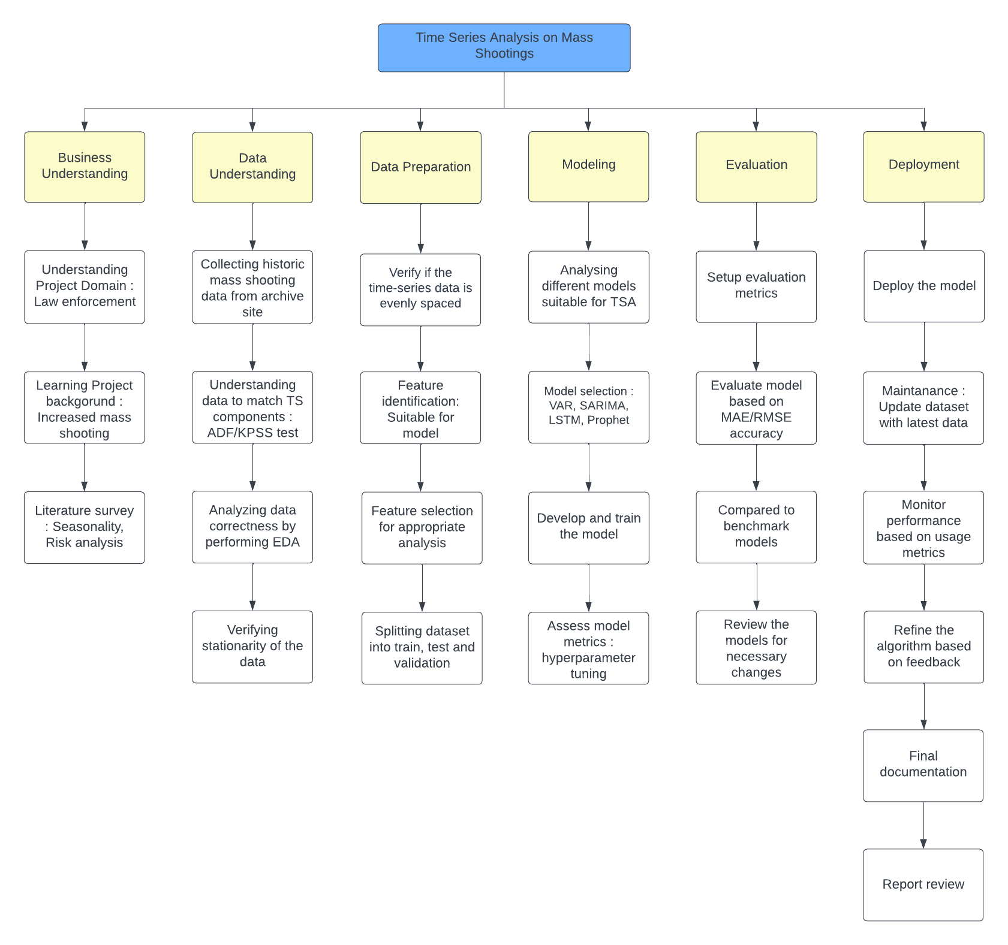

**Project Resource Requirements and Plan**

An outline of the resources required to execute this research project and how they will be distributed is found in the project resource requirements and plan. It is an important part of project management and helps to guarantee that the project is finished on schedule and within budget.

***Hardware Requirements***

Hardware requirements are an essential aspect of any study that involves the use of technology. The most recent MacBook computer system, which this research project is utilizing for the entirety of the project, has the hardware combinations shown below. As for the computer system's CPU, GPU, RAM, and storage space, among other things, table 4 reveals all the hardware information and its function.

**Table 4**

*Hardware Requirements of This Research Project*

|  |  |  |  |  |
| --- | --- | --- | --- | --- |
| **Hardware** | **Memory** | **Configuration** | **Purpose** | **Cost** |
| Chip: 8-core CPU with 4 performance cores and 4 efficiency cores | 8GB unified memory | 256GB SSD | Computation engine for  running ML/DL Model in  Jupyter Notebooks | $1200 |
| 7-core GPU | (Configurable to:  16GB) | (Configurable to  512GB SSD,  1TB SSD) | ML/DL Model | $600 |
| 16-core Neural Engine | (Configurable to:  16GB) |  | ML/DL Model | $800 |

***Software Requirements***

In addition to hardware requirements, software requirements are also an important consideration for any study that involves technology. In summary, this research paper requires specific software applications, including Microsoft Word, Jupyter Notebook, and Python programming language. It's important to ensure that the required software versions are used, and that compatibility is verified. Table 5 depicts all the software information and its function.

**Table 5**

*Libraries Used in This Research Project.*

|  |  |  |  |
| --- | --- | --- | --- |
| **Libraries/Packages** | **Purpose** | **Version** | **Cost** |
| Python | Data Preprocessing | 3.8 | $0 |
| Pandas | Data Cleaning and Analysis | 1.3.2 | $0 |
| NumPy | Data Cleaning, Analysis and Manipulation | 3.2 | $0 |
| Matplotlib | Creating Visualizations | 3.2 | $0 |
| Seaborn | Advanced Visualizations | 0.12.0 | $0 |
| scikit-learn | Machine Learning Model Building | 1.1.2 | $0 |
| keras | Developing DL models | 2.10.0 | $0 |
| Google Authentication | Geo locations | 1.35 | $0 |

In addition to hardware and software requirements, database requirements are also an important consideration for any study that involves data collection and analysis. As shown below Table 6 shows the database repository used in this project.

**Table 6**

*Databases Used in This Research Project.*

|  |  |  |  |
| --- | --- | --- | --- |
| **Databases** | **Purpose** | **Version** | **Cost** |
| MySQL Workbench | Dataset Modification and Storage | 8.0.29 | $0 |

***Tools and Licenses***

Project resource requirements and plans can be supported by a range of software tools that can help track and manage resources, create schedules, and analyze resource utilization. Table 7 shows the list of some popular project management software tools used.

**Table 7**

*Tools and Licenses used.*

|  |  |  |  |
| --- | --- | --- | --- |
| **Tools** | **Purpose** | **License** | **Cost** |
| Jupyter Notebook | Create documents that contain code | Open Source | $0 |
| Draw.io | Create diagrams and flowcharts for variety of purposes like Pert chart | Free | $0 |
| ClickUp | Project management tool | Free until 30 days | $0 |
| Microsoft Excel | For Data Analysis | Free | $0 |
| Google Docs | For Creating rows | Free | $0 |
| Google Cloud | For Accessing APIs and deployment purpose | Student | $32.00 |
| GitHub | Create and use project repository | Free | $0 |
| Zoom | For Team meetings | Free | $0 |
| Google Meet | For Team Collaborations | Free | $0 |

Project resources cost and justification involves identifying the resources needed for a project, estimating their costs, and justifying those costs. Table 8 explains the cost of all required resources.

**Table 8**

*Project Resources Cost and Justification*

|  |  |  |  |
| --- | --- | --- | --- |
| **Resources** | **Justification** | **Duration (Months)** | **Cost** |
| Google Cloud | To get the Longitudes, Latitudes using Maps API | 4 | $0 |
| ClickUp | Creation of Gantt Chart, WBS and Project Management | 4 | $50.00 |

**Project Schedule**

***Gantt Chart***

A Gantt chart is an invaluable tool in project management to help visualize a project's timeline, tasks, and dependencies. This project's Gantt chart follows the Cross-Industry Standard Process for Data Mining (CRISP-DM), so each phase will be represented as its bar with its timeline running along the horizontal axis. This diagram illustrates task interdependencies within each phase and potential bottlenecks or critical paths (see Appendix A).

Adopting the CRISP-DM methodology and integrating it into a Gantt chart can guarantee that the project remains process-driven and follows an organized plan. The chart allows to monitor progress, identify potential delays, and guarantee that each phase is completed promptly and efficiently. Furthermore, such a process-oriented Gantt chart helps assign tasks and responsibilities to team members efficiently, allocating resources so everyone works towards a common goal while everyone knows their responsibilities and deadlines.

**Business Understanding**. The Business Understanding phase is the initial phase, lasting 7 days, including 2 weekends starting from Feb 13, 2023, until Feb 19, 2023. The problem statement has been solved at this point by extracting important information from the research papers referred to. Understanding the domain, project planning, literature, and technical review are the three tasks in this phase, and these are all assigned to everyone working on this research project. This step stands alone as its independent phase with no dependencies on other stages, and all tasks and subtasks were completed on time. Figure 4 displays deadlines and task assignees for each job within this initial stage.

**Figure 4**

*Business Understanding Phase*

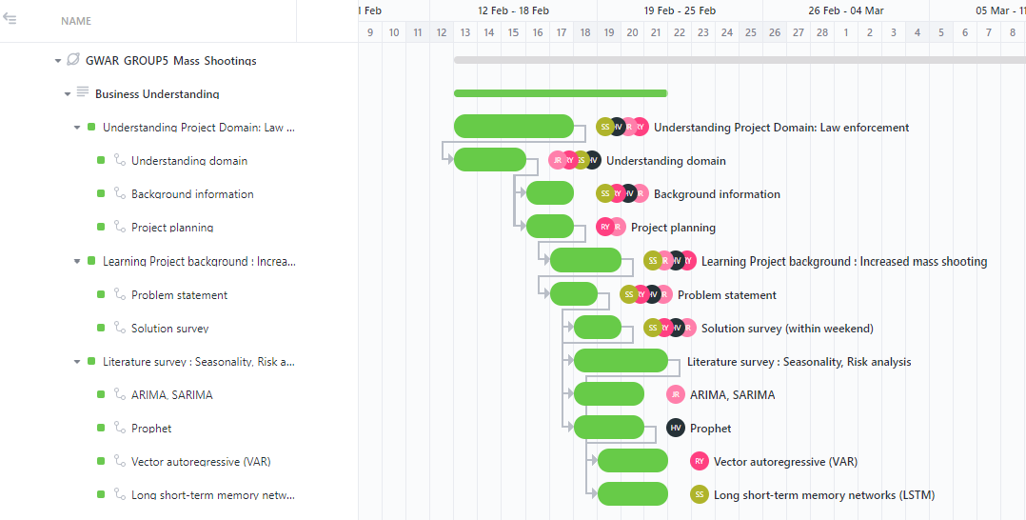

**Data Understanding.** The data understanding phase takes up to 14 days, including 4 weekends. The stage begins on Feb 20, 2023, and ends on Mar 05, 2023. This phase took up some extra time as collected and went through many datasets. Selected a dataset from all the datasets, and three people worked simultaneously on two tasks to check whether the data matched time series components and its seasonality before finalizing the dataset. Finally, Shilpa Bai and Hruthik Vinnakota spent three days analyzing the chosen dataset for stationarity. This phase depends on the preceding step. All the tasks and subtasks are completed in the stipulated time without affecting previous or future tasks and subtasks. Figure 5 exhibits the simultaneously assigned tasks, deadlines, and dependencies for each task.

**Figure 5**

*Data Understanding Phase*

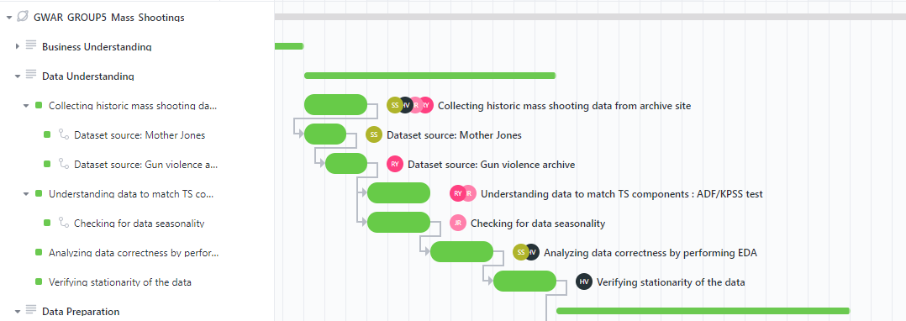

**Data Preparation.** Data Preparation is the third phase that took 14 days that includes 4 weekends days. It starts on Mar 06, 2023, and ends on Mar 19, 2023. This phase includes the major steps such as spacing validation and feature engineering. Rajeev Yenugula and Jugal Kishore Ruvva used interpolation to fill in the missing values so that data would be evenly spaced for yearly, monthly, and weekly. Then, each one of team worked simultaneously on their own to select features for their model before splitting the data. The task assignees finished all tasks and subtasks before the deadline. Each task's assignee, deadline, and dependencies are presented visually in Figure 6. This phase depends on the preceding phase and the next phase depends on this phase.

**Figure 6**

*Data Preparation Phase*

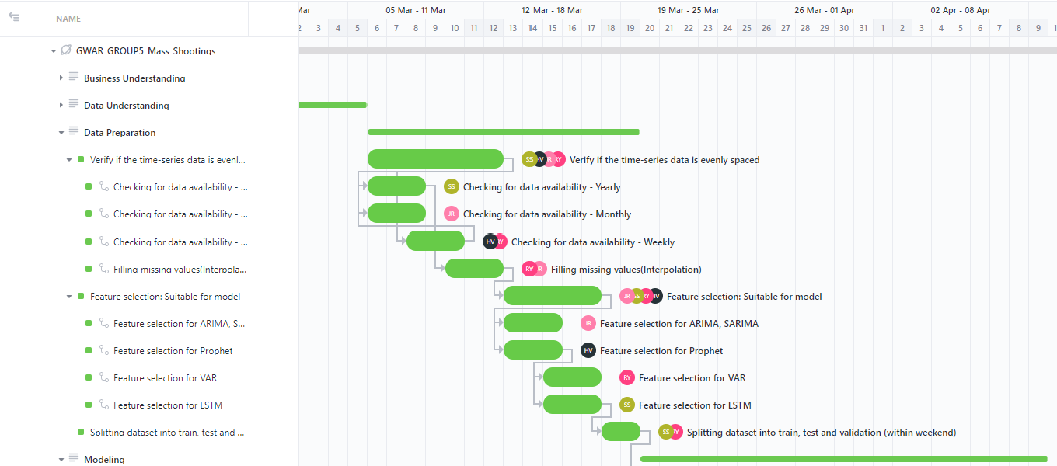

**Modeling.** The fourth phase is the modeling phase. This phase lasts 21 days, including 6 weekends and 1 week of spring break. This phase's period begins on Mar 20, 2023, and ends on Apr 09, 2023. Analyzed different models that are suitable for time series analysis. Jugal Kishore Ruvva, Rajeev Yenugula, Hruthik Vinnakota, and Shilpa Bai decided to work on SARIMA, VAR, Prophet, and LSTM respectively. In this phase, fine-tuned and tested all four models and compared them. Due to spring break, there has been a slight delay in the development of models but completed this phase on time. Figure 7 shows the progress of the project in the modeling phase, along with the tasks assigned, their respective deadlines, and dependencies.

**Figure 7**

*Modeling Phase*

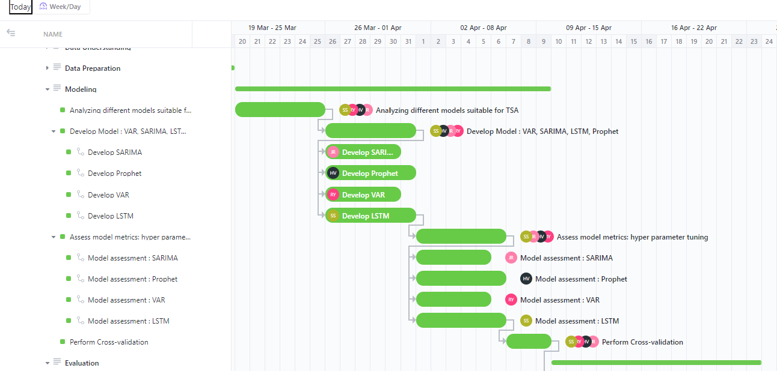

**Evaluation.** The evaluation phase occurs immediately before deployment. For this project this evaluation will last 14 days, including 4 weekend days starting from Apr 10, 2023, and concluding on Apr 23, 2023. During the Evaluation phase, each team member is accountable for setting up their evaluation metrics and using them to assess the performance of their models. This involves comparing results against benchmark models and making necessary adjustments to improve accuracy and efficiency. To guarantee the evaluation process is thorough and comprehensive, various accuracy metrics such as MAE and RMSE were utilized. These measurements will enable, to assess the precision of the model’s predictions of future trends and patterns in mass shootings data. Completed this phase on time as there were no delays from the previous phases. Figure 8 illustrates each task assigned to each team member along with its timeline, status, and dependencies for the evaluation phase.

**Figure 8**

*Evaluation Phase*

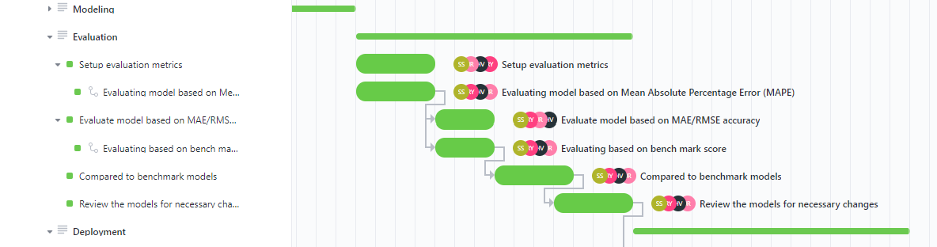

**Deployment.** The deployment phase is the ultimate phase of this research project that spans over 14 days, including 4 weekend days starting from Apr 24, 2023, and concluding on May 7, 2023. The initial task in the Deployment phase is to deploy all the models, allowing them to make real-time predictions. Once the model is deployed, monitored, and maintained its performance. This includes measuring its accuracy in predicting mass shootings data and recognizing any potential errors or issues that may arise. To guarantee the model remains effective over time, ongoing maintenance tasks such as periodic updates to its parameters and retraining it with new data when available were performed. These steps are essential in guaranteeing the model continues to deliver accurate and actionable insights into the complex problem of mass shootings. Completed this phase without any slack time. Figure 9 depicts a visual representation of the tasks assigned to each team member in the deployment phase of the project. Each task is shown with its associated timeline, status, and dependencies so team members can better understand the overall project flow and their individual responsibilities.

**Figure 9**

*Deployment Phase*

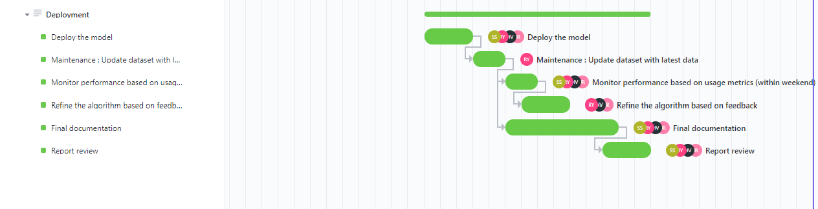

***Pert Chart***

A PERT (Program Evaluation and Review Technique) chart is valuable for visualizing a project's timeline, schedule, and critical path. The critical path represents the sequence of tasks that must be completed on schedule for the overall completion within given deadlines. In other words, it's the longest path through the PERT chart, determining when it will be complete.

The PERT chart displays all tasks needed to finish a project and their dependencies and estimated duration. By identifying the critical path, can focus on the most pressing tasks and guarantee they are completed on schedule to avoid delays in the overall timeline. Furthermore, it helps determine the minimum time necessary for completion, the earliest start and finish times for each task, and any slack time available for non-critical ones.

**Critical Path.** The Critical Path Method is integral to the project planning, helped in allocating resources and prioritizing tasks. Through critical path analysis, identified tasks that must be completed on schedule to guarantee the overall project is finished on schedule. According to CRISP-DM methodology, PERT chart has been divided into six stages business understanding, data understanding, data preparation, modeling, evaluation, and deployment.

The PERT chart illustrates a critical path, with red-colored boxes denoting hierarchical and interdependent tasks. For instance, identifying the project goal is essential in the business understanding phase before moving on to the literature survey. Likewise, data preparation requires seasonality validation before proceeding with feature selection and data splitting.

Conversely, blue-colored boxes in the diagram represent tasks with zero dependencies, indicating that delays in these will not impact other tasks or subtasks. For instance, delays in the solution survey during the phase will not impact subsequent tasks. The below PERT chart displays critical paths and zero slack time for each phase, underscoring how important timely completion of each task is for successful project completion. Figure 10 illustrates the PERT chart with essential outputs required to accomplish a project and provides information on the estimated time and resources required for each task. It follows the CRISP-DM methodology. The chart visually depicts the interdependence and sequence of the tasks or deliverables using arrows. Critical tasks are indicated in pink and normal path in blue color.

**Figure 10**

*Pert Chart*

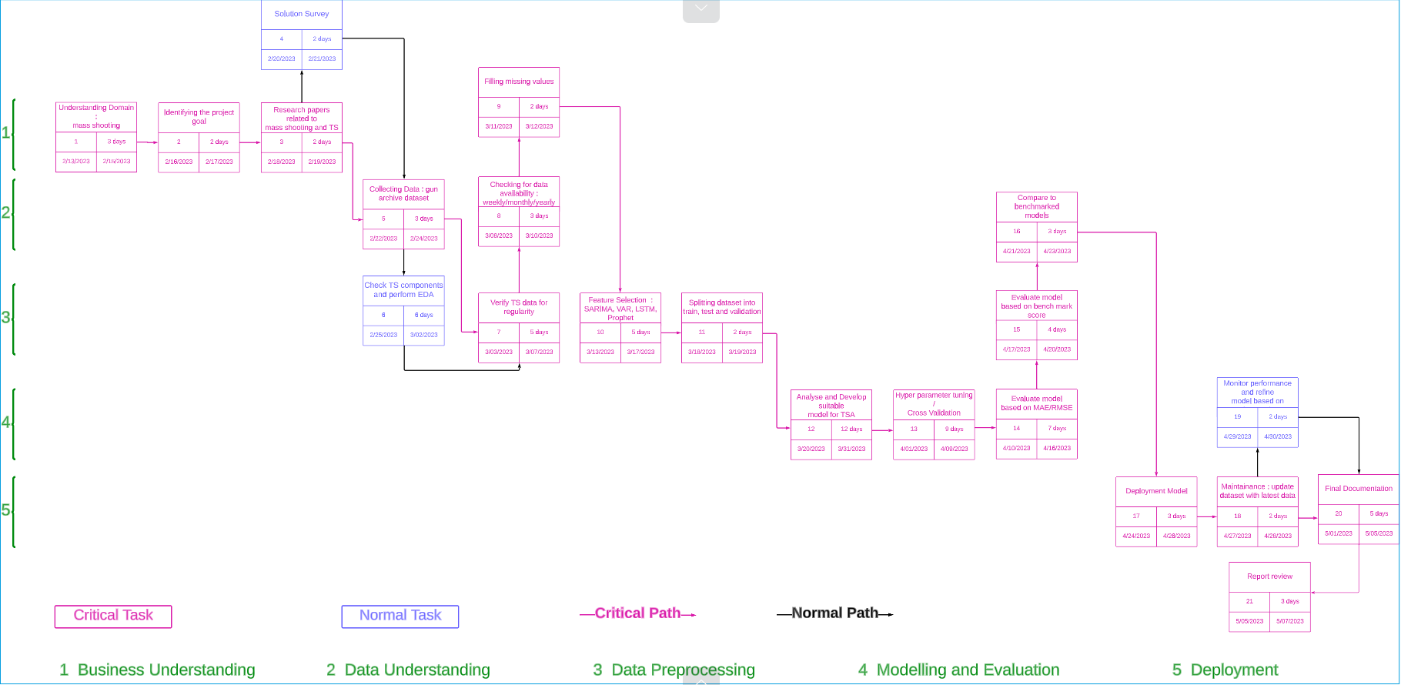

**Data Engineering**

**Data Process**

For the project, the datasets are gathered from the Mother Jones and Gun Violence Archive websites, respectively. Three datasets are separated based on years from 2014 to 2022 and are recorded in CSV format. The three datasets are combined using Pandas for the data exploration stages. The data will be explored on the 11 columns of the dataset which are injured, killed, address, city or country, state, operation, full address, latitude, and longitude, incident date, and an incident ID. For the data exploration stages, Pandas is used to combine the three datasets. In the following step, data is preprocessed by executing Exploratory Data Analysis (EDA). This technique is used to identify data anomalies, such as outliers, inconsistent data, noisy data, etc. Subsequently the EDA, the dataset is cleaned and transformed so that reliable and clean data can be provided in the model. Incomplete, missing, inconsistent, and noisy data that may have resulted from mistakes made when gathering the data from the websites are treated as part of the data cleaning process. The dataset is resized to an ideal size, which speeds up model training and improves performance. The modification of the data utilizing methods such as data smoothing, normalization, feature engineering, regularization, and dimension reduction is a key next stage in the pre-processing of the data for better model efficiency.

Feature engineering technique is used to create new features from existing ones to improve predictions that involve different methods to alter or combine features, as well as removing unnecessary features that can affect model performance. Data regularization is used to improve the accuracy of predictions for location-based services using geocoding data with precise latitude and longitude coordinates. The Python code requests the Google Maps Geocoding API for the coordinates by providing the API key and address as variables. By reducing the number of columns in a dataset, data reduction can produce a more streamlined, organized data structure with less complexity. Principal Component Analysis (PCA) was then used to reduce the number of columns and also reduce the amount of time. So, this makes the data easier to analyze for the specific requirements of the analysis. Additionally, it can help to avoid overfitting the data, as unnecessary information will be removed. Afterward, the data is partitioned into training and testing sets, a necessary step to assess the model's performance on new, unseen data and prevent overfitting. Subsequently, the model is trained on the train set, and its performance is assessed using the test set. Once the data has been preprocessed, the next step is to prepare the data for modeling. To achieve the best possible model effectiveness, the data is initially partitioned into training and testing sets at an 80:20 ratio. Then, the training data is partitioned further into two segments with a 3:1 ratio, where the first segment is designated for training and the second for validation. Consequently, the final dataset is segregated into three categories: 60% for training, 20% for validation, and 20% for testing as seen in figure 11.

**Figure 11**

*Representation of a Workflow for Data Engineering*

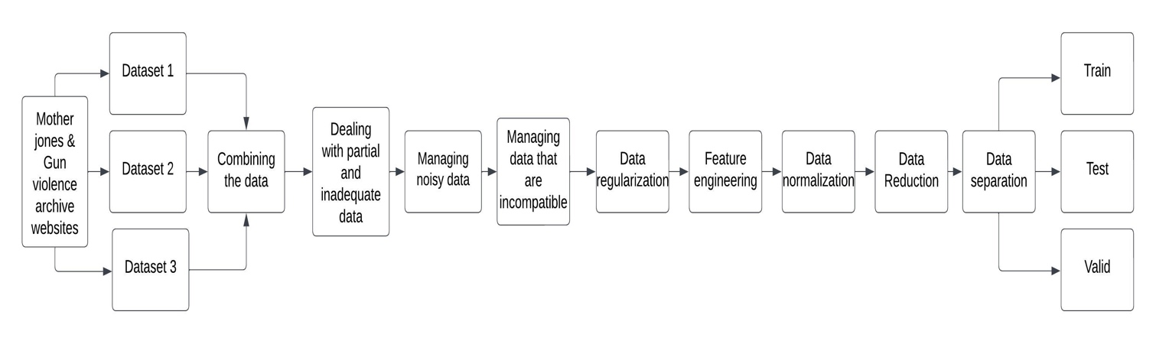

**Data Collection**

Gathering large amounts of high-quality data is crucial in developing accurate and reliable machine-learning models. Obtaining high-quality training data is an essential initial step in any machine learning project as it enables the creation of dependable models. Therefore, to construct a proficient machine learning model, it is imperative to acquire superior data. Additionally, the data must be labeled correctly for the machine-learning model to be effective. Furthermore, data should be regularly updated to ensure the model is up-to-date and can predict outcomes accurately. Machine learning models must handle enormous amounts of data to produce reliable predictions. Several data collection techniques can be employed to predict multiple casualty shootings involving guns in the US by analyzing time series. The collected data from various sources can then be used to create and train machine learning models to identify patterns and accurately predict mass shootings. A machine learning model can be created to foretell mass shootings in America by exploring time series. This data collection approach gives an adequate and comprehensive dataset for this purpose.

For this initiative, data was collected from a few websites, including mother jones and the gun violence archive which provide data on gun violence incidents in the United States. The data was downloaded as separate CSV files for each year, resulting in eleven attributes in total including eleven columns with information on various aspects of the incidents, such as the number of victims who were injured or killed, the location of the incident, including its address, city or country, state, latitude, and longitude. Additionally, the dataset contains the day of the incident and an incident ID that uniquely identifies each incident. The time series of the data spans from 2014 to 2020, which is collected from the Gun Violence Archive website. Whereas the other portion of the data is sourced from Mother Jones from 2021 and 2022. The data from the original sources, including the media, data aggregators, local, state, and federal law enforcement, as well as other sources on the internet. The process of acquiring information in close to actual time concentrates on two distinct aspects: firearm suicides and uninjured armed robberies these data are merged quarterly and yearly reports with law authorities, and different distribution mechanisms are utilized by government agencies. The websites employ comprehensive and rigorous methods to search for information from different sources, ensuring that the data obtained is accurate and up to date. Figure 12 displays the data collection plan.

**Figure 12**

*Data Collection plan*

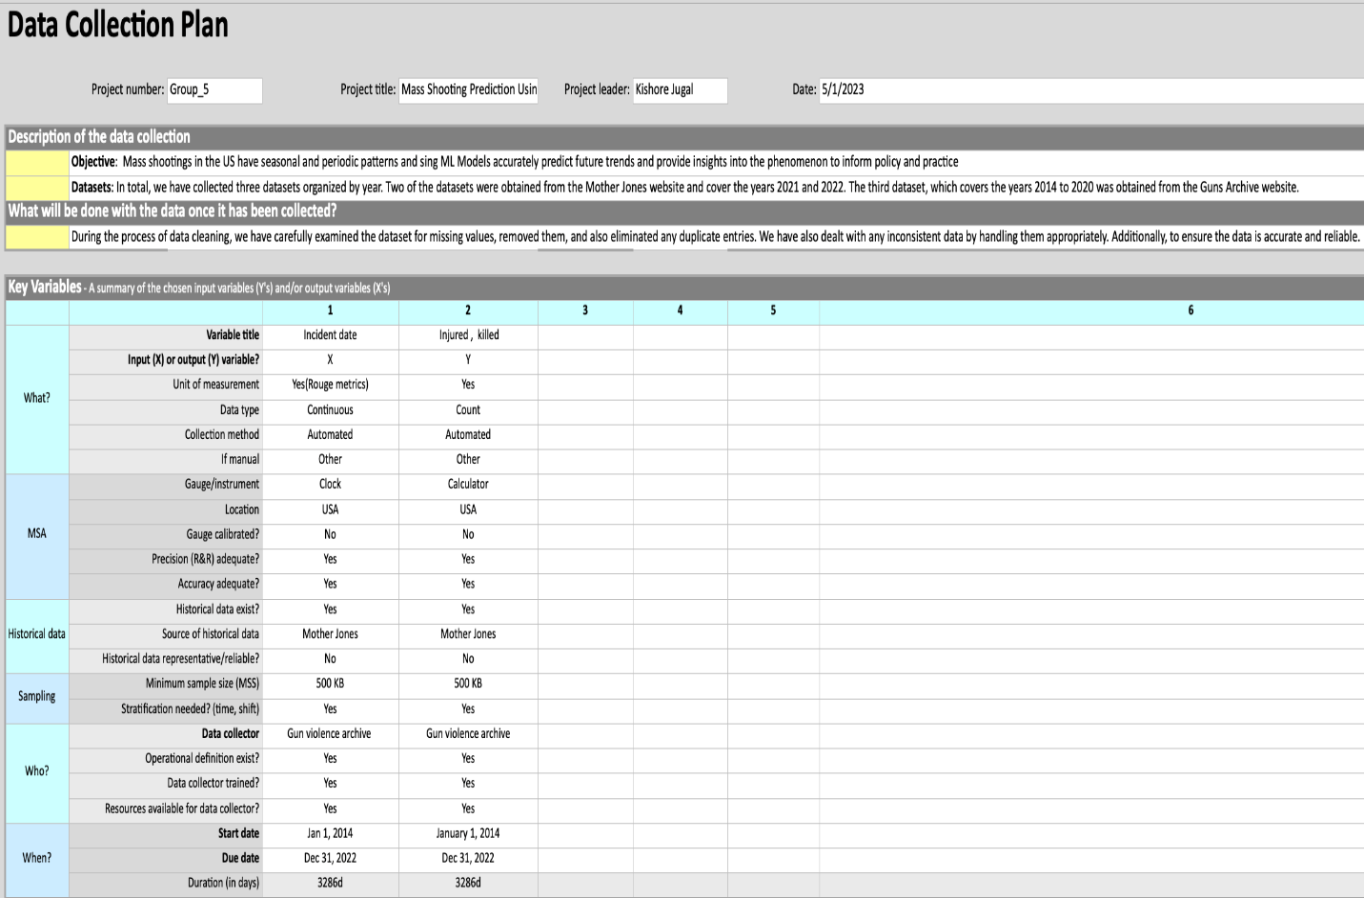

The data was split into three separate sets for analysis, with 60% of the data allocated to the training set, and 40% allocated to both the validation and test sets equally. This approach ensures that the model is trained on a significant portion of the data while still being validated and tested on independent datasets, enabling the development of a reliable and accurate model.

The Dataset is approximately 400kb in size. Among the 11 columns in the data are injured, killed, address, city or country, state, operation, latitude, longitude, Incident ID, and state. Each dataset division or partition is loaded into a Pandas data frame and the data instances or observations are extracted as rows in the resulting output. Figure 13 displays data from the Gun Violence Archive website, spanning the time frame of 2014 to 2020. The dataset contains 2373 instances and eleven columns, including any null values.

**Figure 13**

*The First Dataset Header*

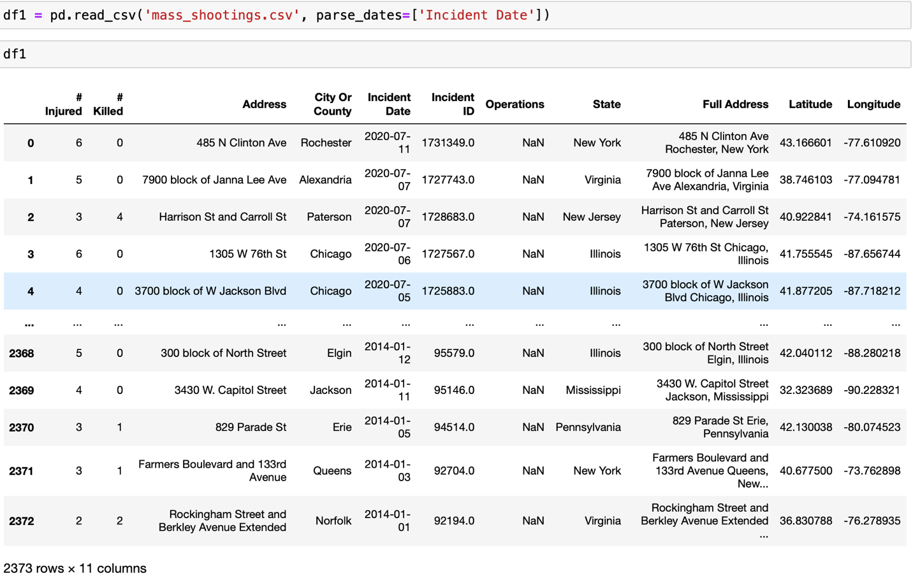

Figure 14 presents the data obtained from the Mother Jones website, based on the year 2021. A total of 690 instances and eight columns are included in the dataset.

**Figure 14**

*The Second Dataset Header*

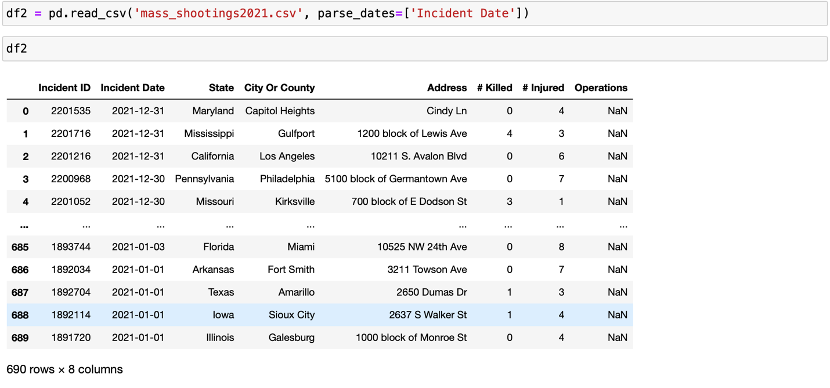

The data presented in Figure 15 is sourced from the Mother Jones website, covering the time period of 2022. The dataset contains 647 instances and eight columns.

**Figure 15**

*The Third Dataset Header*

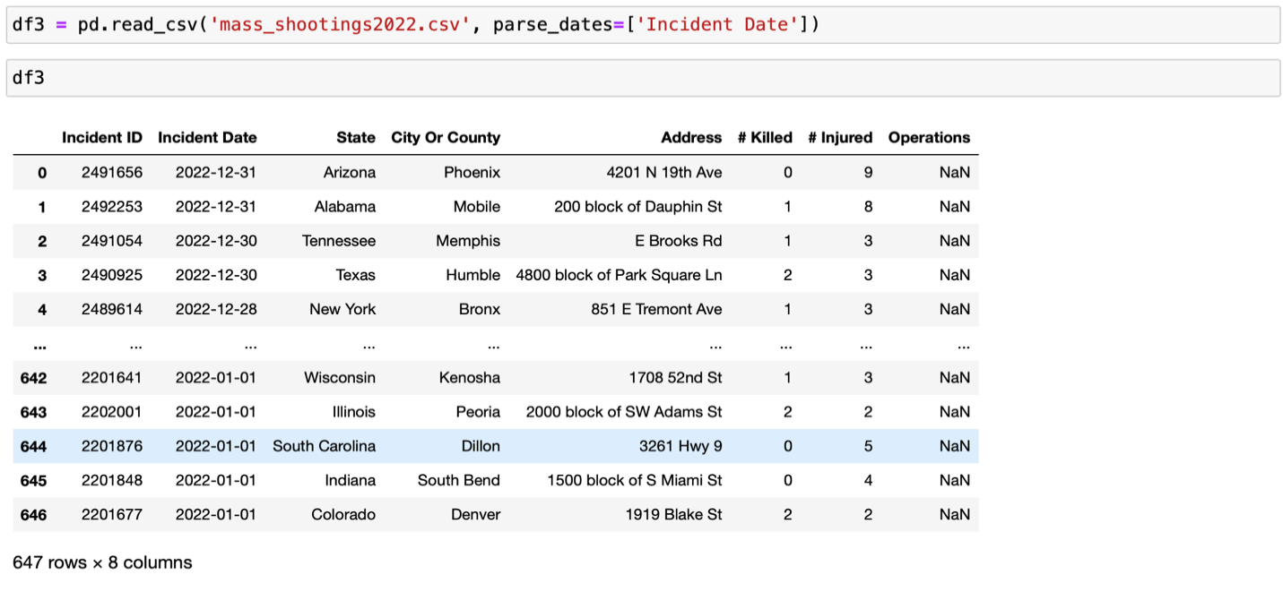

Figure 16 displays a merged dataset that includes all three previously mentioned datasets. The merged dataset comprises 3710 instances and 11 columns, including any null values that may be present.

**Figure 16**

*An Overview of the Concatenated Data Set*

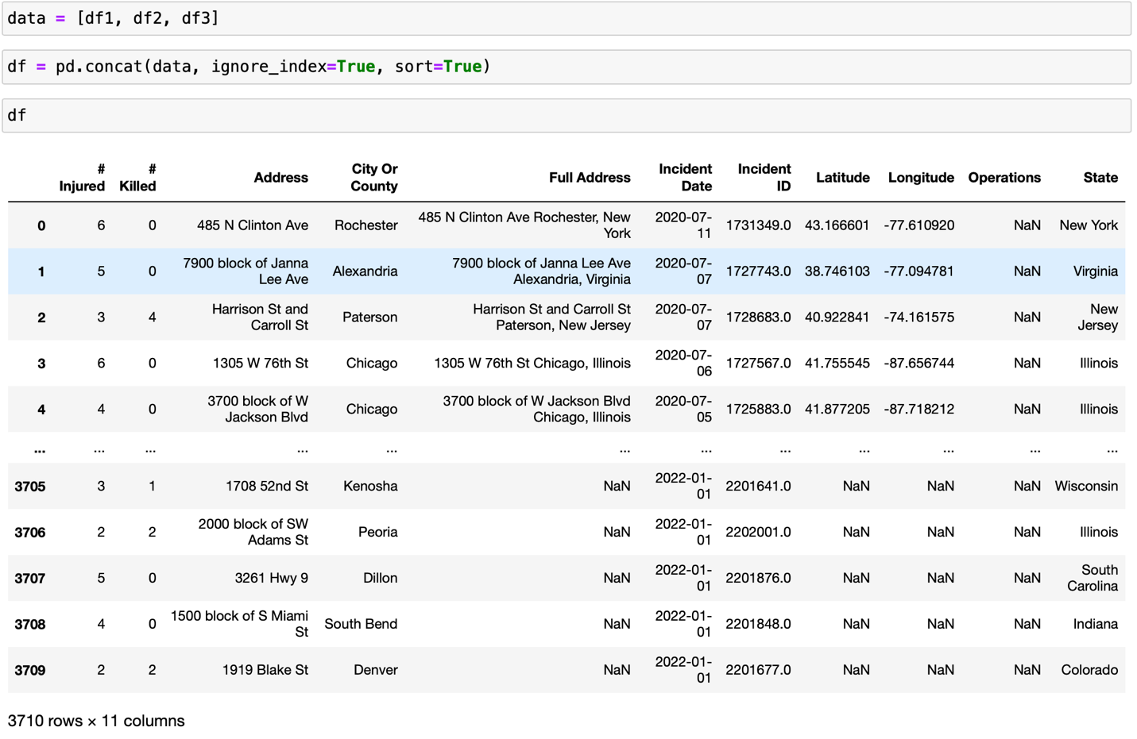

Described in Figure 17 is the csv file the following Jupyter Notebook carried into the data frame because of the 'info' function provides a comprehensive overview of the dataset. Datatypes and range indexes of the dataset are also listed here, along with the total number of columns. Additionally, the summary displays the number of non-null values found in each column. The size of the data frame is 319.0 KB, and it contains data in various data types such as object, int64, and float64. Except for the operation column, there are no null values in the data frame.

**Figure 17**

*An Overview of the Data Set*

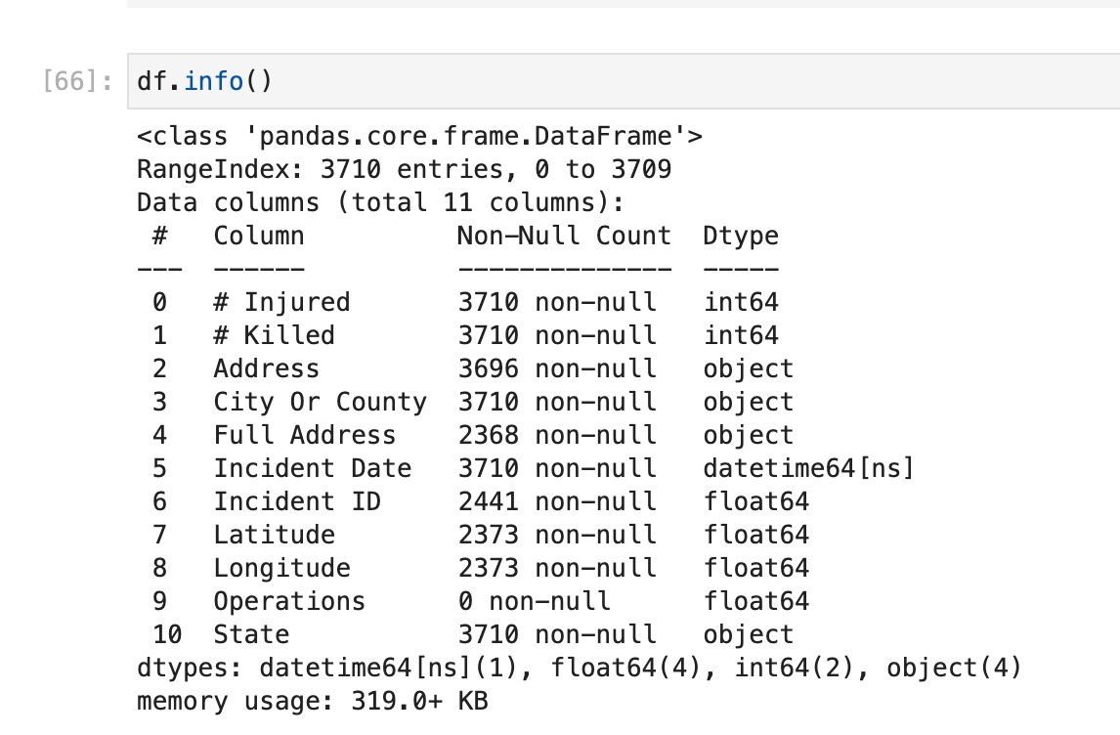

As a result of employing the describe function, Figure 18 shows all the data frame's characteristics.

**Figure 18**

Analyses of the Dataset Based on Statistics.

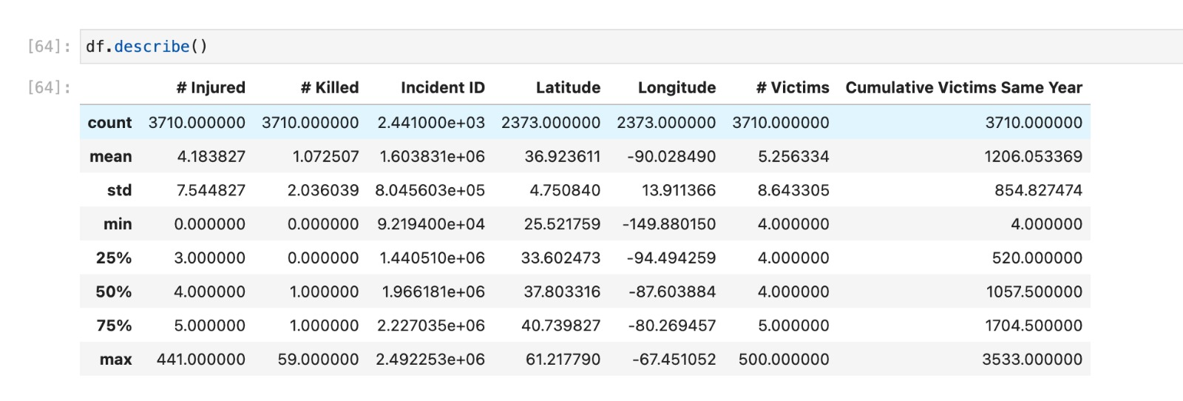

**Data Preprocessing**

Data preprocessing is the step where we work on raw data to get it ready for further processes such as data processing, by removing duplicates, outliers, and noisy data and by keeping necessary columns for further process. By performing all these operations, wanted to make sure the model gets processed data so that it gives accurate and better results. The raw dataset which was used for this research project consists of many duplicate values, outliers and unknown columns which needs to be handled.

EDA is essentially the first step in any machine learning project which helps to understand data, identify patterns, and make decisions. It not only helps to identify errors and patterns but is also useful in finding outliers, and relations among variables.

Loading and inspecting data is an initial part in any EDA process as it helps to inspect data to make informed decisions in EDA plan. After carefully loading the data for different time periods by merging, got around 4000 rows for the ten columns. There were records including the number of injured or killed, along with incident date, place. It consists of different data types ranging from numerical, date and time to categorical values. Used pandas and numpy libraries to process all these data.

After checking the count of each column it was found that “Operations” column had zero data, that all its value were Nan and there were some missing values in Incident ID, and other features. There are different ways in which the date column is recorded, that was addressed as well. Also, there is strong correlation among injured and killed column compared to others.

**Figure 19**

*Box Plot Showing Outliers.*

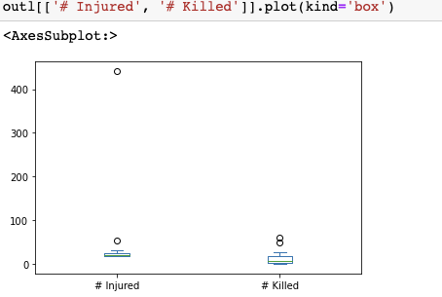

Next step is to compute descriptive statistics to understand spread, and distribution of data. From the statistics, could see that number of injuries were in the range of 0 to 441 whereas, number of records for the killed were in between 0 and 59, which was less compared to those injured records. Also, removed some of the special characters by renaming the columns. By plotting box chart, made sure that the max values in injured record was potential outlier as shown in figure 19.

There may be many duplicate values in the dataset, and after checking, found that there were around 80 duplicates for Address column as in figure 20.

**Figure 20**

*Duplicate Records Present in the Dataset.* 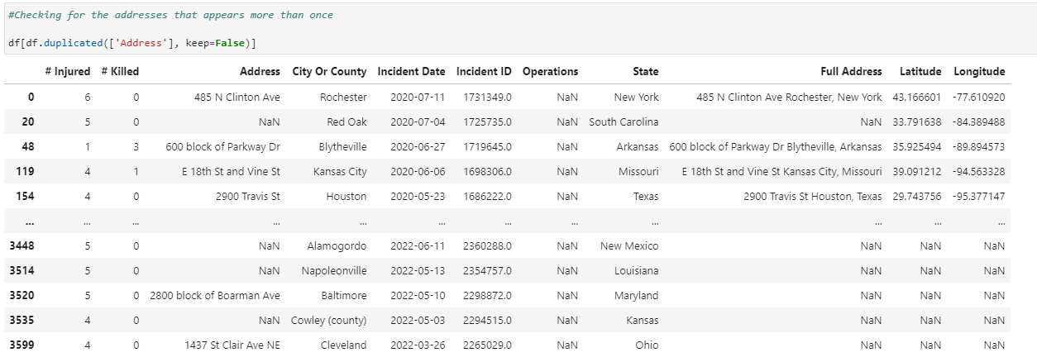

To know which city has the maximum outlier value, the plotted bar chart of the records showing max value of injuries and murder as shown in figure 20. From figure 21 and figure 22 we can say that incidents that took place in Las Vegas and Orlando have maximum value and are potential outliers.

**Figure 21**

*Top 5 Cities Where Maximum Incidents Were Reported.*

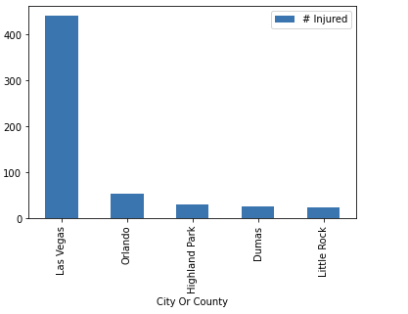 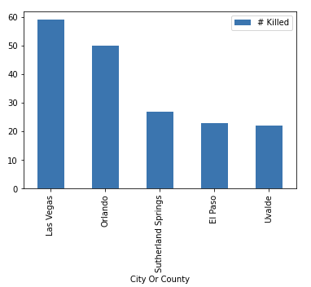

**Figure 22**

*Top 5 Cities When Total Incidents Recorded.*

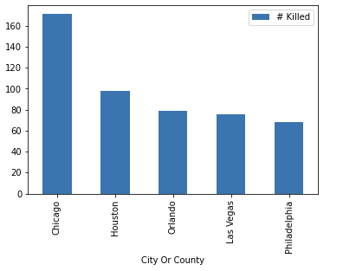 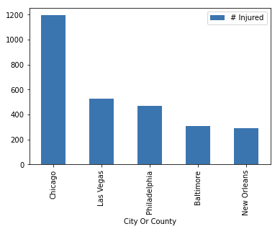

In order to analyse how many incidents have took place from years, extracted the year information from the incident data and grouped all the incidents based on that year. Then plotted the line chart showing trend of injured records and killed records over the years. From which it is observed that number of incidents of both injured and killed are increasing from past few years. Also it is keen to observe from the below figure that, even though there is slight decrease in number of cases during pandemic in 2019, post pandemic there is a significant rise in the number of cases considering both injuries and killing as shown in the figure 23.

**Figure 23**

*Trend in Number of Injuries and Killing Over the Years.*

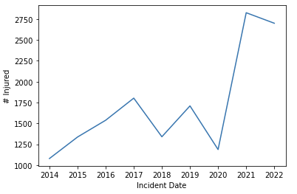 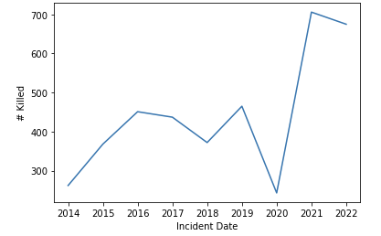

But when grouped the city to see how many total incidents have occurred in each city, it is found that Chicago has the most cases recorded so far with the total incidents of around 1200 injuries and 170 reports of killing. If consider the state wise reports of total incidents that have occurred so far, by grouping the records by state, it is evident that most cases incidents took place in Illinois followed by California and Texas. Many more such analyses can be performed on this raw dataset to extract some useful insights.

After performing all this analysis, it is easy to understand where and how the data needs to be cleaned or transformed. There is scope to analyze how the data is suitable for time series analysis. Now, can handle outliers, missing values, renaming columns, and modifying date along with extracting components from date column in further steps involving data cleaning and transformation.

***Data Cleaning and Validation***

There are several methods available to deal with missing and incomplete data. Deleting the missing data is one of the most popular methods. As the "Operations" column is empty and does not affect the model's accuracy in any way, can delete the column. Also removed other columns such as city name, incident id, address and state name as these columns were redundant by keeping full address column along with latitude and longitude as shown in figure 24.

**Figure 24**

*Dropping Redundant Columns.*

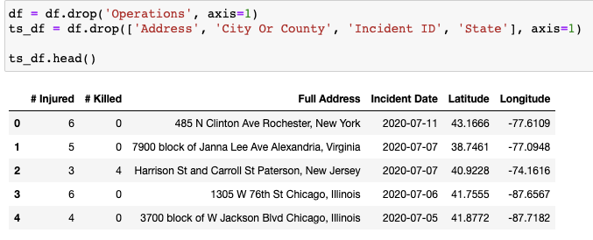

## Data Transformation

Machine learning uses the data transformation process to change the data format so that it is more suited for analysis. This procedure entails altering the original data in a variety of ways, including scaling characteristics to fall within the same range, turning categorical data into numerical data, extracting latitudes and longitudes using Google Maps Geocoding API, and merging two features into one feature. By altering the data in this way, may lessen noise and redundancy, stop certain characteristics from dominating the model, and enhance the precision and effectiveness of the algorithm.

### Feature Engineering

In machine learning, a procedure called feature engineering creates new features from the existing features of the data set. In order to facilitate the machine learning algorithm's ability to recognize patterns and provide reliable predictions, feature engineering aims to extract relevant information from the already-existing features. This method might involve altering features by using mathematical functions or statistical processes, such as determining ratios or differences between two characteristics. It can also involve constructing new features from existing ones. Another aspect of feature engineering is the removal of pointless or superfluous features that might impair the performance of the model.

### Data Regularization

For applications involving geographic analysis or location-based services, geocoding data has the potential to improve model fitting's accuracy and precision. By incorporating geocoding data into the model, it takes advantage of the precise latitude and longitude coordinates to improve the accuracy of the predictions. From Figure 24, To obtain the longitude and latitude coordinates for a given address, Python requests the library to submit a request to the Google Maps Geocoding API. The API key and address are initially established as variables by the code, after which a request URL is created using these parameters. The response is obtained as a JSON object, and using dictionary indexing, the latitude and longitude are extracted from the response. Finally, the console prints the latitude and longitude.

## Figure 25

*Example to Retrieve Latitude and Longitude from Google Maps Geocoding API for a Given Address*

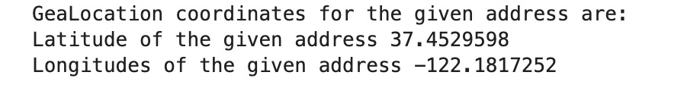

Figure 25 and 26 demonstrates the displaying coordinates obtained from the Google Maps Geocoding API for a given address by importing the requests library and setting the API key and address variables. The API key is used to authenticate and access the Geocoding API, while the address is the location, we want to obtain the coordinates.

## Figure 26

*Incorporating Geocoding Data into Models: Extracting Latitude and Longitude Coordinates from APIs*

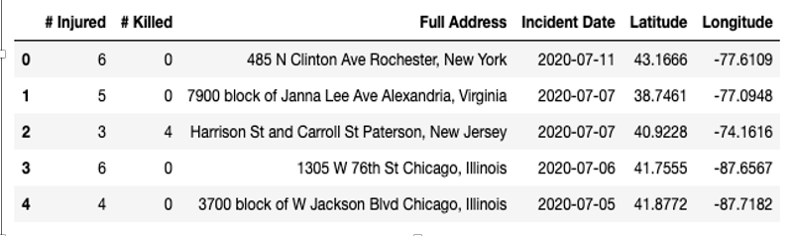

### Data Reduction

Principal Component Analysis is a dimensionality reduction technique that can be used to reduce the number of features or columns in a dataset, including the full address column, by transforming the data into a lower-dimensional space. Here PCA is applied to the data to obtain the principal components and now the principal components are less than the original number of features because the “Full Address” column was deleted. Now the feature extraction and selection are more appropriate depending on the specific requirements of the time series analysis.

The next step in the analysis involved identifying outliers in the data using a box plot. The outliers were then removed using the Z score. This was done to ensure that extreme values did not affect the analyzed data. Once the outliers were removed, a new data frame was created using selected columns from the original data frame. In addition, new columns were created by performing calculations and integrating data columns from the original data frame. This new data frame was designed to capture the monthly trends in mass shootings.

**Figure 27**

*Calculating Total Victims.*

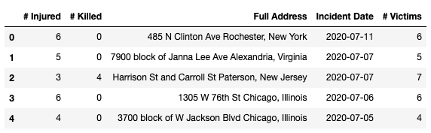

Performed the analysis on the total victims that are reported based on the incidents such as injuries and killing. So, calculated total victims count by combing number of injuries and killing and assigning that value by a new column name as victims as shown below in the figure 27.

As this project is about time series analysis, data preparation also includes transforming a time column into a month and year. Time series data is frequently gathered at intervals as frequent as hourly, daily, or weekly. So, for this analysis considered month and week components from the incident date column. By extracting these features, get the desired processed data set as shown in figure 28. Also, duplicates and null values were removed, so that the dataset is ready for further operations.

**Figure 28**

*Extracting Different Time Components from Date.*

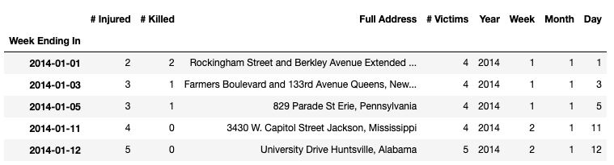

### Seasonal Adjustment

To expose underlying trends and patterns in the data, seasonal adjustment entails removing the seasonal component of the data. For modeling and forecasting data with strong seasonal patterns, this method is especially helpful. Data patterns that recur every so often, such as daily, weekly, monthly, or yearly cycles, are referred to as seasonal patterns. In order to create a "seasonally adjusted" time series that is simpler to model and analyze, these seasonal impacts must be removed from the data.

Several methods can be used to compensate for seasonality, including seasonal decomposition using moving averages, regression-based methods, and Fourier analysis. The purpose of seasonal adjustment is to eliminate any repeating seasonal fluctuations in the data, such as those brought on by weather changes, holidays, or other recurring occurrences, to make it easier to understand the data's underlying trend and cyclical components. In Figure 29, the logic provides about performing seasonal decomposition on a time series variable called Victims using both additive and multiplicative models. The function from the statsmodels.tsa.seasonal module is used to perform the decomposition. The model parameter is set to 'additive' or 'multiplicative', depending on the type of seasonal decomposition being performed. After performing the seasonal decomposition, it can help to identify trends, seasonal patterns, and other features of the data.

## Figure 29

*Seasonal Decomposition on a Time Series Variable Called ‘# Victims’ Using an Additive model.*

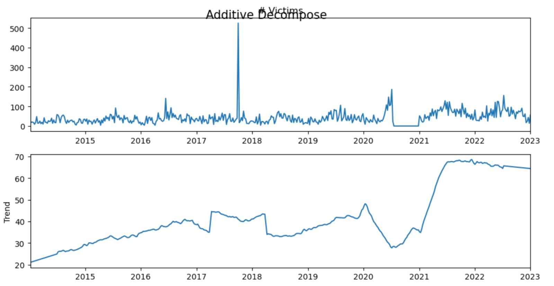

**Data Preparation**

The time series data should be divided into training, validation, and test sets to train the model. It is essential to make sure that the order of the data order is maintained during the split. The validation set is used to tune hyperparameters and assess the model's performance during training, whereas the training set is used to fit the model, and the test set is used to assess the model's ultimate performance. Several preprocessing methods are used in time series modeling during the split to increase the model accuracy and results. The time series data can also be converted using the sliding window method into a format appropriate for model training. To do this, input-output pairs that each represent a time series window are created from the original time series data. Scaling is another preprocessing method that ensures that all variables have a similar scale by normalizing or standardizing the data. The accuracy and dependability of the time series model can be greatly enhanced by using these preprocessing methods during splitting.

Divided the dataset such that the training dataset consists of 60% of data and test and validation dataset consist of 40% of data. Since it is a time series data, it is important to make sure that training data consists of old data in a timely order, whereas test and validation data should have latest data in a timely manner. Depending on the model building it is necessary to perform some operations such as scaling, transforming and reshaping data to different dimensions to create dataset such that it fits the corresponding model.

Below figure 30, shows the data considered for time series analysis before splitting, where it consists of 470 rows of data starting from 2014 to the latest information in 2023.

## Figure 30

## *Sample Data from Dataset Before Splitting*

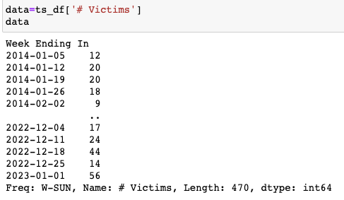

After splitting this data in the ratio 70-30, got training data as shown in figure 31. We can observe that the training set consists of 329 records with data starting from 2014 to 2020.

## Figure 31

## *Sample data from train dataset after splitting*

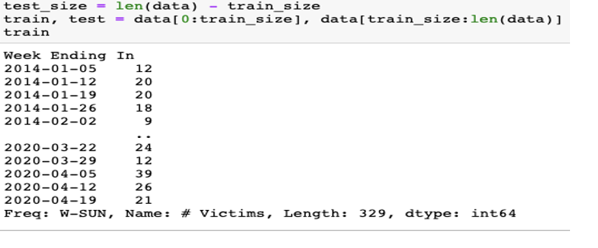

Whereas test data consists of 141 records having latest or young data starting from the year 2020 to 2023, which is shown in figure 32.

**Figure 32**

*Sample Data from Test Dataset After Splitting*

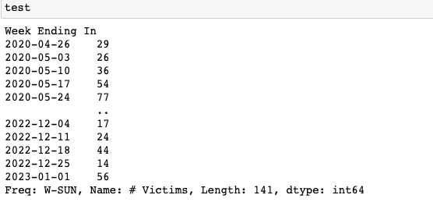

From this data it is keen that, just like any other data, some random shuffle or random split on time series data cannot be performed. It is necessary to keep the temporal order of the data while splitting, so that it helps to predict the next value in time series data based on the fixed number of previous data points.

**Data Statistics**

The number of rows and columns at each stage of the research project is shown in table 9.

**Table 9**

*Number of Rows and Columns at Each Stage*

| **Stage** | **Dataset** | **Statistics** |
| --- | --- | --- |
| Raw data | Mass shootings 2014 - 2020 | 2373 rows x 11 columns |
| Mass shootings 2020 - 2021 | 690 rows x 8 columns |
| Mass shootings 2021 - 2022 | 647 rows x 8 columns |
| Concatenated data | Mass shootings 2014 - 2022 | 3710 rows x 11 columns |
| Data Wrangling | Non-Null dataset | 3710 rows x 10 columns |
| End of pre-processing | Processed dataset | 3710 rows x 10 columns |
| Data Transformation | Time series dataset | 108 rows x 6 columns |
| Outlier detection | Processed time series dataset | 107 rows x 6 columns |
| Data preparation | Training set | 64 rows x 6 columns |
| Testing set | 21 rows x 6 columns |
| Validation set | 22 rows x 6 columns |

For this research project, three different datasets were used. Data from 2014 to 2020 is in the first dataset, the second from 2020 to 2021, and the third from 2021 to 2022. Throughout the project, a single data set was meant to be used, created by concatenating these three datasets. Figure 33 shows the statistics of individual data frames and the final concatenated data frame.

**Figure 33**

*Shape of all Four Data Frames*

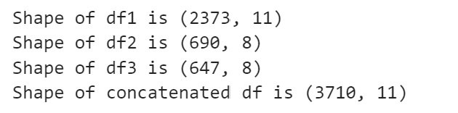

Several steps were taken to ensure the dataset was clean and ready for analysis before beginning the analysis. Data wrangling was the first step, which involved purging the dataset of any redundant or pointless information by dropping some columns, filling null values, by handling the noisy data. Figure 34 shows the data frame statistics after this step.

**Figure 34**

*Data Frame Statistics After Performing Data Wrangling.*

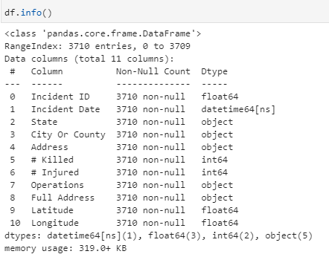

Once the dataset was clean, it was transformed into meaningful time series data. This involved converting the data into a format easily analyzed over time, such as by grouping the data by year or month. Outlier detection and removal were also carried out to ensure that any extreme values in the dataset did not skew the analysis. The shape of the transformed data frame can be seen in figure 35. Data were divided into test, train, and validation sets after being transformed into a meaningful time series. This split was done to train a predictive model on the train set and assess its effectiveness on the test and validation sets. 60% of the data were in the train set, while the remaining 40% were divided equally into the test and validation sets. Figure 36 illustrates the pie chart visualization of shapes of test, train, and validation sets.

**Figure 35**

*Shape of Transformed Time Series Data Frame.*

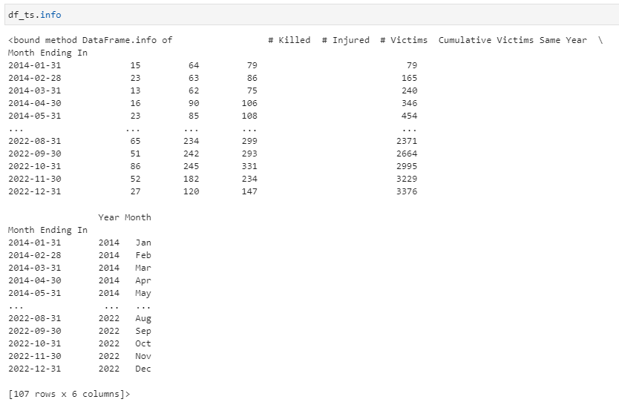

**Figure 36**

*Distribution of Test, Train, and Validation sets.*

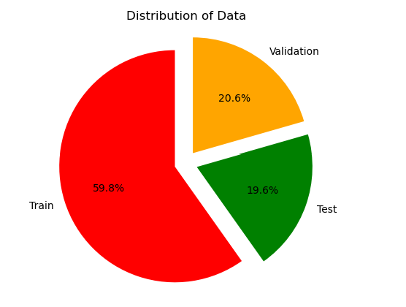

**Data Analytics Results**

In time series data, the term "seasonality trend" describes the predictable pattern of changes in a data series that occur over a set amount of time, such as a month or a year. This pattern can be seen in the data as repeated cycles, and it can be affected by various things, including the weather, holidays, and economic cycles.

Analyzing the seasonality trend in the data on mass shootings in the context of this research project can offer insights into the frequency and severity of incidents at various times of the year. For instance, it may be noted that there are more mass shootings during specific months, such as the summer or around significant holidays.

Changes in trends over time and seasonality trends can offer crucial information about the trends of mass shootings. To gain insights into the trend of the severity of mass shootings over time, it is essential to examine changes in the trend of the number of injured, killed, and victims (combined number of injured and killed in a month of the year). Figure 37 visualizes changes in the trend of the number of injured, while Figure 38 shows the trend of the number of killed, and Figure 39 illustrates the trend of the number of victims. Figure 40 visualizes the seasonality changes in the total time series data related to mass shootings.

**Figure 37**

*Seasonal Trend of Injured Column*

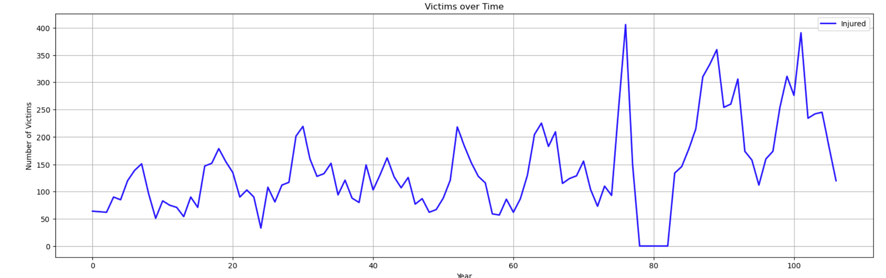

**Figure 38**

*Seasonal Trend of the Killed Column*

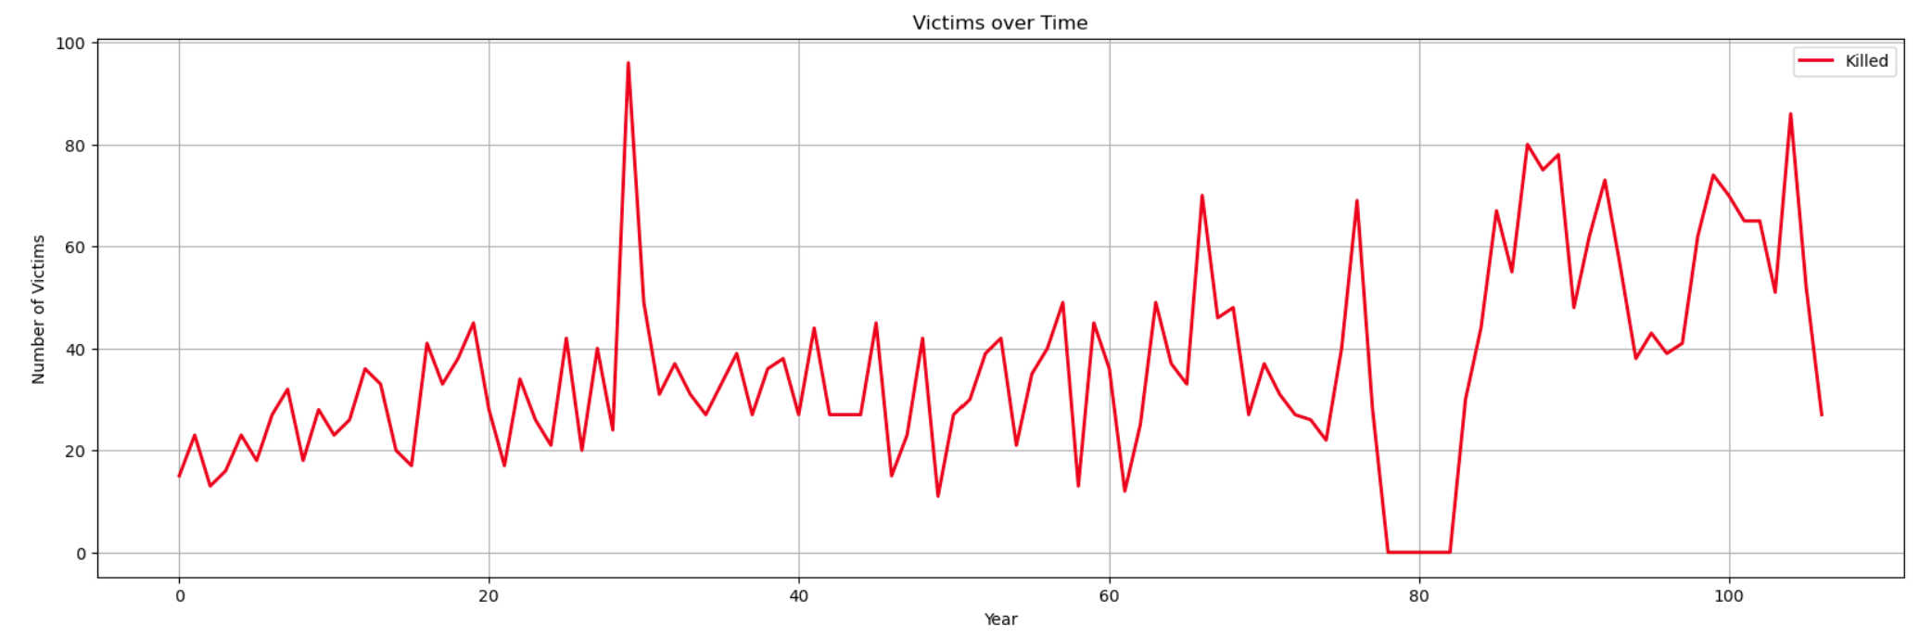

**Figure 39**

*Seasonal Trend of the Victims Column*

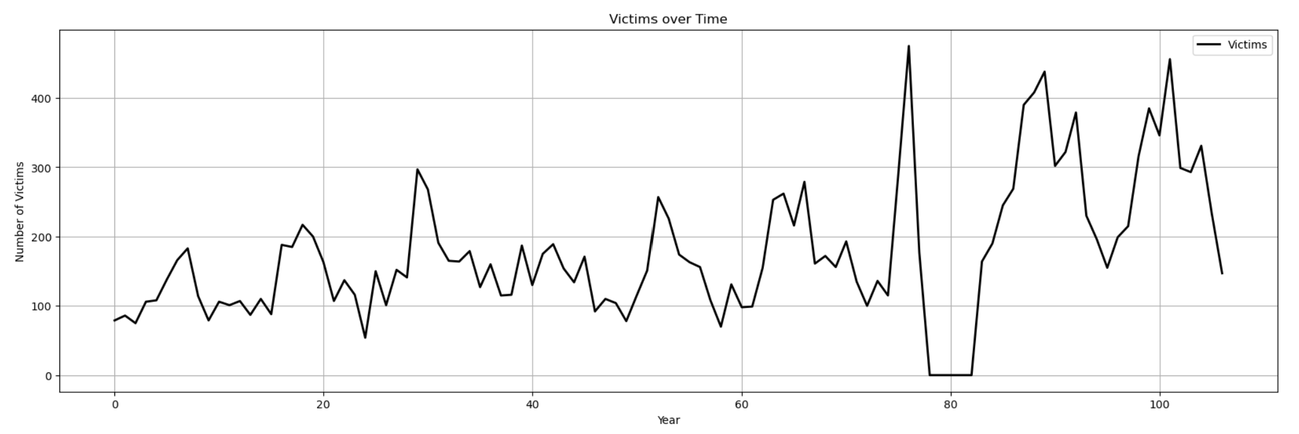

**Figure 40**

*Seasonal Trend of the Time Series Data Frame*

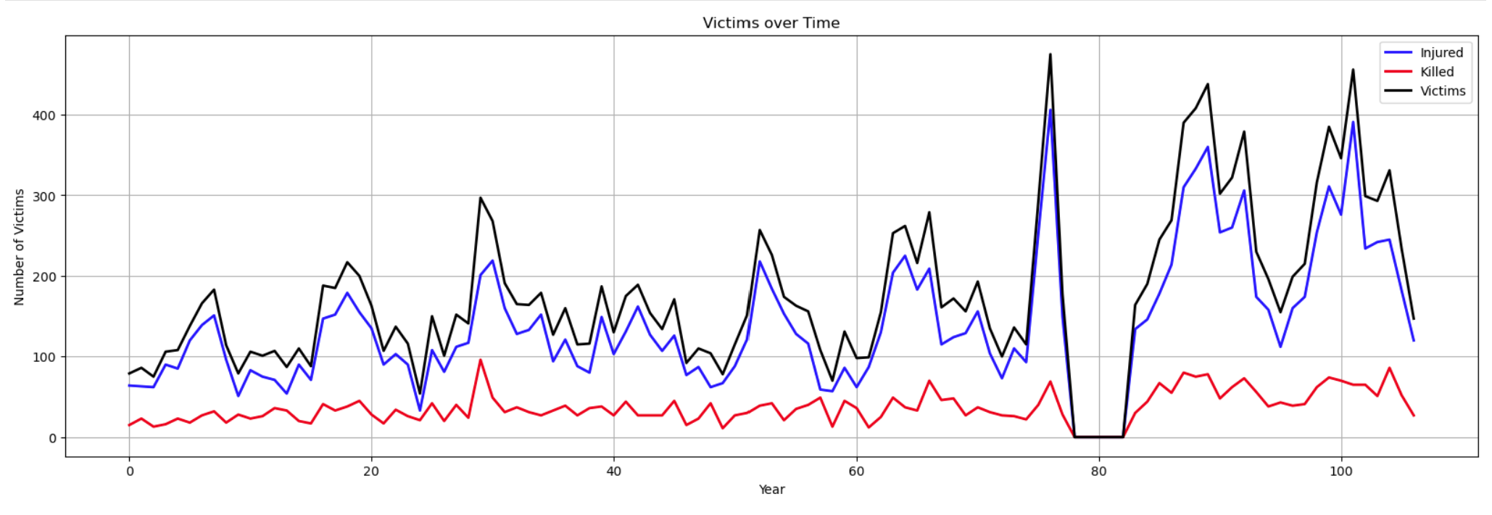

Also, plotted histogram to analyze the density distribution of victims using seaborn library, from which it can be observed that most of the victims are in the range of 20 to 30 as shown in figure 41.

**Figure 41**

*Density Distribution of Total Victims.*

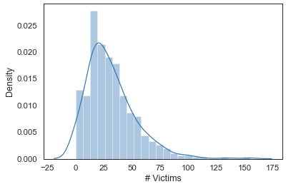

Box plots are used in Figure 42, Figure 43, and Figure 44 to represent the distribution of the total number of Injured, Killed, and Victims, respectively. The extreme values known as outliers, which can skew the data analysis, were found, and eliminated using these figures. It is simpler to spot any data points that deviate from the expected range of values when the data distribution is represented graphically using box plots. The Z-score is one technique that can be used to identify these data points as outliers and remove them from the data set.

**Figure 42**

*Box Plot of the Victims Column*

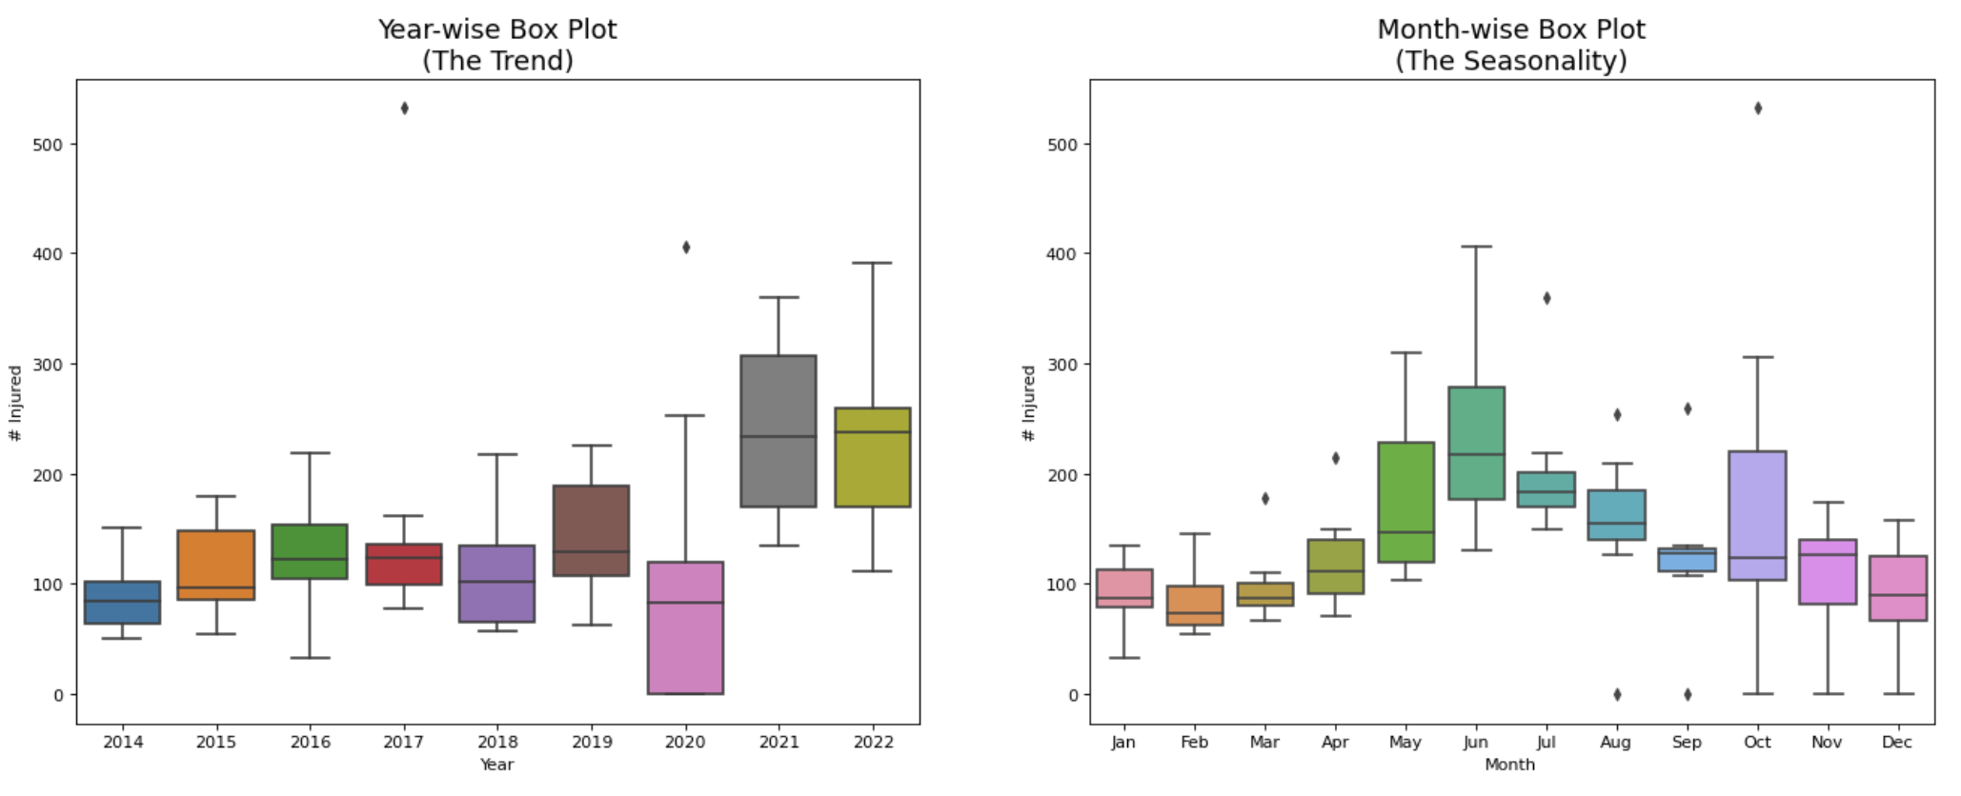

**Figure 43**

*Box Plot of the Killed Column*

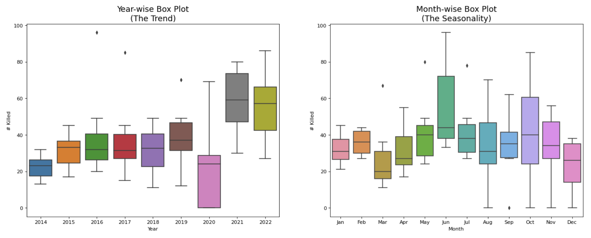

**Figure 44**

*Box Plot of the Victims Column*

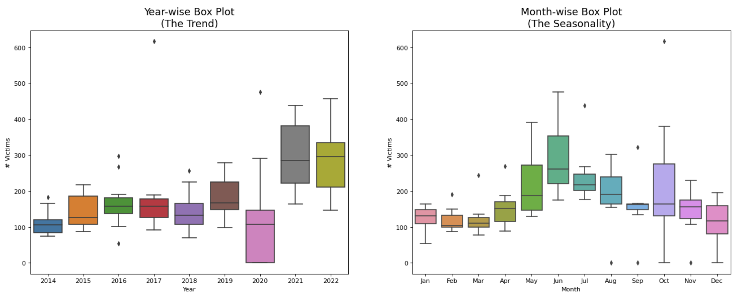

The correlation between a time series and a delayed version of itself is called autocorrelation. The correlation between two points in a time series is measured using partial autocorrelation, which also considers the influence of all intervening points. For instance, a significant autocorrelation at a one-month lag might suggest a relationship between the number of injured, killed, or victims in the current month and the number in the previous month. Similarly, after controlling for the impact of the intervening months, a significant partial autocorrelation at a two-month lag may show that the number of victims, fatalities, or injuries in the current month depends on the number from two months earlier. It is possible to spot any unique patterns or trends in the data by plotting the autocorrelation and partial autocorrelation plots of the three columns (injured, killed, and victims). Figure 45, figure 46, and figure 47 depict the autocorrelation and partial autocorrelation plots of the number of injured, killed, and victims, respectively.

**Figure 45**

*Autocorrelation and Partial Autocorrelation of the Injured Column*

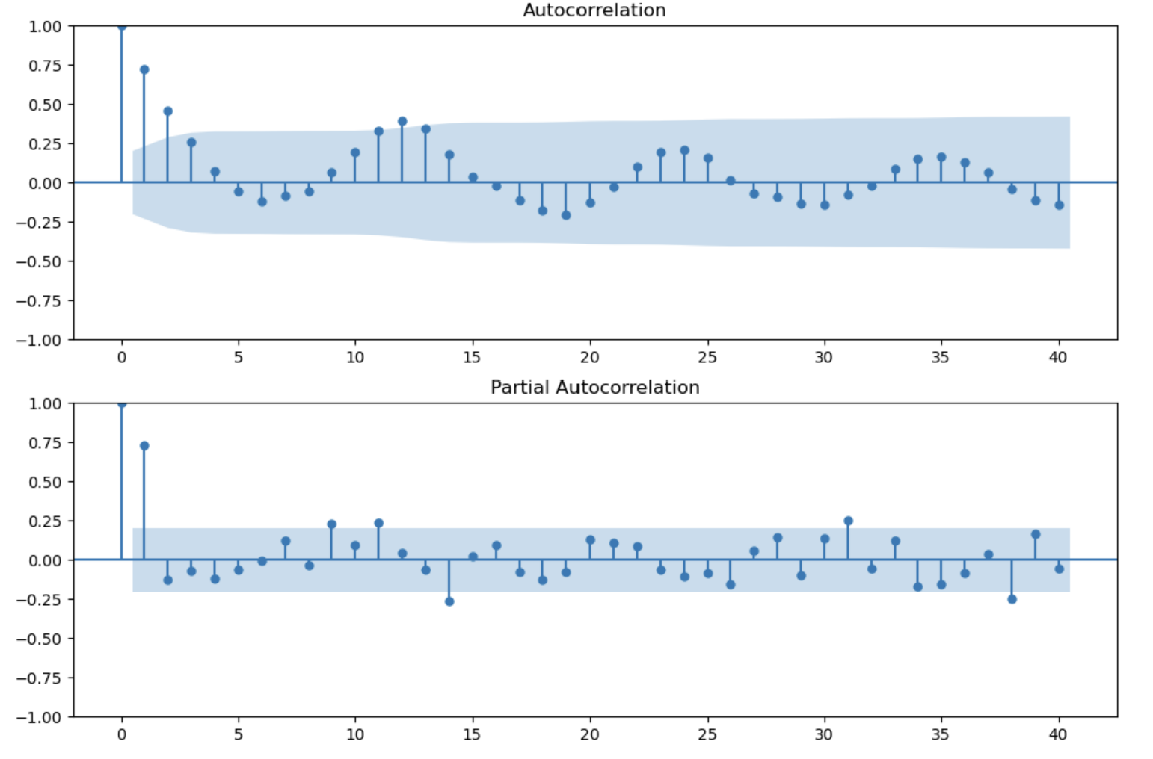

**Figure 46**

*Autocorrelation and Partial Autocorrelation of the Killed Column*

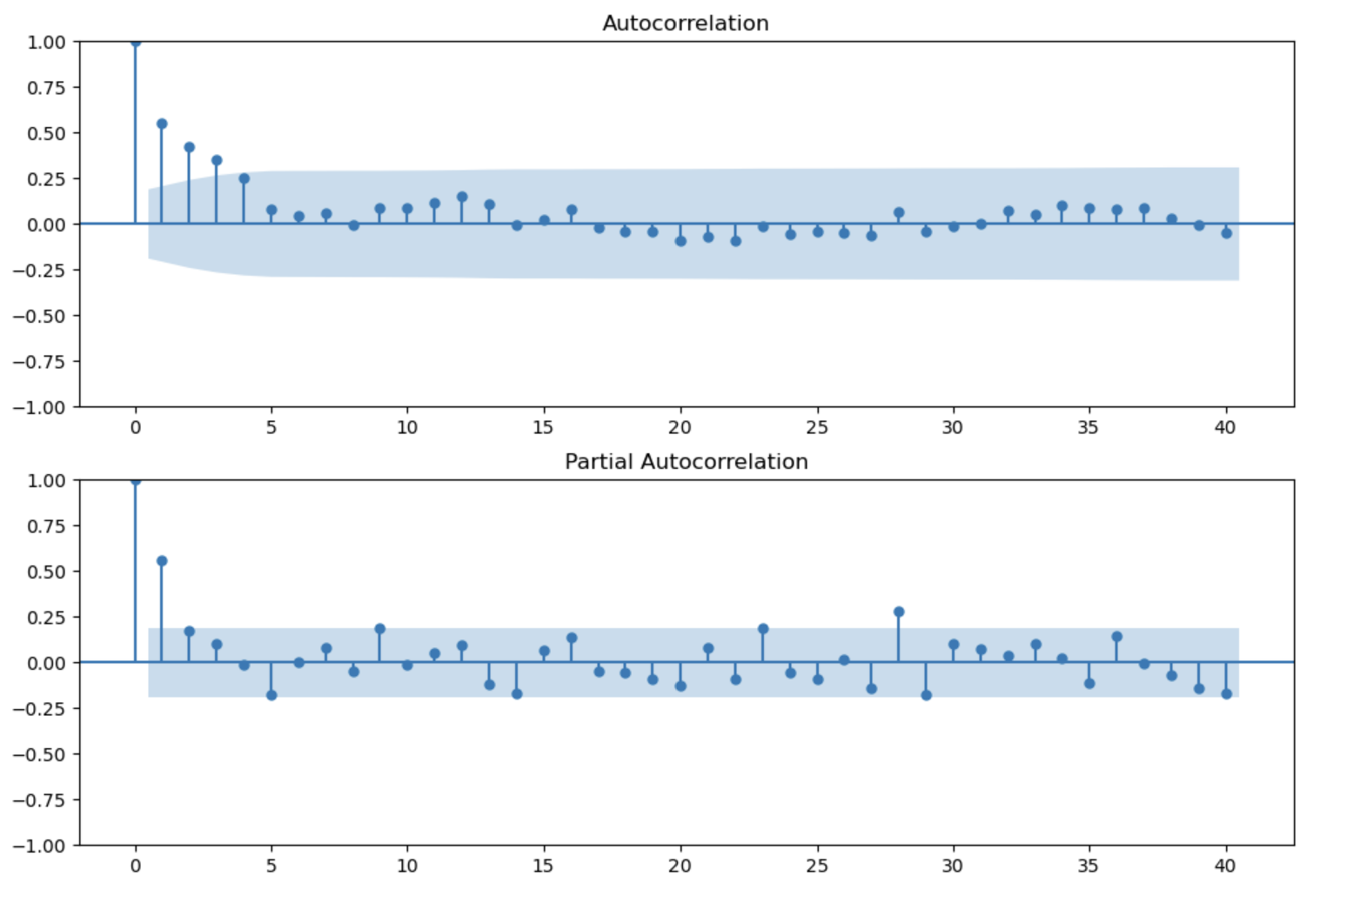

**Figure 47**

*Autocorrelation and Partial Autocorrelation of the Victims Column*

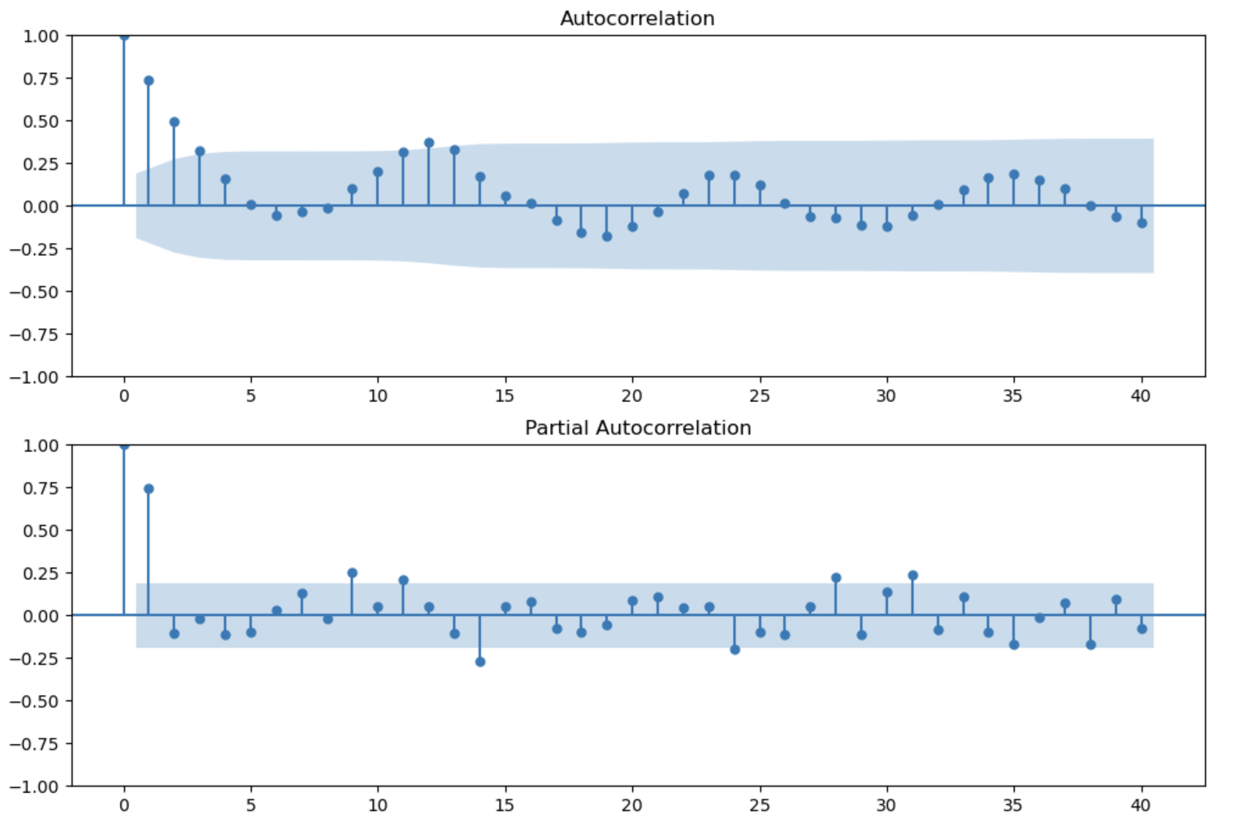

**Model Development**

**Model Proposals**

***SARIMA***

The Seasonal Autoregressive Integrated Moving Average (SARIMA) is one of the most popular and frequently applied time series models for forecasting. SARIMA is an extension of the standard ARIMA model. When the time series data show seasonal patterns, it is beneficial as this model considers the data's seasonality.

In time series analysis, ARIMA models are frequently used to predict future values based on historical data. Their capacity to detect seasonal patterns in the data is constrained. By including seasonal differencing, seasonal autoregressive terms, and seasonal moving average terms in the model, SARIMA was created to get around this restriction. This enables SARIMA to consider seasonal trends and produce more precise forecasts. The SARIMA model has been widely applied in several disciplines, including meteorology, economics, and finance. For instance, SARIMA was used in a study by Anuvarshini et al. (2022), ARIMA models were compared to other forecasting methods, and the results showed that SARIMA outperformed the ARIMA model in accuracy. Sirisha et al. (2022) aimed to use these models to predict a company's future profits and evaluate how well they performed. To complete this task, the authors suggested using time series forecasting models. Because of their widespread use in time series forecasting, they chose the ARIMA, SARIMA, and LSTM models, and the SARIMA model achieved a RMSE of 1.48 and a MAE of 1.162.

To forecast time series data, the SARIMA model combines the ideas of ARIMA and seasonal components. The model consists of four parts seasonal (S), moving average (MA), autoregressive (AR), and integrated (I). While the MA component models the dependence of the current value on the series' past errors, the AR component models how the current value is related to the series' past values. The I component stabilizes the time series, and the S component considers the data's seasonality.

Seasonal differencing is the first step in building a SARIMA model to determine the appropriate degree of seasonal differencing. This involves taking the difference between the observations in the current season and the observations from the same season in the previous year. The autoregressive term represents the relationship between an observation and a lagged value of itself. In SARIMA, the autoregressive terms are denoted by the notation AR(p). The moving average terms represent the relationship between an observation and a residual error from a moving average model applied to lagged observations. SARIMA denotes the moving average terms by the notation MA(q). The seasonal autoregressive terms represent the relationship between an observation and a lagged value of itself from the same season in the previous year. SARIMA denotes the seasonal autoregressive terms by the notation SAR(p). The seasonal moving average terms represent the relationship between an observation and a residual error from a moving average model applied to lagged observations from the same season in the previous year. In SARIMA, the notation SMA(q) denotes the seasonal moving average terms, and it can be represented as the combination of these all as seen in (1).

Y(t) = AR(p) + I(d) + MA(q) + SAR(p) + SMA(q) + ε(t) (1)

Where Y(t) is the time series' value at time t, AR(p) is the time series' autoregressive terms, I(d) is the degree of non-seasonal differencing, MA(q) is the time series moving average terms, SAR(p) is the time series seasonal autoregressive terms, SMA(q) is the time series seasonal moving average terms, and (t) is the time series error term. In general, the seasonal model SARIMA(p, d, q) (P, D, Q) can be expressed as seen in (2).

$Φ_{P}\left(B^{S}\right)φ\left(B\right)∇_{S}^{D}∇^{d}x_{t}= Θ_{Q}\left(B^{S}\right)θ\left(B\right)W_{t}$ (2)

The summary of the algorithm for fitting a SARIMA model to the data is to verify the time series' stationarity and apply differencing if necessary to make it stationary. Then determine the values of s, P, and Q and the seasonal component of the data. To calculate the values of p and q, use the autocorrelation function (ACF) and partial autocorrelation function (PACF). Utilizing maximum likelihood estimation, fit the SARIMA model to the data. Various metrics, such as mean squared error (MSE), root mean squared error (RMSE), and mean absolute percentage error (MAPE), should be used to assess the model. To determine the appropriate AR and MA component values in the SARIMA model, the autocorrelation function (ACF) and partial autocorrelation function (PACF) are crucial tools. The PACF measures the correlation between the time series and its lagged values after removing the correlation explained by the previous lags. In contrast, the ACF measures the correlation between the time series and its lagged values. The ACF and PACF plots can be used to distinguish between seasonal and non-seasonal elements of the time series for the SARIMA model. The seasonal aspect of the series can be shown using the ACF plot, whereas the non-seasonal aspect can be shown using the PACF plot.

The ACF plot can order the seasonal moving average component (Q) and seasonal autoregressive component (P). The data may have a seasonal pattern if the ACF plot exhibits a significant spike at lag s. The number of significant spikes in the ACF plot at lags that are multiples of s can be used to determine the order of the seasonal moving average component. Similarly, the number of significant spikes in the PACF plot at lags that are multiples of s can be used to determine the order of the seasonal autoregressive component. The non-seasonal moving average component (q) and non-seasonal autoregressive component (p) can be ordered using the PACF plot. The series current value may depend on the previous k values if the PACF plot exhibits a significant spike at lag k. The number of significant spikes in the PACF plot following lag 0 can be used to determine the order of the non-seasonal moving average component. The number of notable spikes in the ACF plot after lag 0 can also be used to determine the non-seasonal autoregressive component.

To increase the forecasting accuracy, the model's parameters can be adjusted. The order of the AR, MA, and I components and the seasonal AR and MA components are among the parameters that can be optimized. Using a grid search algorithm to look for the parameters' ideal values is one method of optimizing the SARIMA model. In order to do this, a range of values for each parameter must be chosen, and the model must then be fitted for all feasible combinations of the parameter values. The optimal set of parameter values can be chosen based on a performance metric like the AIC or the BIC.

### Vector Autoregressive

A statistical model called Vector Autoregressive (VAR) is used in econometrics to examine time series data. It involves studying a group of factors that are connected and have an impact on one another throughout time. VAR assumes that each variable in the system is a linear function of both its own lagged values and the lagged values of the other variables. This indicates that the model considers the intricate relationships between variables, enabling a more precise and reliable interpretation of the data. VAR models are frequently used to anticipate future trends, evaluate causal links, and run policy simulations in disciplines including mass shootings predictions.

Vector autoregressive (VAR) system of regression equations is regressed on both its own lags and the lags of the other variables in the system, up to a specified maximum lag order, p. The term VAR(p) model refers to a VAR model with p autoregressive lags. By assuming that each variable depends not just on its own lags but also on the lags of every other variable in the system, VAR models, unlike other regression models, take into consideration the interdependencies between variables. This makes VAR models an effective tool for time series research in disciplines like economics, finance, and environmental science by removing exclusion limits on the interaction of lag model variables. In (3) The equation represents a general form of a Vector Autoregressive (VAR) model

$y_{t}= \sum_{m=1}^{k}{A_{m}y_{t-m}+bt}+c+ ∈_{t}$ (3)

Where yt is a vector of the most recent observations, Am are lag matrices, yt-m are the observations from the past, c is a constant, bt represents a linear time-based trend and t is a random error. VAR models have been applied to various economic problems, including forecasting, investment analysis, poverty reduction, and stock price analysis.

For instance, a study by Mittnik and Neumann (2001) used a VAR model to analyze the Dynamic effect of public investment from six industrialized countries. The authors estimate the model using quarterly data on public investment, output, private investment, consumption, and the trade balance for each of the six countries. The results of the study suggest that public investment has positive effects on output and other macroeconomic variables in the six industrialized countries studied, but the effects vary depending on the country and the time period. In recent years, VAR models have been increasingly employed to analyze complex and dynamic data, such as electronic diary data. Wild et al. (2010) used a VAR model to analyze data from a study on daily emotions and well-being in a sample of Estonian university students. The results of the study suggest that the graphical VAR modeling approach can be a useful tool for analyzing electronic diary data and other types of complex and dynamic data. The temporal causality and dynamics between different economic variables have become an area of interest in economic research. VAR models provide a useful tool to analyze such relationships. An example is the study by Hassan and Islam (2008), which utilized VAR models to analyze the causal relationship between financial development, trade openness, economic growth, and poverty reduction in Bangladesh from 1974 to 2003.

IPO underpricing has been a topic of interest among researchers, and VAR models have been utilized to analyze the determinants of underpricing. Bansal and Khanna (2013) used a VAR model to examine the empirical evidence from the Bombay Stock Exchange and found that underpricing is positively correlated with market returns. Spatial dependencies and network effects in travel behavior have also been an area of interest in economic research using VAR. The data from 1997–1998 work trips to evaluate whether there are any positive network effects in New York City's utilization of public transportation using a spatially autoregressive logit mode choice model. A measure of overall network preference is produced as a result of the study's econometric testing of network preferences. The study presents a framework for evaluations of spatial dependencies and network effects in travel behavior, and the results demonstrate that network effects do exist for transit use. Bansal and Khanna (2013)

***Long Short Term Memory (LSTM)***

To analyze the performance of various models, including LSTM team consisting of Ning et al. (2021) conducted a comparative analysis of LSTM models against other models. The study involved the use of monthly data on oil production, spanning from January 2008 to December 2019. The authors applied the Box-Cox transformation technique to improve the normal distribution of the data. For modifying the hyperparameters for the LSTM model, grid search with cross-validation was employed.

The authors found that the model performed well in forecasting oil production, with the highest accuracy. They used various performance metrics, such as mean absolute percentage error (MAPE), mean squared error (MSE), and root mean squared error (RMSE), to compare the model’s accuracy. The authors acknowledge the limitations of their study, such as the use of a single dataset, and suggest future research to investigate the generalizability of their findings.

Another research by team Lindemann et al. (2021) did a survey on long short-term memory networks for time series prediction. The paper provided an overview of LSTM networks, their architecture, and how they differ from other types of recurrent neural networks.

The paper involved an extensive review of recent research studies that used LSTM networks for time series prediction. The paper focused on the different preprocessing techniques used to analyze data. Also, the architecture of the LSTM network was discussed, including performance evaluation metrics and results. The paper also presented some recent applications of LSTM networks in different domains. The results of the survey showed that LSTM networks have been successfully applied in various fields for time series prediction. The research revealed some of LSTM networks weaknesses, such as their computational cost and proclivity to overfit when not adequately regularized.

Research on review of the LSTM model, a form of Recurrent Neural Network (RNN) designed to learn long-term dependencies in time series data was proposed (Van Houdt et al., 2020), where authors present an overview of the LSTM model's construction and operation, including its gating mechanism and memory cell, and compare it to other RNN models. Following that, the paper looks at LSTM training and optimization, covering regularization approaches, hyperparameter adjustment, and optimization algorithms.

A recurrent neural network called a Long Short-Term Memory (LSTM), which is ideal for modeling time-series data with long-term dependencies, served as the core model for this research. A fully linked output layer came after several LSTM layers in the LSTM model's sequential architecture. A series of past gun violence occurrences served as the model's input, and its output was to analyze the pattern for test and validation set. Using the Adam optimizer and a loss function, the LSTM model was trained and verified. To improve the performance of the model, hyperparameters like the number of LSTM layers, the number of hidden units, the learning rate, and the batch size were modified using methods like grid search or random search. LSTMs were first introduced by Hochreiter and Schmidhuber, and several researchers have since refined and further enhanced them (Gulli & Pal, 2017). Recurrence is implemented by the SimpleRNN using the current input and the hidden state from the previous time step in a tanh layer. Similarly, LSTMs uses four layers to interact in a very particular way rather than a single tanh layer to implement recurrence. The transformations that are made to the concealed state at time step t are shown in figure 48.

**Figure 48**

*LSTM Gate Transformations*

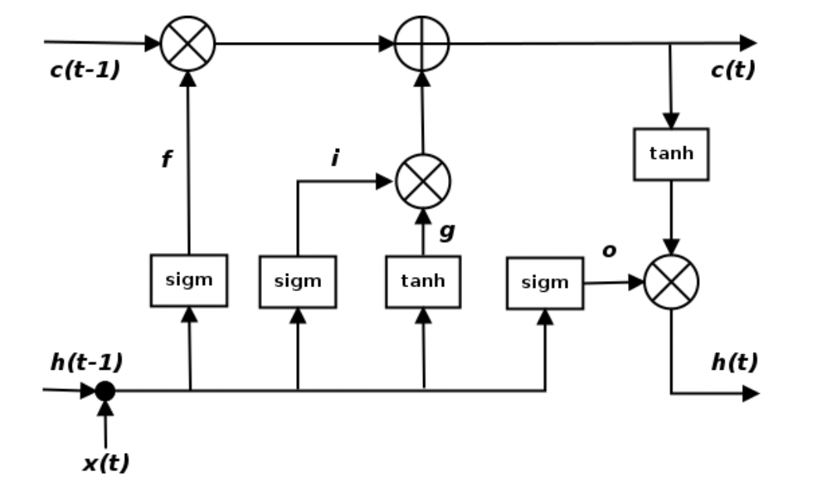

Note. From *Deep learning with keras* by Gulli and Pal (2017).

The cell state c line that is present at the top of the diagram stands in for the internal memory of the unit. The LSTM uses the i, f, o, and g gates to get around the vanishing gradient problem; the line across the bottom represents the hidden state. The LSTM gains knowledge from these parameters during training. The sigmoid function is applied to these gates to limit their outputs to values between 0 and 1. The amount of the second vector that is permitted to flow through the first one is controlled by doing an element-wise multiplication with the resulting output vector.

The quantity of the prior state h(t-1) that is allowed to flow through is determined by the forget gate. The output gate controls how much of the internal state should be revealed to the next layer, and the input gate controls how much of the newly state should be permitted. Using the current input xt and the prior hidden state h(t-1), the internal hidden state g is calculated. The equation for g is comparable to that of the SimpleRNN cell, however in this instance the output is controlled by the input gate i. The different gates of the LSTM model such as input, forget, and output modulate the hidden state. To find the best setting that will speed up the model's convergence to a minimum loss, the optimizer's learning rate can be changed. This can be accomplished by testing out several learning rates and selecting the one that results in the quickest decrease in loss during training.

The batch size and sequence length can also be changed to improve the training process. The model's capacity to generalize to the data may be enhanced by a larger batch size, although training times and memory usage may be prolonged. Large sequences, like larger sequence lengths, may provide the model with additional context, but they also require more memory and processing capacity.

***Prophet***

Ning et al. (2022) This study compares three machine learning techniques such as Auto-Regressive Integrated Moving Averages (ARIMA), Long-Short Term Memory (LSTM) recurrent neural network, and Prophet model for time series oil production forecasting in the petroleum industry. Machine learning models in energy resources because of their cost-effectiveness in extracting the most value from large information created in subsurface reservoirs, assessment, drilling, completion, production, and other activities. the distinctions in exploration and production between supervised and unsupervised learning. Unlike standard empirical decline curve analysis and science-based reservoir simulation models, which are frequently employed for predicting the performance of unconventional oil reservoirs. In order to forecast time series oil production in the petroleum business, the Prophet model was contrasted with two other machine-learning techniques that specialize in modeling nonlinear time series data with seasonality effects on a daily, monthly, and annual basis. It was used to forecast future oil output from 65 wells in the Denver-Julesburg Basin (DJ Basin), and it performed better than previous methods because it could manage missing data and outliers, making the matching process nearly automatic. When compared to other models, the Prophet model excelled in terms of RMSE and MAE results and was able to anticipate the general declining trend as well as the seasonal impact. Additionally, it identified prospective seasonal effects that might be useful to operators beforehand to avoid any production changes the Prophet model performs better than the (ARIMA) and (LSTM) models in predicting the oil production trend with the least amount of error for a period of two years, followed by the LSTM model. As the Prophet model may do a better job of capturing the seasonality effect, the ideal model may depend on whether or not there is seasonality in the production data.

Yang and Li (2022) in the paper the creation of a shared bicycle traffic forecast model is important for controlling shared bicycles, maintaining the availability of shared services, and enhancing user convenience and effectiveness. The Prophet and Bidirectional Long-Short Term Memory (BiLSTM) models, which are used to create a prediction model based on pre-processed data, are coupled using the least squares approach to acquire the best weights in order to increase prediction accuracy. The Prophet-BiLSTM combination model offers the best forecasting performance, according to tests and comparisons with single-item forecasting models and three widely used time series forecasting models. The Prophet model can incorporate seasonal elements into time series and fit cyclical fluctuations with the general trend. Piecewise linear and piecewise logistic regression are two popular methods.

Piecewise logistic regression is written as in the (4)

g(t) = $\frac{C}{1+e^{(-k \left(t-b \right))}}$ (1)

Where g(t) is the trend function, saturation value (C), growth rate (k), and offset (b) from (4). The saturation value is the maximum limit that a process can reach. It cannot grow beyond this limit. The growth rate determines how quickly the process approaches the saturation value. A higher growth rate means the process reaches its limit faster. From (5) the offset represents the starting or ending point in time for the process's growth. When the formula is graphed, there is an initial flat line until the offset (b) is reached. Then, the function starts increasing and eventually flattens out at the saturation value (C). The steepness of the curve is determined by the growth rate (k).

g(t) = (k + a (${t)}^{T}δ$) * (t + (m + a (${t)}^{T}γ$)) (2)

The Linear Additive Model (LAM) is used by piecewise linear. The piecewise linear model divides the data into parts and draws straight lines for each part. It assumes that the data changes at different speeds in each part. It assumes that the relationship between the data is a straight line in each part. This model is used to analyze data that is not a straight line. The model was initialized with the holiday item set for significant holidays affecting bicycle traffic, changepoints set to 0.15, and changepoint_prior_scale set to 10. To get the best fitting effect, the predictions were assessed using evaluation measures like RMSE, which measures the difference between the observed value and the real value. Eventually, it was discovered that the model, which was created to forecast shared bicycle traffic, was more successful when it extracted periodicity from the data, factoring in vacation effects, as well as other influencing elements like weather and temperature. Bidirectional long-short-term memory (BiLSTM) was utilized to identify the temporal dependencies in the data, and the Prophet model was used to match the bicycle rental data to daily, weekly, and holiday periodicity components. For each model, the mean absolute error (MAE) and root mean square error (RMSE) are utilized as evaluation metrics.

Samal et al. (2019) Analyzed the efficacy of several analytics models in predicting air pollution levels, particularly in Bhubaneswar City, India, utilizing time series forecasting approaches due to the inadequacy of conventional linear regression methods. It emphasizes the serious effects of pollutants like RSPM, SO2, NO2, and SPM on human health, causing both acute and chronic effects. Various techniques, including Box-Jenkins, ARIMA, SARIMA, and Prophet model, emphasize the effectiveness of the SARIMA and Prophet models used for subsequent execution. Using Mean Squared Error (MSE) and Root Mean Square Error (RMSE) incorporates the impacts of seasonal changes and holidays on air quality levels and assesses the model accuracy. With a wide confidence interval, the Prophet model was utilized to predict future pollution levels. The Prophet model was used to build an early warning system for public safety and can be extended to analyze healthcare data to establish health correlations with pollution levels in the future. The findings demonstrate that the Prophet model on log transformation is the most effective method for predicting future pollution levels. However, both the SARIMA and Prophet models offer good accuracy in this regard. To create a public safety early warning system that can be improved further by deep learning algorithms.

Pindiga (2022) focused on time-series forecasting to anticipate stock index using ARIMA and Facebook Prophet models, notably forecasting the Dow Jones Industrial Average (DJIA) to assist investors of the 30 businesses featured in it in making informed judgments examining the responses of the ARIMA and Facebook Prophet models to the forecasted DJIA index value and gathers data from 2009 to 2019 to forecast stock prices, verify forecasts, and create price visualizations. Due to the volatile nature of the stock market, close observation of the predictions is required. However, ARIMA forecasting produces fewer errors than Facebook Prophet offers insights on predicting stock market trends and can be used as a reference by investors and economic professionals. The Facebook Prophet is a tool designed to easily predict time series data at a large scale. The model is designed to easily predict time series data at a large scale, using a single variable of time to forecast results. According to equation (6) the prophet model has three main components includes three key components: trend, seasonality, and holiday effects. 𝑦(𝑡) represents a dependent variable that is the sum of four components: 𝑔(𝑡), 𝑠(𝑡), ℎ(𝑡), and 𝑒.

+ h(t) + $ε_{t}$ (6)

The trend function is denoted by g(t), the periodic function by s(t), the holiday function by h(t), and the error or noise by et. T is the error term that accounts for any unusual changes that the model does not account for the ARIMA model performed better than the Facebook Prophet model in forecasting the Dow Jones Industrial Average index. Therefore, ARIMA is a better model to use for forecasting stock market trends, especially for short-term predictions. However, they also caution that the stock market is critical and requires careful observation of predictions, regardless of whether the model used gives information on predicting stock market trends and can be used as a reference by investors and economic analysts. Prophet employs several kinds of characteristics to regulate the model's behavior and the accuracy of the forecasts. The Prophet uses a number of significant factors, including the following.

**Growth.** Prophet's preference for the trend model depends on this setting. Depending on the type of trend you wish to model, it can be set to linear, logistic, or custom. The linear model is a straight line, meaning that the rate of change is constant over time. The logistic model is an S-shaped curve, meaning that the rate of change increases or decreases over time. The custom model allows you to specify a trend function, allowing you to more accurately model complex trends.

**Seasonality Mode.** This setting regulates the kind of seasonality model that the Prophet employs. Depending on whether the seasonality is additive or multiplicative, it can be set to either an additive or multiplicative calculation. In an additive seasonality model, the seasonality is added on top of the trend to model the time series. Whereas in a multiplicative seasonality model, the seasonality affects the trend by multiplying it. Thus, the trend is adjusted depending on the seasonality of the data.

**Holidays.** The time series is predicted to be affected by the holidays listed in this parameter. The names of the holidays and the dates they fall on can be used to identify them. Prophet will automatically modify the forecasts to take these holidays into consideration. It is important to note that holidays must be specified in advance for Prophet to adjust for their effects on the forecast, as Prophet does not have the ability to detect them automatically.

**Changepoints.** The dates when the trend, seasonality, or holiday effects are anticipated to alter in the time series are specified by this option. Prophet will automatically modify the model to take these changes into consideration and generate more precise forecasts.

**Uncertainty samples.** This parameter defines the number of samples to be used when computing uncertainty intervals for the forecasts. Higher values will bring more accurate uncertainty intervals, but they will also increase the computation time significantly.

In general, Prophet employs a number of parameters to regulate the model's behavior and the accuracy of the forecasts. These variables can be changed to suit the unique properties of the time series data and the user's forecasting requirements. By adjusting the parameters, users are able to create models that can better capture the underlying patterns of the data and produce more accurate forecasts. Furthermore, this flexibility allows Prophet to be used for a wide range of forecasting problems, such as short-term and long-term forecasting, as well as forecasting at different levels of granularity.

**Model Supports**

The system used for the time series analysis of mass shootings has a high-performance 8 core CPU with same number of performance and efficiency cores with a base clock speed of 2.6 GHz and 16GB of RAM. The system also included an effective Apple GPU with 16GB VRAM and 16 core neural engine. The training and evaluation of machine learning models are among the complex computational tasks this hardware setup can handle. In addition to hardware requirements, software requirements are also an important consideration for any study that involves technology. For this project macOS, Microsoft Word, Jupyter Notebook, and Python programming language are used. It is made sure that the required software versions are used, and its compatibility is verified. The Jupyter Notebook, which offers an interactive computing environment for the Python programming language, was the software configuration used for the project. The particular version of Python used for the project was 3.8. Jupyter Notebook is a popular tool for data analysis and modeling due to its ease of use. macOS, a widely adopted and reliable operating system that supports a variety of programming tools and applications, served as the project's operating system. Its user-friendly interface and support for various hardware configurations make it an excellent option for modeling and data analysis tasks. Table 10 shows the libraries used in this project.

**Table 10**

*List of Functions and Methods Used for This Research Paper.*

|  | **Library** | **Method** | **Usage** |
| --- | --- | --- | --- |
| Dateutil | dateutil.parser | parser | Parse dates from the dataset |
| NumPy | numpy | math, random | Used for numerical operations and functions and random numbers. |
| Pandas | pandas  pandas.plotting | DataFrame, Series, Concat, read_csv  autocorrelation_plot | Used for data manipulation, time series analysis, and data visualization. |
| Matplotlib | matplotlib.pyplot | pyplot | Used for plotting. |
| Seaborn | seaborn | seaborn, boxplot | Used for creating statistical graphics. |
| Scikit-Learn | sklearn.metrics  sklearn.models_selection  keras.models | mean_squared_error, train_test_split,  Sequential | Used for evaluating the models, split data and open source platform for machine learning. |
| Google Map | googlemaps | models, plotting, Title_providers | Used to interact with the API to perform geocoding |
| Tensorflow | keras.layers | Dense, LSTM | Deep learning neural network models |
| Prophet | prophet | prophet | Used for Prophet model. |
| Statsmodels | statsmodels.tsa.stattools  statsmodels.graphics.tsaplots  statsmodels.tsa.statespace.sarimax  statsmodels.tsa.vector_ar.var_model | adfuller, kpss, acf, pacf  plot_acf, plot_pacf  SARIMAX  VAR | Used for statistical modeling and time series analysis, including functions for testing stationarity, ACF and PACF plots, seasonal decomposition, SARIMA, VAR modeling. |

**Model Architecture and Data Flow**

***SARIMA***

One of the model used in this project is SARIMA, famous for time series analysis. Figure 49 shows the data flow diagram for this model. It shows that data is gathered from various ".csv" files before training and testing the models and goes through several data transformation steps. The data flow diagram starts with gathering information from three ".csv" files that contain data on gun violence from 2014 to 2022. For further analysis, these files are read into three separate data frames and combined into one. The next step is data exploration, to learn which cities and states have the most gun violence incidents. After that, data wrangling is performed. Firstly, look for duplicate records and empty columns that need to be dropped, null values in numerical columns replaced with their corresponding means, and the word "Others" in non-numerical columns. The data is then transformed into a time series data frame by designating the date column as the index and removing unnecessary columns. The "injured" and "killed" columns are added together to form a new column called "Victims." Outliers are then removed using the z-score method for one hyperparameter and another one is considered with outliers, and the final dataset is tested for stationarity and seasonality using the Adfuller test.

**Figure 49**

*Data Flow Diagram*

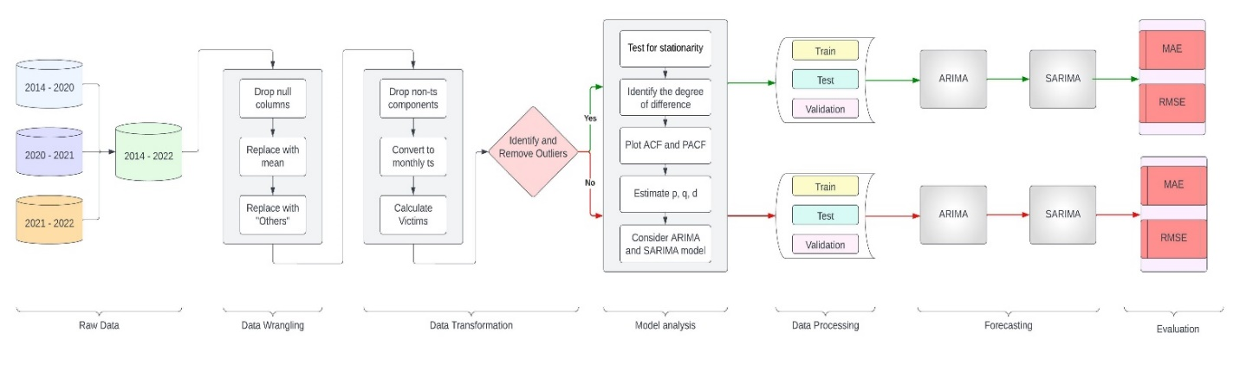

For the SARIMA model to function appropriately, the time series data must be complete and spaced evenly. SARIMA model might only be able to fully capture the underlying patterns and relationships in the data if the data is sparse or complete, which means there are missing values or irregular gaps in the time series. Using interpolation techniques to fill in the inconsistent time series data is one way to deal with this problem. Interpolation is a technique for estimating a function's values between known data points, in this case, the time series data. A more complete and evenly spaced time series can be produced that can be used with SARIMA models by using interpolation to fill in missing values or gaps. Various interpolation techniques may be employed depending on the nature of the missing data. Interpolation methods that are frequently used include spline, polynomial, and linear interpolation. In this research problem, the time series is performed on monthly time series data. So, to counter unevenly spaced data, the data is transformed into a time series data frame by cumulating the number of killed, injured, and victims by the end of each month.

The autocorrelation and partial autocorrelation graphs must be plotted to ascertain the values of attributes for the SARIMA model. A train (60%), test (20%), and validation (20%) set is then created from the data frame. With the addition of seasonal order identification, the SARIMA model is then evaluated using the test data and validation data after being trained using the training data. Several metrics, including Mean Absolute Error (MAE) and Root Mean Squared Error (RMSE), are used to assess the results. Appendix B illustrates the performance of SARIMA on data with outliers.

***Vector Autoregressive (VAR)***

Three datasets from separate years (2014-2020, 2021, and 2022) were combined into one dataset. First, the system needs to be loaded with each individual dataset. Once the datasets have been loaded and joined together or separated based on shared characteristics like column names or distinctive identifiers. This merging process will provide a single data set with data from each of the three files. The data flow for applying vector autoregressive (VAR) model to the process includes data wrangling and transformation that come next after the datasets have been combined. First, data identification is performed to identify and handle duplicate values. Duplicate records are dropped from the dataset to avoid skewing the analysis results. After that, the dataset's missing values must be dealt with. The mean value of the relevant feature can be used as a replacement for missing values. As a result, there will be less chance of bias in later studies and the dataset will remain intact. To enhance the analysis, geolocation coordinates can be obtained using a Geocoding API or Geocoding service like Google Cloud Geocoding API (GCE). Utilizing the GCE service can enrich the dataset with latitude and longitude information corresponding to the shooting incidents.

In order to analyze the data as a time series, it is beneficial to convert the data to a weekly time series format. This involves aggregating the data at a weekly level, allowing for more granular analysis of temporal patterns and trends. By summarizing the data on a weekly basis, it becomes easier to identify recurring patterns and variations in the occurrence of mass shooting incidents over time. The time series data can be tested for stationarity using techniques like the Augmented Dickey-Fuller (ADF) test. In order to determine stationarity, this test computes the ADF statistic and compares it to crucial values. The significance of the results is also determined by the p-value received from the test. The time series can be broken down into its individual elements using the Fast Fourier Transform (FFT), such as trend, seasonality, and residual. To study the relationship between the components and the original time series, multiplicative and additive decompositions can be used. These studies offer insightful information about the nature and properties of the time series data. Figure 50 shows the dataflow for VAR.

## Figure 50

### The Architecture of the VAR Model

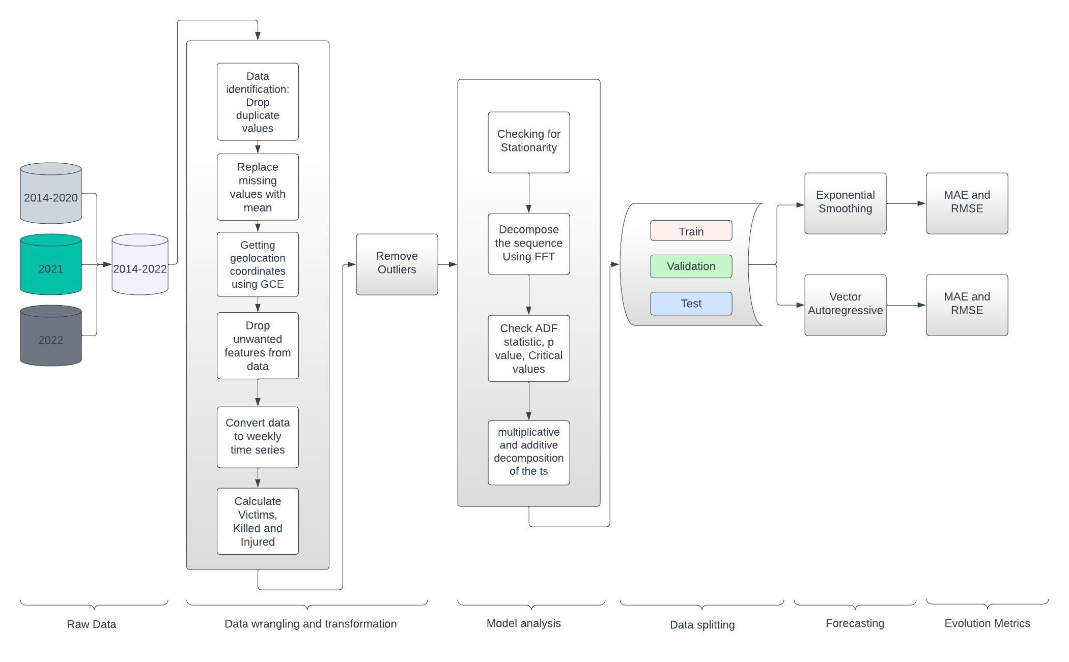

This involves preparing the data for analysis by cleaning it, dealing with missing numbers, and eliminating duplicates. Depending on the unique analysis of the investigation, data wrangling techniques may involve data normalization for time series analysis, feature scaling, or encoding date format to monthly and weekly analysis. The model analysis phase can begin once the data is cleaned and transformed. The evaluation metrics commonly used for analyzing mass shootings include the number of fatalities, the number of injuries, and the overall impact on the affected community. Appendix C shows the data flow in work and the performance of VAR on the time series dataset.

***Long Short Term Memory (LSTM)***

Datasets from Gun Violence Archive and Mother Jones are divided and stored in CSV format, and Pandas is used to merge them. Loading and inspecting data is essential for making informed decisions in EDA plans, and 4000 rows were processed using pandas and numpy libraries. Operations, Incident ID, and injured and killed columns need to be addressed to ensure accurate data. There may be many duplicate values in the dataset, and after checking, found that there were around 80 duplicates for the Address column. Deleting missing data is a popular method for dealing with incomplete or missing data, such as the Operations column and other redundant columns. Total victims count is calculated by combining injuries and killing and assigning a new column name.

For time series analysis, data preparation also includes transforming a time column into a month and year. Time series data is frequently gathered at intervals as frequent as hourly, daily, or weekly. So, considering year, month, week components from the incident date column is necessary for analysis. Several preprocessing methods are used in time series modeling during the split to increase the model accuracy and results. The time series data can also be converted using the sliding window method into a format appropriate for LSTM model training. To do this, input-output pairs that each represent a time series window are created from the original time series data. Scaling is another preprocessing method that ensures that all variables have a similar scale by normalizing or standardizing the data. The accuracy and dependability of the time series model can be greatly enhanced by using these preprocessing methods during splitting.

The dataset is divided into 70% training and 30% testing data. Since it is a time series data, it is important to make sure that training data consists of old data in a timely order, whereas test and validation data should have latest data in a timely manner. For the LSTM model it is necessary to normalize data by using Power Transformer and MinMaxScaler library and reshaping data to from third dimension to lower dimensions such that it fits the corresponding model. The input form of the model is (look_back,1) and it comprises of a single LSTM layer with 4 neurons. The output layer, which has 1 neuron, comes after the LSTM layer in the stack. Mean squared error is the loss function and Adam is the optimizer used when training the model. The model is trained with a batch size of 1 across 100 epochs. The model is used to make predictions on the training and testing sets after it has been trained. The scalers inverse_transform method is then used to invert the anticipated values to their original scale. Additionally, the training and testing sets' real values are scaled down to their original values. Finally, separate numpy arrays are used to record the anticipated and actual values for the training and testing sets and plotted using matplotlib library. Figure 51 shows the data flow diagram for the explained process. Appendix D illustrates the performance of VAR.

**Figure 51**

*Architecture and Data flow for LSTM Model.*

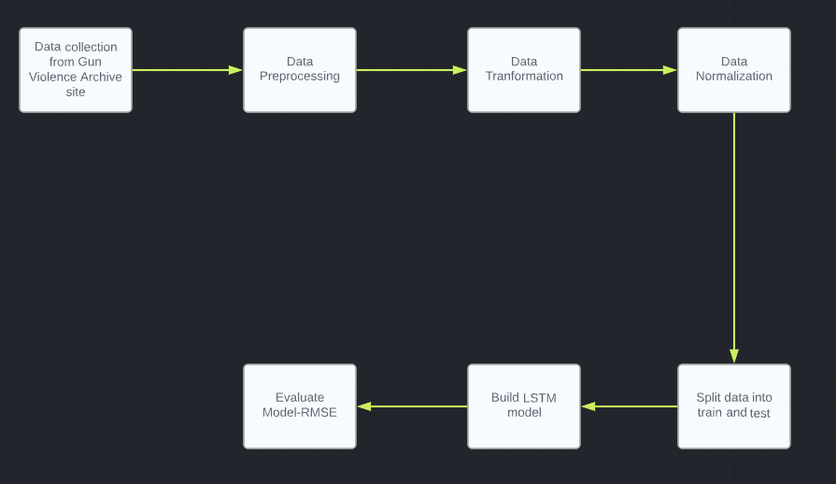

***Prophet***

The datasets utilized in this study were obtained from the Gun Violence Archive website for the years 2014 through 2022, while the Mother Jones websites were used for the years 2021 and 2022. It was combined after loading the three datasets by using a union statement. The EDA process included identifying patterns and trends in the data using tools such as Pandas and data visualization to identify and remove anomalies, inconsistencies, and noisy data. The process also included identifying outliers, and data points that do not fit the general pattern of the data and discarding them. Finally, EDA allowed for data cleaning by removing noise from the data set, which improved the accuracy of the analysis. Data preprocessing is an important step in this study. It helped to improve the accuracy and performance of the model by transforming raw data into a more suitable format, which created new features from existing data and reduced the number of features. This helped to reduce complexity and improved the generalization capability of the model. The Data preparation involved the preprocessed datasets segregated into three sets for analysis, 60%allocated for training, and 40% allocated for both validation and testing.

The datasets were used to demonstrate the value of data quality and labeling for the prophet model, as well as the steps involved in creating reliable and precise predictions. The Prophet Library is used to forecast time series by feeding the data into the model using the fit method. Future time points were represented by "ds" and "y" expected values were represented by "yhat," and their corresponding lower and higher bounds were represented by "yhat_lower" and "yhat_upper." The actual numbers of casualties over time were represented by values for metric evaluations. The plot was labeled with the relevant axis labels, a title, and a legend. Each category was plotted using a distinct color virtually in Figure 52 which was elaborated in a detailed structure. Appendix E illustrates the performance of Prophet.

**Figure 52**

*Representation of Data Flow Diagram*

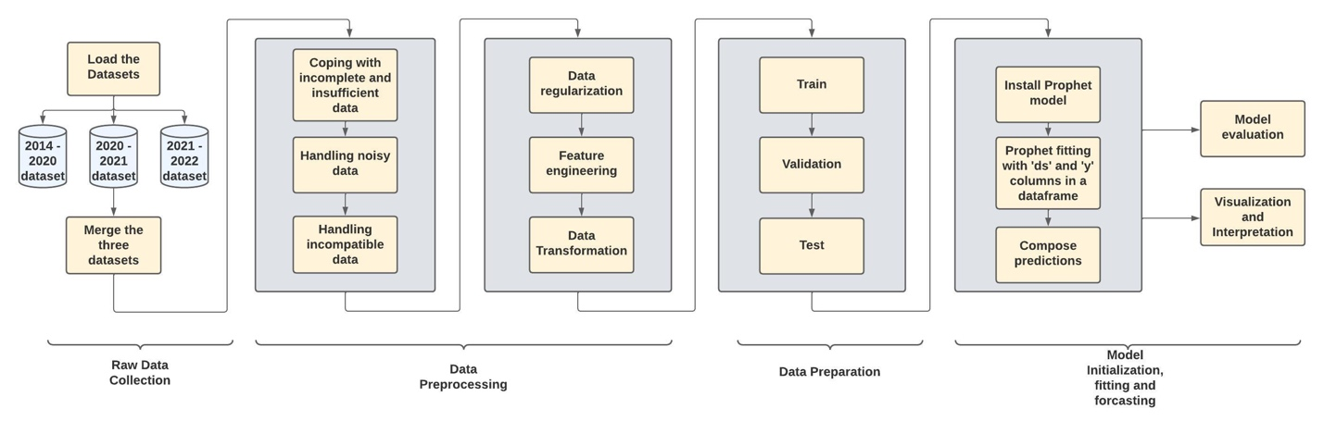

**Model Comparison and Justification**

The popular linear model SARIMA (Seasonal Autoregressive Integrated Moving Average) combines autoregressive and moving average components. It is appropriate for univariate time series analysis and can detect trends and seasonality. SARIMA is the best tool for tracking mass shooting incidents over time because it works well with tabular and time-series data. To make the series stationary, preprocessing techniques like differencing are needed. SARIMA is effective for large datasets because of its relatively low training time and space complexity. It has low computational demands and can be trained on a CPU. SARIMA, however, might need to help capture intricate nonlinear patterns.

An extension of the autoregressive model that can manage multiple time series variables at once is called vector autoregression (VAR). VAR can capture the dependencies between various variables and is appropriate for multivariate time series analysis. Both tabular and time-series data can be processed. To ensure that the time series is stationary, VAR needs to be preprocessed. Training time and spatial complexity become more complex with more variables, but medium-sized datasets can still be used. Although VAR can be trained on the CPU, GPU acceleration may be helpful for large-scale applications. With VAR, overfitting can be a problem, especially when there are many variables and sparse data.

Recurrent neural networks (RNNs) of the Long Short-Term Memory (LSTM) variety are particularly good at identifying long-term dependencies and patterns in sequential data. Given that it can handle sequential and time-series data, LSTM is well-suited for time-series analysis, including studying mass shootings. It can handle both tabular and textual data, including more background information. Significant preprocessing is needed for LSTM models, including scaling and sequence preparation, but this can be automated. Training an LSTM model is computationally expensive and time-consuming, particularly for large datasets. GPU acceleration is frequently suggested as a way to expedite training. Overfitting is a problem with LSTM models, especially when working with small data sets.

Prophet, a forecasting tool created by Facebook, uses an additive model with elements for trends, seasonality, and holidays. It can handle univariate and multivariate data and is specifically made for time series forecasting. Prophet requires very little preprocessing and performs well with time-series data, such as mass shootings. It is appropriate for large-scale applications because training time and spatial complexity are relatively low. Prophet does not require much computational power to train on a CPU. Prophet's capabilities, however, might be constrained in the presence of sparse data and intricate nonlinear patterns. Moreover, the amount of preprocessing needed and the quantity of the dataset both had an impact on how sophisticated the models were. Therefore, different tasks like data exploration, data wrangling, and data transformation were carried out prior to fitting the models in this study effort. LSTM performed well compared to all other models due to taking seasonality into account and it’s functional and non-functional characteristics. Table 11 shows the characteristics of the model used.

**Table 11**

*Comparison of Model Functional and Non-Functional Characteristics*

|  |  |  |  |  |
| --- | --- | --- | --- | --- |
| **Characteristics** | **SARIMA** | **VAR** | **LSTM** | **Prophet** |
| Architecture | Linear model | Linear Model | Neural Network | Additive Model |
| Data type | Tabular, Time Series | Tabular, Time Series | Tabular, Text,  Time Series | Uni and Multi, Time Series |
| Sparse Data | Will struggle | Possible with high dimension | Needs regularization | Limited performance |
| Small Dataset | Works well | Works well | Overfitting | Works well |
| Overfitting/Underfitting | With complex patterns | With sparse data and many variables | With large data | With nonlinear patterns |
| Complexity | Low preprocessing, training time, and space complexity | Preprocessing required for stationarity | Moderate preprocessing, high training time | Low preprocessing, training time, and space complexity |
| Strengths | Captures seasonality and trend | Captures interdependencies between variables | Captures long-term dependencies | Handles trend, seasonality, and holidays |
| Limitations | Struggles with nonlinear patterns | Prone to overfitting with high dimension | Computationally expensive, requires GPU for efficiency | Limited performance with sparse data |

**Model Evaluation Methods**

A crucial component of any machine learning project is model evaluation. It entails evaluating a model's performance to ascertain how well it predicts brand-new data. Several evaluation techniques are used to rate the effectiveness of machine learning models, each appropriate for a specific objective. The two evaluation metrics employed in this research project will be covered in this section.

***Mean Absolute Error***

Mean Absolute Error (MAE) is a measurement metric that assesses the average magnitude of errors in a set of predictions without considering their direction. The MAE is the standard deviation of the absolute difference between a dataset's actual and predicted values. The equation is used to calculate MAE is as shown in (7)

$MAE= \frac{1}{n} \sum_{i=1}^{n}{|y_{i}- \hat{y_{i}}|}$ (7)

Where $y_{i}$ is the actual value, $\hat{y_{i}}$ is the predicted value, and n is the number of observations. The MAE metric is beneficial when assessing a model's predictive power because it can be applied to continuous numerical data.

MAE gives a general idea of how far, on average, the predicted values are from the actual values. The performance of the model improves with decreasing MAE. Use a scatter plot with a regression line to depict the idea of MAE. The x-axis represents the actual values, and the y-axis represents the predicted values. The closer the points are to the diagonal line, the better the model's performance as shown in figure 53.

***Root Mean Square Error***

The difference between the predicted and actual values is measured using the Root Mean Square Error (RMSE), another evaluation metric. The root mean square error (RMSE) is the average squared difference between predicted and actual values. The RMSE calculation formula is seen in (8)

$RMSE= \sqrt{\frac{1}{n} \sum_{i=1}^{n}{{(y_{i}- \hat{y_{i}})}^{2}} }$ (8)

Where $y_{i}$ is the actual value, $\hat{y_{i}}$ is the predicted value, and n is the number of observations. RMSE is similar to MAE but gives more weight to more significant errors. This is because larger errors affect the overall RMSE value more because the squared differences are used. A lower RMSE indicates better performance. Lower values denote better model performance. The RMSE value ranges from 0 to infinity. A graph between the actual and predicted values, with the actual values on the x-axis and the predicted values on the y-axis, shows the RMSE as illustrated in figure 53. The model's performance improves as the points reach the diagonal line.

**Figure 53**

*MAE and RMSE Graph for Validation Set.*

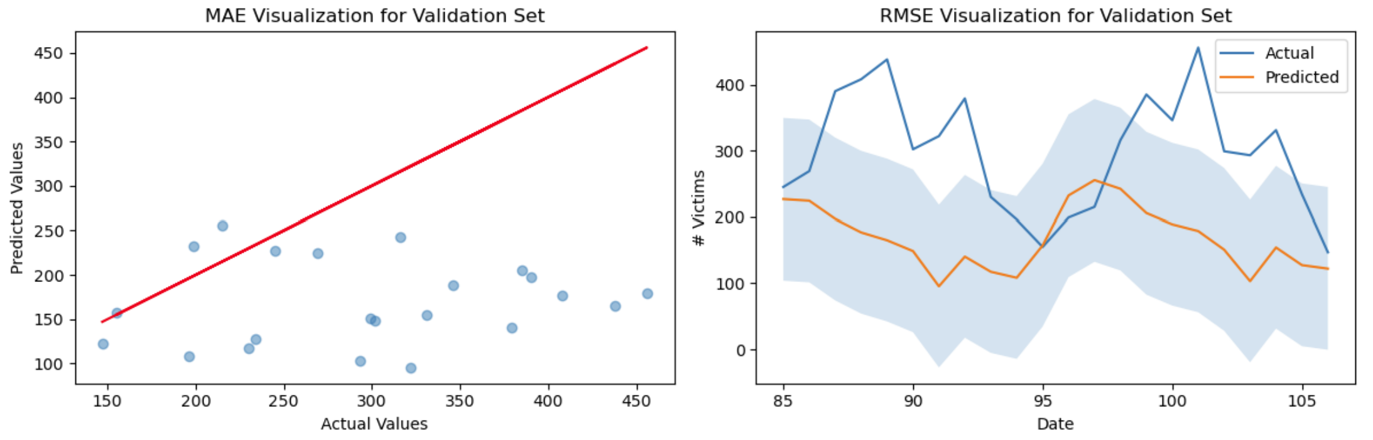

Used the corresponding actual and predicted values for that subset in the respective formulas to determine the MAE and RMSE for each subset of the data. Additionally, determine whether the model is overfitting or underfitting by contrasting the evaluation metrics.

**Model Validation and Evaluation**

***SARIMA***

The SARIMA model, on the other hand, performed well in predicting the number of gun violence victims. The evaluation metrics for the SARIMA model showed relatively low values for both MAE and RMSE, 57.46 and 70.92, respectively, indicating better performance than the ARIMA model as seen in figure 54. The seasonality in the data was captured and accurate predictions.

**Figure 54**

*MAE and RMSE of SARIMA*

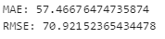

To support these results that show how well the SARIMA model performed, two graphs were plotted with the actual values on the x-axis and the predicted values on the y-axis to show MAE and RMSE. The graph displayed predicted values relatively close to the diagonal line, which suggests that the model performed well. The model's performance improves as the points reach the diagonal line. Figure 55 illustrates the MAE and RMSE graphs for the test set.

**Figure 55**

*MAE and RMSE Graphs for Test Set*

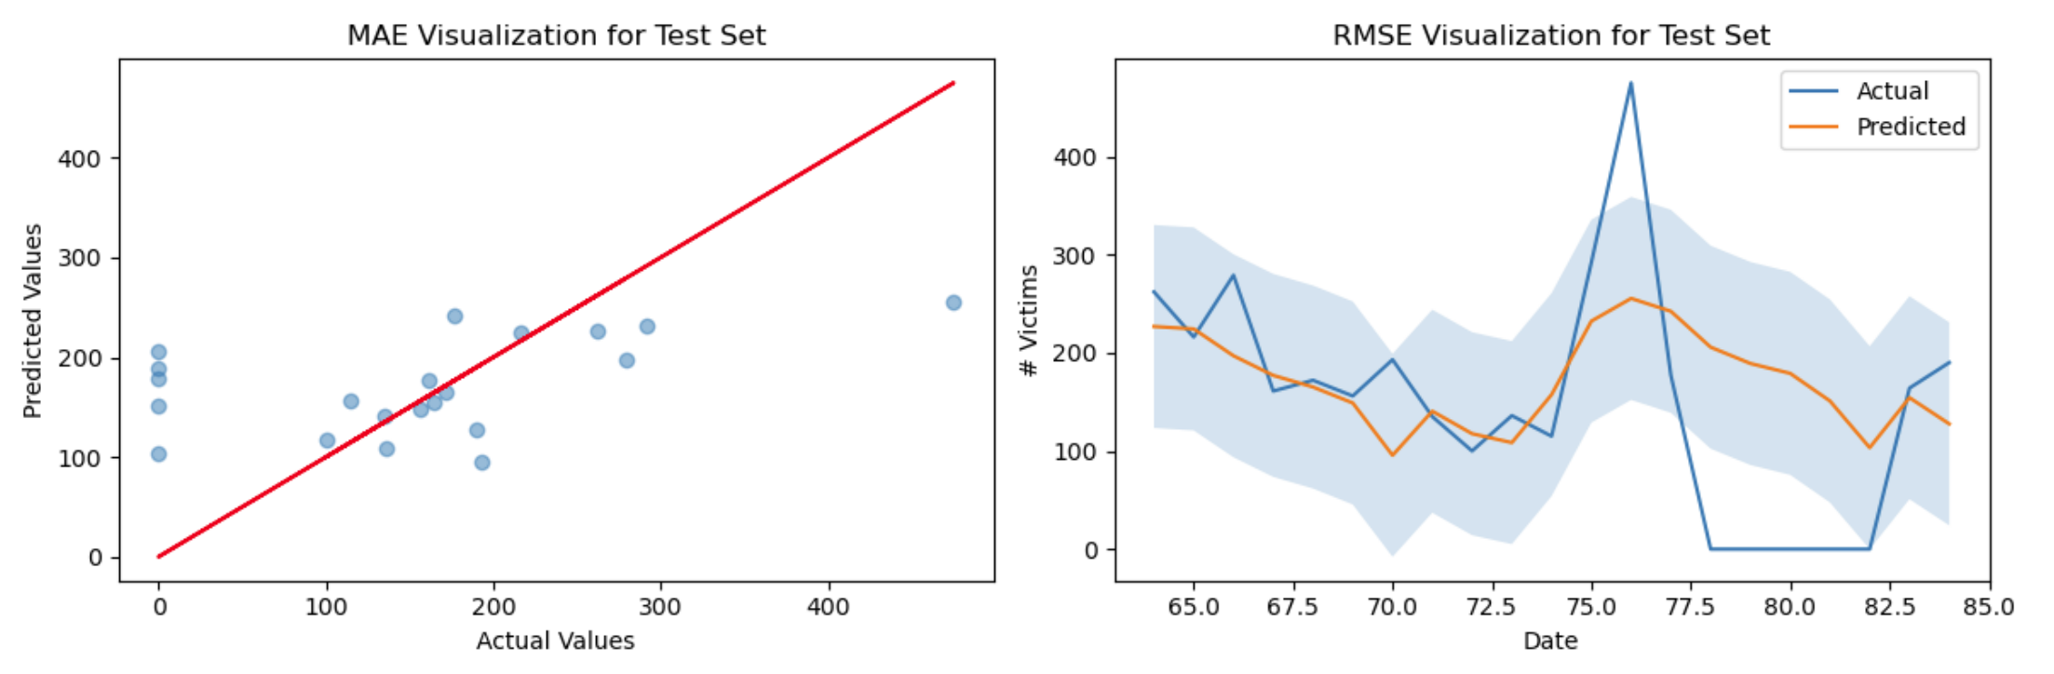

## *Vector Autoregressive*

The non-stationary nature of the data presented a challenge for implementing exponential smoothing, as the assumption of a constant mean was violated. However, the Vector Autoregressive (VAR) model proved to be effective in handling non-stationary data. By incorporating lagged values and considering the interdependencies among multiple time series variables, the VAR model was able to capture the underlying dynamics and patterns in the data. As a result, the VAR model demonstrated good performance in predicting the outcomes of interest. Figure 56 illustrates the comparison between the actual number of casualties during a specific period (2020-01-05 to 2020-03-29) and the predicted number of casualties generated by the model.

## Figure 56

### Actual vs Predicted Casualties

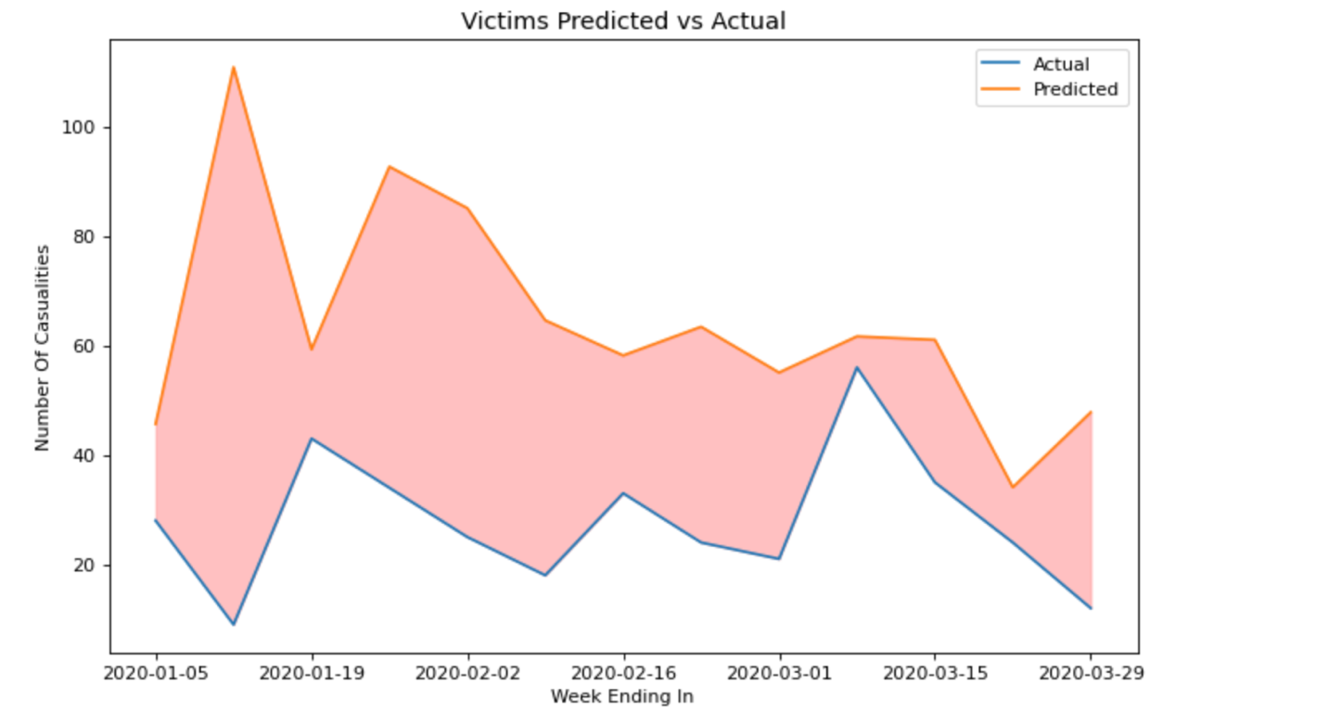

The blue line represents the actual values, while the orange line represents the predicted values. The x-axis represents the week-ending dates, and the y-axis represents the number of casualties. By visually comparing the two lines, this can observe how closely the model's predictions align with the actual values. The shaded area between the two lines provides a visual representation of the prediction error, showing the extent to which the model's predictions deviate from the actual values. For some weeks, the predicted values are very close to the actual and some values are far from the actual values.

In Figure 57, The obtained RMSE value of 44.40 and MAE value of 36.73 for the VAR model indicate relatively low levels of error in the predictions. These values suggest that, on average, the predicted values deviate from the actual values by approximately 44.40 and 36.73 units, respectively.

## Figure 57

### Evaluation Metrics for Vector Autoregressive

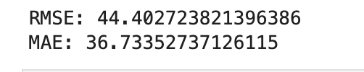

***LSTM***

RMSE and MAE were generated for the train and test datasets to assess the performance of the LSTM model. The RMSE provides insight into the average difference between the expected and actual values. As per the RMSE values, the stateful LSTM model with look back of 15 has less training error compared to testing error which indicate that the model is overfitting the training set while under-generalizing to the real world. However, the stateless LSTM model has less testing error compared to training error. Figure 58 shows the train and test predictions plot.

**Figure 58**

*Results Showing Train and Test Predictions Against Actual Data.*

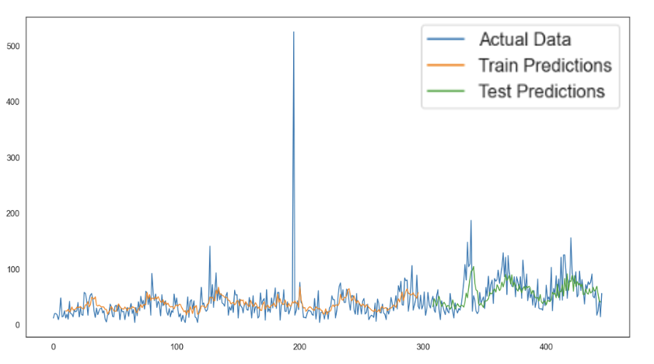

The stateful LSTM model's evaluation results with a lookback period of 10 display a Train Score of 32.95 RMSE and a Test Score of 39.64 RMSE as seen in figure 59.

The stateless LSTM model performs better in evaluation than the model with a lookback value of 5. The model's test dataset prediction error is low, as seen by the MAE and test RMSE scores of 25.36 and 28.71, respectively. The fact that the test RMSE score is lower than the train RMSE score, which shows that the model is not overfitting to the training data, is also significant. Overall, it appears that the stateless LSTM model is outperforming the model with a look back value.

**Figure 59**

*RMSE of Test and Train*

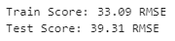

***Prophet***

In Prophet, predictive models were rapidly and readily created using the sklearn model API. These models may then be used to anticipate future trends and behaviors. To determine the data's prophet model, trials were conducted with various algorithms and parameters. The fit method is used to fit the model to the data, while the predict method is used to generate predictions based on the fitted model. The "ds" column should contain the date, of the data points and the "y" column contained the corresponding values of the victim's column.

The target metric in the y column must be a numerical value such as an integer, float, or decimal. This is because the metric was used to measure the success of a particular outcome or action. The data frame also contained a column labeled "y" that contains the values of the target variable for the corresponding dates in the "ds" column. This column is used to train a predictive model, which is then used to generate predictions for the future values of the target variable. A data frame is created, including the dates for the predictions to be made in the "ds" column. This will enable us to assess the accuracy of the model by comparing the predictions to actual historical data. Additionally, the inclusion of historical dates will also help us to identify any potential issues or discrepancies in the model.

The original forecast data represents the expected values, while the lower and upper intervals represent the range of values within which the true value is likely to fall. This range was calculated by taking into account the uncertainty associated with the forecast. The prophet model was initialized with the seasonality mode set to 'multiplicative'. Deseasonalized victims’ data (column: 0) up to '2019-12-29' is selected, and the data frame is prepared for training. The model is fitted to the deseasonalized victims' data. For future data preparation DataFrame is created using the make_future_dataframe() function with a period of 26 weeks and a frequency of weekly. Moreover, for forecasting and reconstruction, the model is used to predict the values for the future time points specified in the future DataFrame where the forecasted values are multiplied by the corresponding seasonal factors from '2020-01-05' to '2020-06-28' to reconstruct the original scale of the victim's data and at last separate columns ('yhat', 'yhat_lower', 'yhat_upper') were created in the forecast DataFrame to store the reconstructed values.

Eventually, The prophet_pred_df DataFrame was displayed, by showcasing the forecasted values ('yhat', 'yhat_lower', 'yhat_upper') and the corresponding actual values. Yhat_lower values represented the accuracy of the model, with lower values indicating higher accuracy this means that the current model was more accurate. From the plot, the values compared the predicted values with the actual values over time. However, it was observed that the predicted values exceeded the upper and lower boundaries in 5 out of the 26 predictions in Figure 60. This indicates that the model's predictions were less reliable and suggested that further refinement or evaluation was necessary.

**Figure 60**

*Comparison Between Predicted and Actual Values*

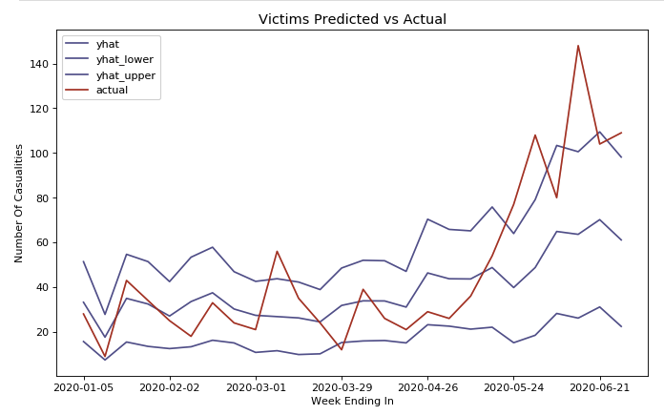

Figure 61 shows the MAE and RMSE of the prophet model achieved. MAE for Prophet is 91.54 and RMSE for Prophet is 104.685.

**Figure 61**

*MAE and RMSE for Prophet*

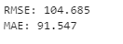

Table 12 shows the comparison of all the used evaluation metrics for the four models implemented.

**Table 12**

*Comparison of all the Models Used in This Research Paper.*

|  |  |  |
| --- | --- | --- |
| **Model** | **MAE** | **RMSE** |
| SARIMA | 57.47 | 70.92 |
| VAR | 44.40 | 36.73 |
| LSTM | 25.36 | 28.71 |
| PROPHET | 91.54 | 104.68 |

Due to its capacity to recognize intricate patterns and long-term dependencies in sequential data, LSTM outperformed all other models for this project. This makes it particularly appropriate for analyzing time series data of mass shootings. Its neural network architecture enables it to recognize subtle temporal patterns and learn complex relationships that may be difficult to capture for linear models like SARIMA and VAR. Additionally, due to LSTM's adaptability in processing different types of data, including tabular and textual data, contextual information can be added to improve the analysis and forecasting accuracy.

**Conclusion**

This research paper proposed a time series analysis and forecasting model that predicts the number of victims of gun violence incidents in the United States. Exploratory data analysis was performed, followed by data wrangling to handle null and duplicate values. After data transformation into monthly-based time series data, SARIMA, VAR, LSTM, and Prophet models were implemented on the dataset and evaluated their performance using the MAE and RMSE metrics. The primary goal of the project is to demonstrate the effectiveness of time series forecasting models for predicting crime rates. Results indicate that LSTM outperformed all other implemented models in predicting the number of victims, with a lower RMSE and MAE on the test set. In the future, explore the potential of other advanced time series forecasting models and ensemble methods to improve the accuracy of crime rate predictions.

**Limitations**

One of the limitations of this research paper is the data quality. The dataset only includes reported incidents of gun violence and may not account for unreported incidents. Additionally, only a limited set of features were considered, and did not consider other important variables, such as the type of attack or the location. Including more features, such as geographic location, demographics, and socioeconomic factors, might help increase the evaluation metric score of both models. The model is limited by the assumptions made in the SARIMA, VAR, LSTM, and Prophet models, and other time-series models may perform better on this dataset.

**Future Scope**

It is important to note that this project represents an initial step in the analysis of mass shooting incidents. Further research and analysis could be conducted to explore additional variables, refine the models, and incorporate more sophisticated techniques to improve the accuracy of predictions. Developing real-time monitoring systems that can detect early warning signs of potential mass shootings can help law enforcement agencies and policymakers take proactive measures to prevent such incidents. Utilizing social media analytics, natural language processing, and sentiment analysis can assist in identifying indicators and trends associated with mass shootings. Future research in this area can be done in different ways. Investigating the use of additional time-series models is one potential course of action, which uses neural networks or hybrid models. Another direction is to include other variables that influence the number of victims, such as the type of attack or the location, demographics, and socioeconomic factors. Additionally, future research could investigate ways to improve the accuracy and robustness of these models by incorporating interpolation to fix inconsistent data and to execute the models on more minute units of time, such as weeks, hours, and minutes.

**References**

Ahmed, A. A., & Okoroafor, N. (2023). An ML-powered risk assessment system for predicting prospective mass shooting. *Computers*, *12*(2), 42. https://doi.org/10.3390/computers12020042

Akkineni, A. (2021). Machine Learning Analysis of Gun Violence. *Machine Learning*. https://doi.org/10.47611/harp.82

Bansal, R., & Khanna, A. (2013). Vector auto-regressive analysis of determinants of IPO underpricing: Empirical evidence from Bombay Stock Exchange. *Global Business Review*, *14*(4), 651–689. https://doi.org/10.1177/0972150913501609

Barak-Ventura, R., Marín, M. R., & Porfiri, M. (2022). A spatiotemporal model of firearm ownership in the United States. *Patterns*, *3*(8), 100546. https://doi.org/10.1016/j.patter.2022.100546

Barboza, G. (2018). A secondary spatial analysis of gun violence near Boston schools: A public health approach. *Journal of Urban Health*, *95*(3), 344–360. https://doi.org/10.1007/s11524-018-0244-8

Bashir, F., & Wei, H.-L. (2018). Handling missing data in multivariate time series using a vector autoregressive model-imputation (VAR-IM) algorithm. *Neurocomputing*, *276*, 23–30. https://doi.org/10.1016/j.neucom.2017.03.097

Chang, X., Gao, M., Wang, Y., & Hou, X. (2012). Seasonal autoregressive integrated moving average model for precipitation time series. *Journal of Mathematics and Statistics*, *8*(4), 500–505. https://doi.org/10.3844/jmssp.2012.500.505

Densley, J., & Peterson, J. (2019, September 1). Opinion: we analyzed 53 years of mass shooting data. attacks aren’t just increasing, they’re getting deadlier.

Dierenfeldt, R., Brown, T. C., & Roles, R. A. (2016). Re-considering the structural covariates of gun crime: An examination of direct and moderated effects. *Deviant Behavior*, *38*(2), 208–225. https://doi.org/10.1080/01639625.2016.1196974

Duwe, G., Sanders, N. E., Rocque, M., & Fox, J. A. (2021). Forecasting the severity of mass public shootings in the United States. *Journal of Quantitative Criminology*, *38*(2), 385–423. https://doi.org/10.1007/s10940-021-09499-5

Fitzpatrick, V., Castro, M., Jacobs, J., Sebro, N., Gulmatico, J., Shields, M., & Homan, S. M. (2018). Nonfatal firearm violence trends on the Westside of Chicago between 2005 and 2016. *Journal of Community Health*, *44*(5), 866–873. https://doi.org/10.1007/s10900-018-00603-8

Gulli, A., & Pal, S. (2017). *Deep learning with keras: Implement neural networks with Keras on Theano and tensorflow*. Packt.

*Gun violence archive*. Gun Violence Archive. (n.d.). https://www.gunviolencearchive.org/

Hassan, A. F. M. K., & Islam, M. R. (2007). Temporal causality and dynamics of financial development, trade openness, and economic growth in vector auto regression (VAR) for Bangladesh, 1974-2003: Implication for Poverty Reduction. *Journal of Nepalese Business Studies*, *2*(1), 1–12. https://doi.org/10.3126/jnbs.v2i1.50

Heller, S., Jakubowski, B., Jelveh, Z., & Kapustin, M. (2022). Machine learning can predict shooting victimization well enough to help prevent it. *Machine Learning*. https://doi.org/10.3386/w30170

Hodson, T. O. (2022). *Root Mean Square Error (RMSE) or Mean Absolute Error (Mae): When to Use Them or Not*. https://doi.org/10.5194/gmd-2022-64

Khan, F., Saeed, A., & Ali, S. (2020). Modelling and forecasting of new cases, deaths and recover cases of COVID-19 by using vector autoregressive model in Pakistan. *Chaos, Solitons & Fractals*, *140*, 110189. https://doi.org/10.1016/j.chaos.2020.110189

Kleck, G., & Patterson, E. B. (1993). The impact of gun control and gun ownership levels on violence rates. *Journal of Quantitative Criminology*, *9*(3), 249–287. https://doi.org/10.1007/bf01064462

Lankford, A. (2016). FAME-seeking rampage shooters: Initial findings and empirical predictions. *Aggression and Violent Behavior*, *27*, 122–129. https://doi.org/10.1016/j.avb.2016.02.002

Leonard, L., & Aguas, H. (2018). Homeless Demography in Los Angeles County. In *Environmental criminology: Spatial analysis and regional issues* (1st ed., pp. 9–10). essay, Emerald Publishing.

Lindemann, B., Müller, T., Vietz, H., Jazdi, N., & Weyrich, M. (2021). A survey on long short-term memory networks for time series prediction. *Procedia CIRP*, *99*, 650–655. https://doi.org/10.1016/j.procir.2021.03.088

Liu, G., & Wiebe, D. J. (2019). A Time-series analysis of firearm purchasing after mass shooting events in the United States. *JAMA Network Open*, *2*(4). https://doi.org/10.1001/jamanetworkopen.2019.1736

Loeffler, C., & Flaxman, S. (2017). Is gun violence contagious? A spatiotemporal test. *Journal of Quantitative Criminology*, *34*(4), 999–1017. https://doi.org/10.1007/s10940-017-9363-8

Milam, A. J., Buggs, S. A., Furr-Holden, C. D., Leaf, P. J., Bradshaw, C. P., & Webster, D. (2016). Changes in attitudes toward guns and shootings following implementation of the Baltimore Safe Streets Intervention. *Journal of Urban Health*, *93*(4), 609–626. https://doi.org/10.1007/s11524-016-0060-y

Mittnik, S., & Neumann, T. (2001). Dynamic effects of public investment: Vector autoregressive evidence from six industrialized countries. *Empirical Economics*, *26*(2), 429–446. https://doi.org/10.1007/s001810000064

New York City Police Dept                    Address              1 Police Plaza, C. A. (2012). *Active shooter: Recommendations and analysis for risk mitigation*. Active Shooter: Recommendations and Analysis for Risk Mitigation | Office of Justice Programs. https://www.ojp.gov/ncjrs/virtual-library/abstracts/active-shooter-recommendations-and-analysis-risk-mitigation

Ning, Y., Kazemi, H., & Tahmasebi, P. (2022). A comparative machine learning study for time series oil production forecasting: Arima, LSTM, and prophet. *Computers & Geosciences*, *164*, 105126. https://doi.org/10.1016/j.cageo.2022.105126

Pindiga, S. N., Gurram, N., & Motati, D. (2022). Time-series forecasting: Predicting stock index using Arima and Facebooks Prophet model. *International Journal for Research in Applied Science and Engineering Technology*, *10*(6), 4832–4839. https://doi.org/10.22214/ijraset.2022.45073

R, A. S., Nidhi, D., C, D. S., & Sowjanya K, K. (2022). Crime forecasting : A theoretical approach. *2022 IEEE 7th International Conference on Recent Advances and Innovations in Engineering (ICRAIE)*. https://doi.org/10.1109/icraie56454.2022.10054345

Riley, C., Roy, B., Harari, N., Vashi, A., Violano, P., Greene, A., Lucas, G., Smart, J., Hines, T., Spell, S., Taylor, S., Tinney, B., Williams, M., & Wang, E. A. (2017). Preparing for disaster: A cross-sectional study of social connection and gun violence. *Journal of Urban Health*, *94*(5), 619–628. https://doi.org/10.1007/s11524-016-0121-2

Samal, K. K., Babu, K. S., Das, S. K., & Acharaya, A. (2019). Time Series Based Air Pollution Forecasting using Sarima and prophet model. *Proceedings of the 2019 International Conference on Information Technology and Computer Communications*. https://doi.org/10.1145/3355402.3355417

Saunders, J., Hunt, P., & Hollywood, J. S. (2016). Predictions put into practice: A quasi-experimental evaluation of Chicago’s predictive policing pilot. *Journal of Experimental Criminology*, *12*(3), 347–371. https://doi.org/10.1007/s11292-016-9272-0

Shumway, R., & Stoffer, D. (2019). *Time Series: A Data Analysis Approach Using R*. Chapman and Hall.

Sierra-Arevalo, M., Charette, Y., & Papachristos, A. V. (2016). Evaluating the effect of project longevity on group-involved shootings and homicides in New Haven, Connecticut. *Crime & Delinquency*, *63*(4), 446–467. https://doi.org/10.1177/0011128716635197

Sirisha, U. M., Belavagi, M. C., & Attigeri, G. (2022). Profit prediction using Arima, Sarima and LSTM models in time series forecasting: A Comparison. *IEEE Access*, *10*, 124715–124727. https://doi.org/10.1109/access.2022.3224938

Valasik, M. (2018). Gang violence predictability: Using risk terrain modeling to study gang homicides and gang assaults in East Los Angeles. *Journal of Criminal Justice*, *58*, 10–21. https://doi.org/10.1016/j.jcrimjus.2018.06.001

Van Houdt, G., Mosquera, C., & Nápoles, G. (2020). A review on the long short-term memory model. *Artificial Intelligence Review*, *53*(8), 5929–5955. https://doi.org/10.1007/s10462-020-09838-1

Vehtari, A., Gelman, A., & Gabry, J. (2016). Practical bayesian model evaluation using leave-one-out cross-validation and WAIC. *Statistics and Computing*, *27*(5), 1413–1432. https://doi.org/10.1007/s11222-016-9696-4

Wild, B., Eichler, M., Friederich, H.-C., Hartmann, M., Zipfel, S., & Herzog, W. (2010). A graphical vector autoregressive modelling approach to the analysis of Electronic Diary Data. *BMC Medical Research Methodology*, *10*(1). https://doi.org/10.1186/1471-2288-10-28

Xu, J., & Griffiths, E. (2016). Shooting on the street: Measuring the spatial influence of physical features on gun violence in a bounded Street Network. *Journal of Quantitative Criminology*, *33*(2), 237–253. https://doi.org/10.1007/s10940-016-9292-y

Yang, G., & Li, H. (2022). Prediction method of shared bicycle traffic based on Prophet-BILSTM Combined Model. *Proceedings of the 2022 10th International Conference on Information Technology: IoT and Smart City*. https://doi.org/10.1145/3582197.3582239

Zeoli, A. M., Grady, S., Pizarro, J. M., & Melde, C. (2015). Modeling the movement of homicide by type to inform Public Health Prevention efforts. *American Journal of Public Health*, *105*(10), 2035–2041. https://doi.org/10.2105/ajph.2015.302732

**Appendix A**

Complete Gantt Chart

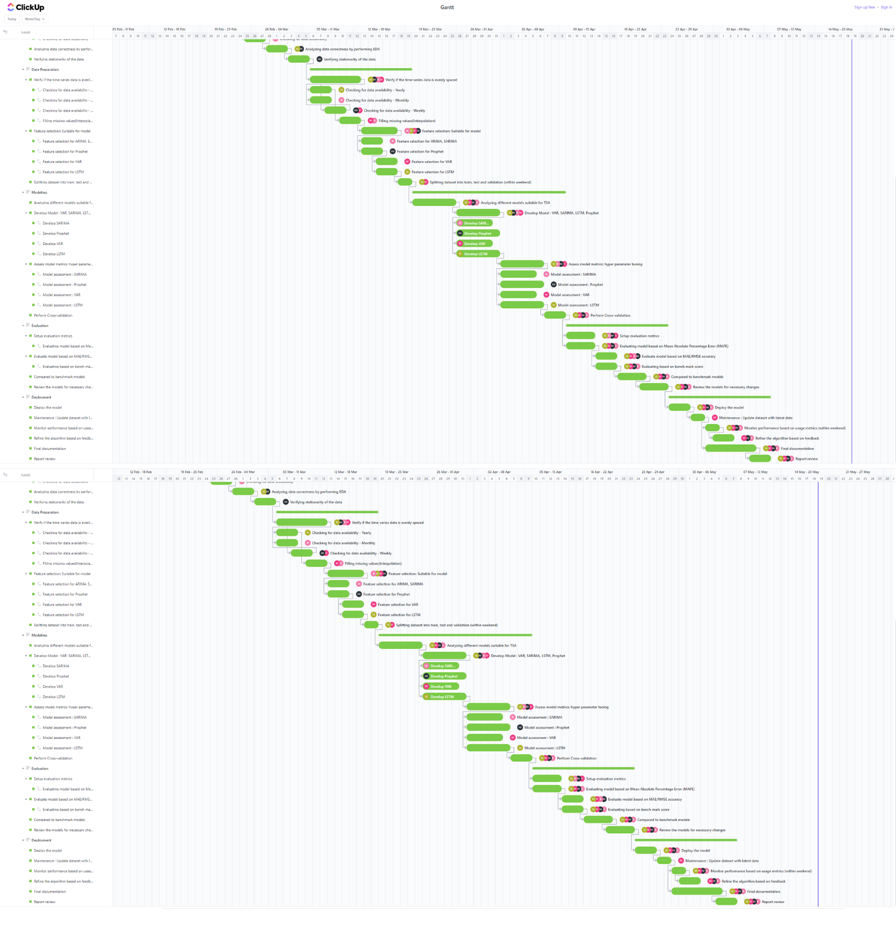

Figure A1. Gantt Chart including all tasks, deadlines, and dependencies of all phases that are developed using ClickUp. This chart can be viewed here [Gantt](https://sharing.clickup.com/9009082557/g/h/8cfqc5x-480/8e37ff24fe4b4d3).

**Appendix B**

Implementation of on Mass Shootings Data

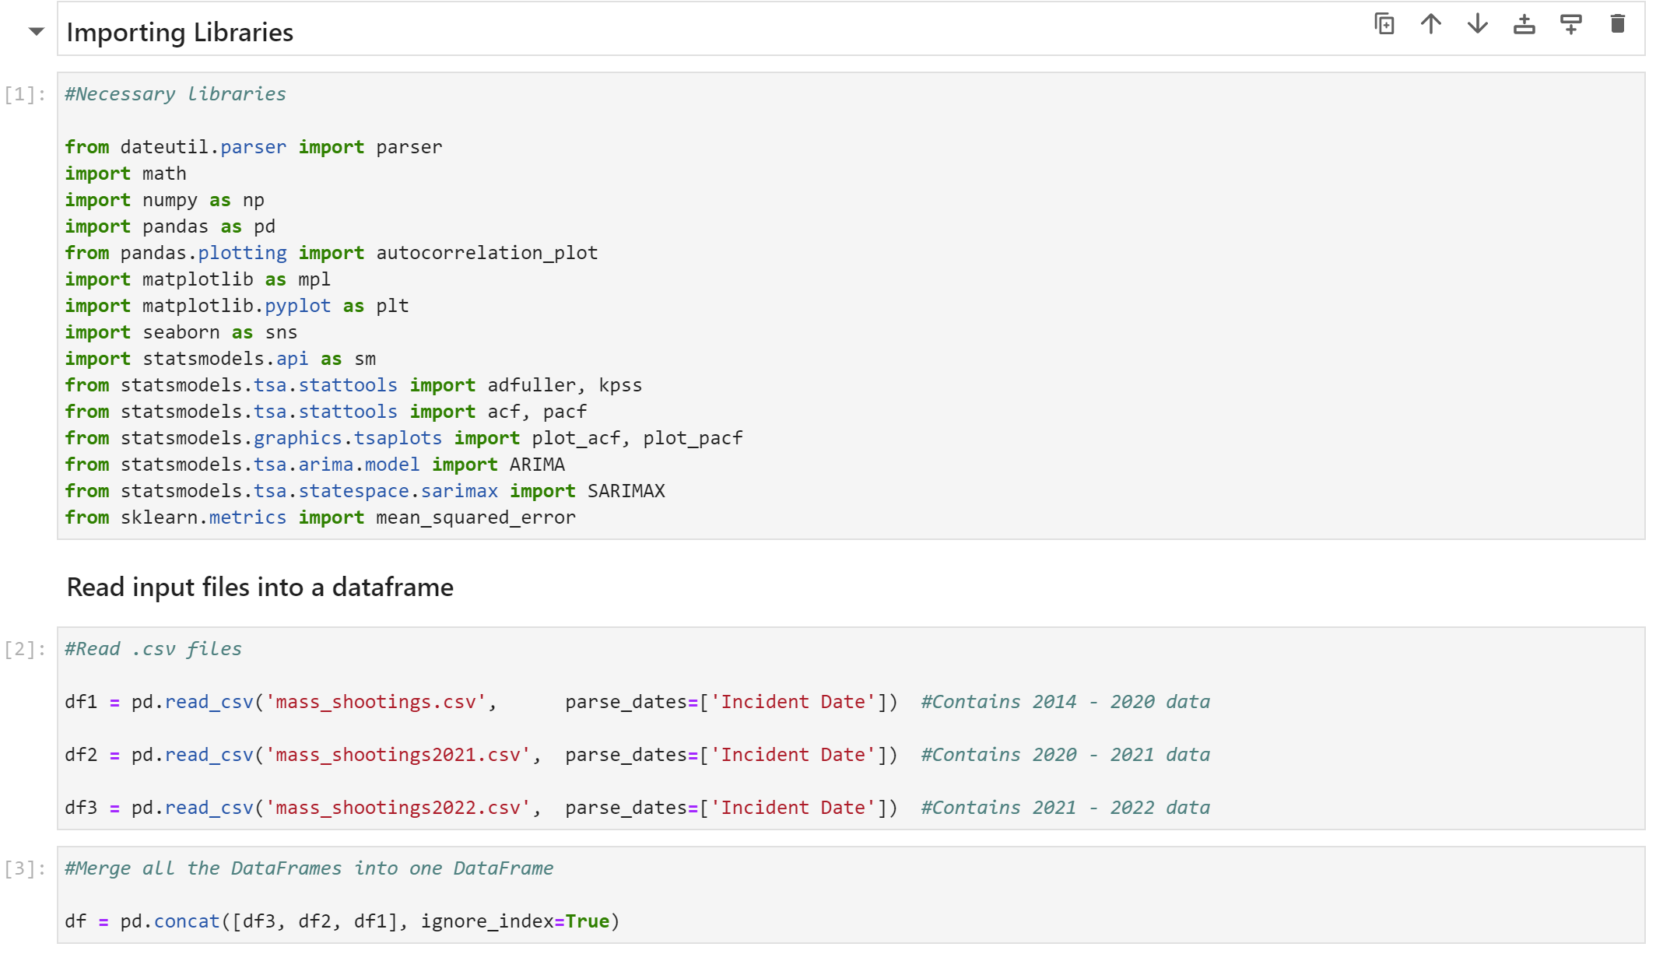

Figure B1. Demonstrates the libraries importing and file reading step.

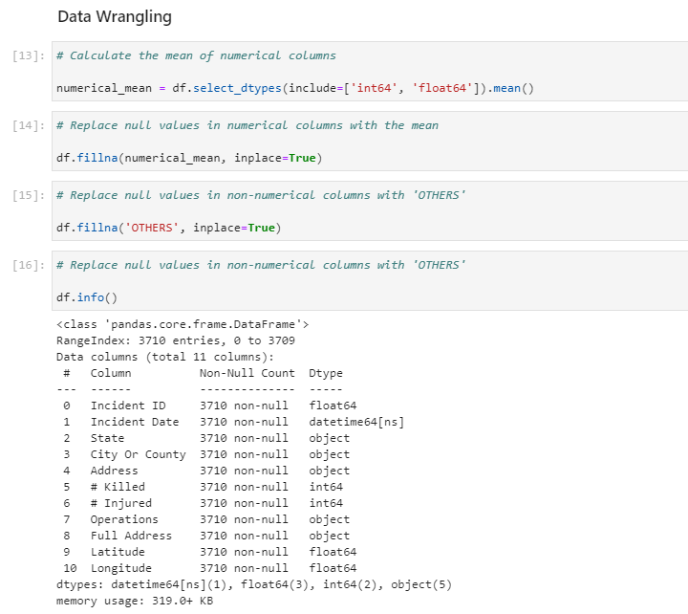

Figure B2. Illustrates the data wrangling step that deals with noisy and inconsistent data.

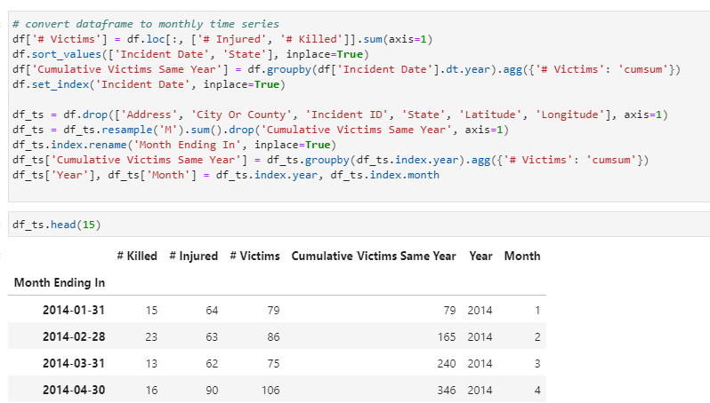

Figure B3. Shows the data transformation step that changes data time series model compatible.

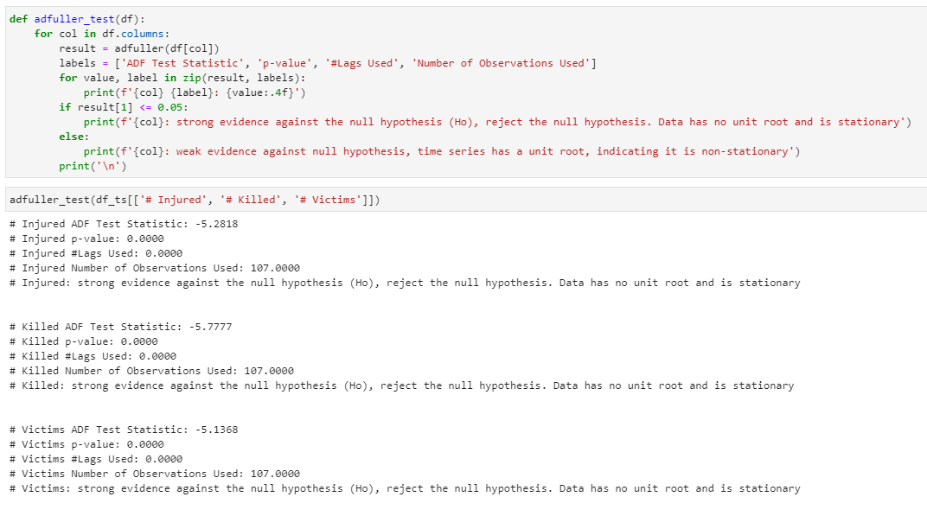

Figure B4. Illustrates use of Adfuller test to test stationarity of the time series data.

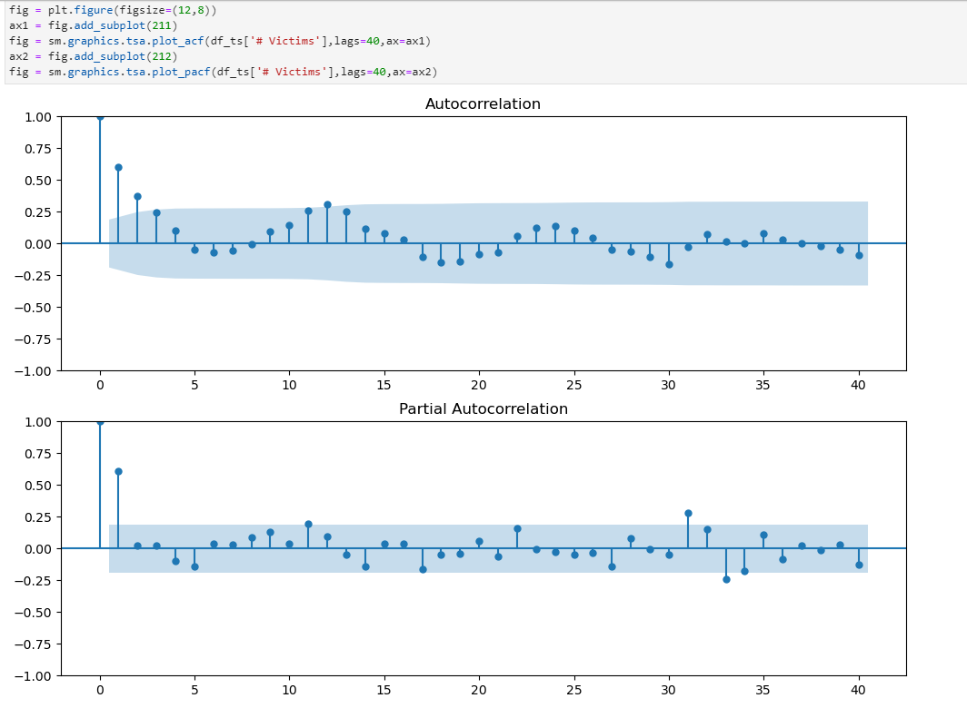

Figure B5. Demonstrates use of ACF and PACF curves to decide p, d, and q values.

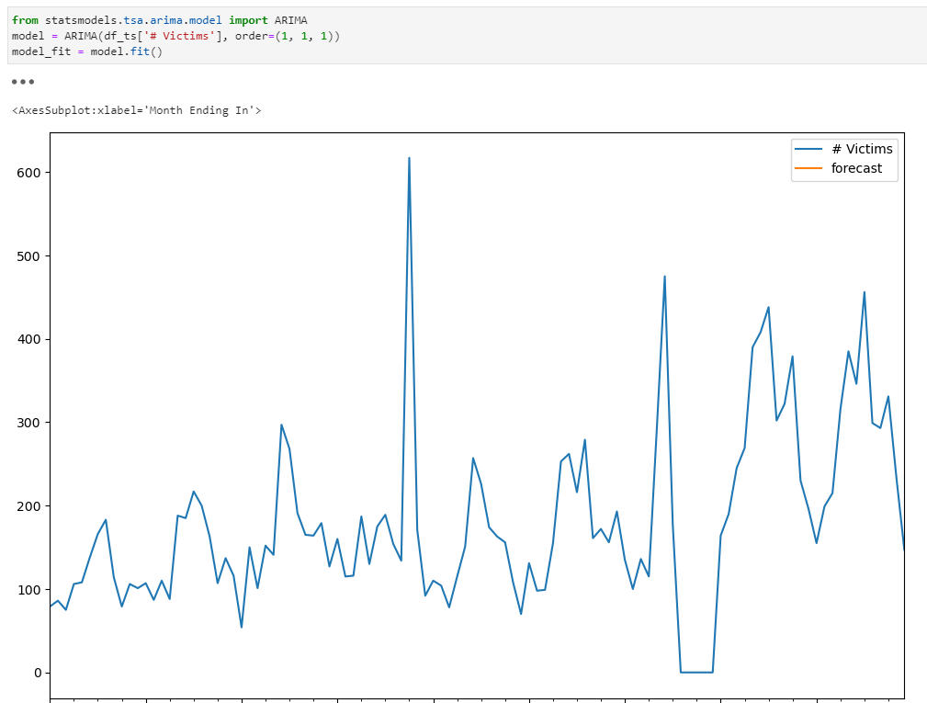

Figure B6. Illustrates implementation of ARIMA, it is clearly visible that ARIMA did not forecast the test data.

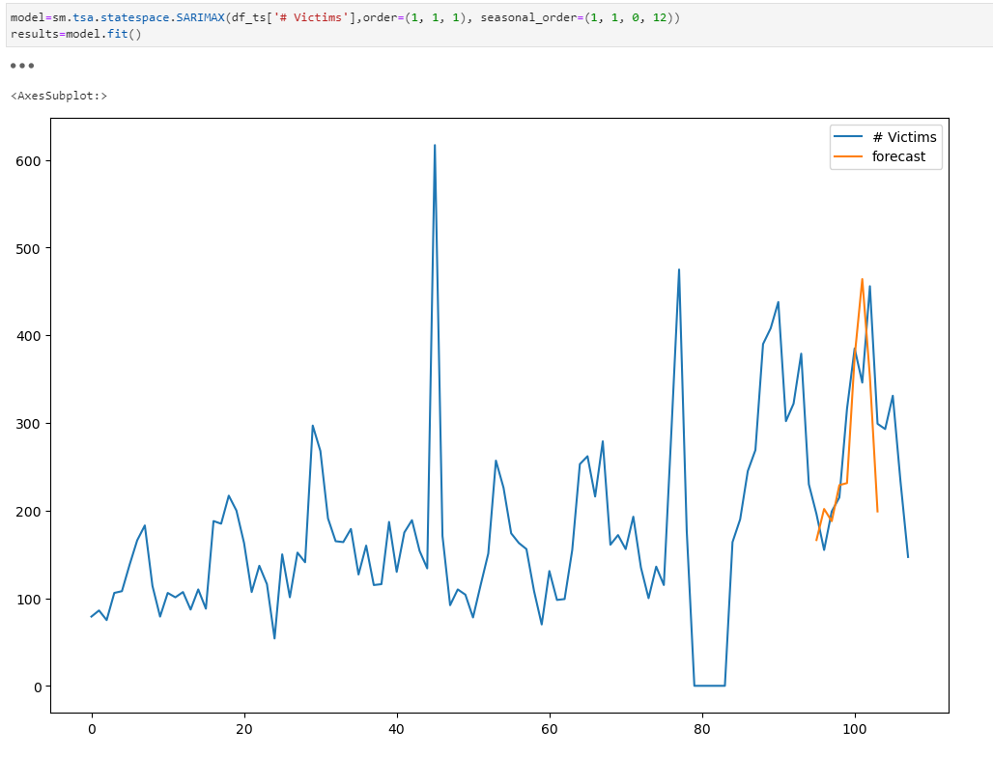

Figure B7. Illustrates the implementation of SARIMA and its prediction of test data.

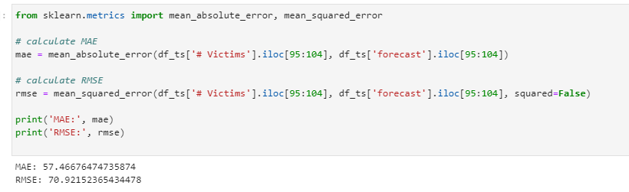

Figure B8. Shows the MAE and RMSE scores of SARIMA model.

**Appendix C**

Implementation of VAR on Mass Shootings Data

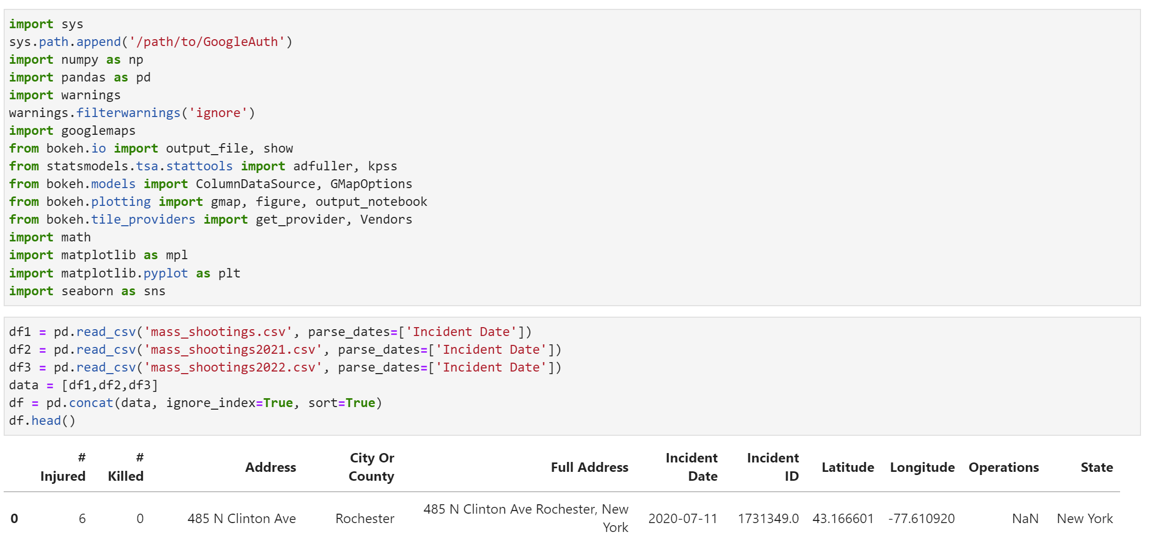

Figure C1. Demonstrates the libraries importing and file reading step for VAR model.

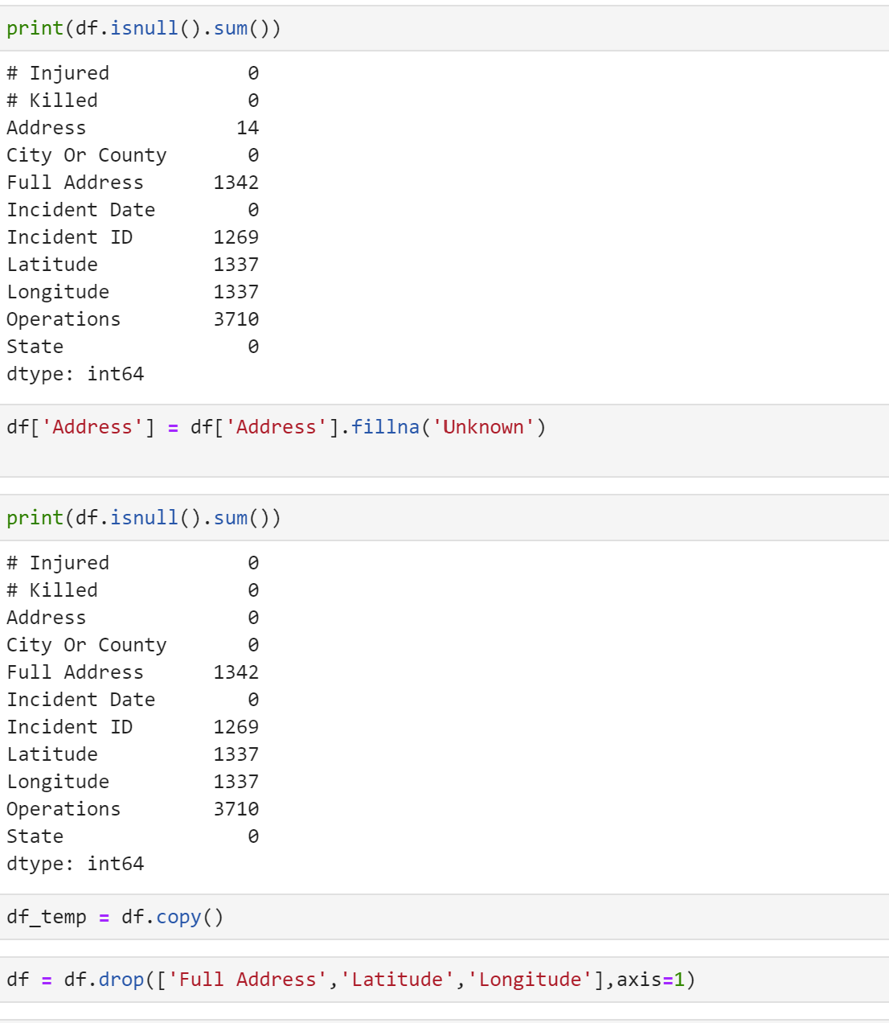

Figure C2. Illustrates the data wrangling step that deals with noisy and inconsistent data.

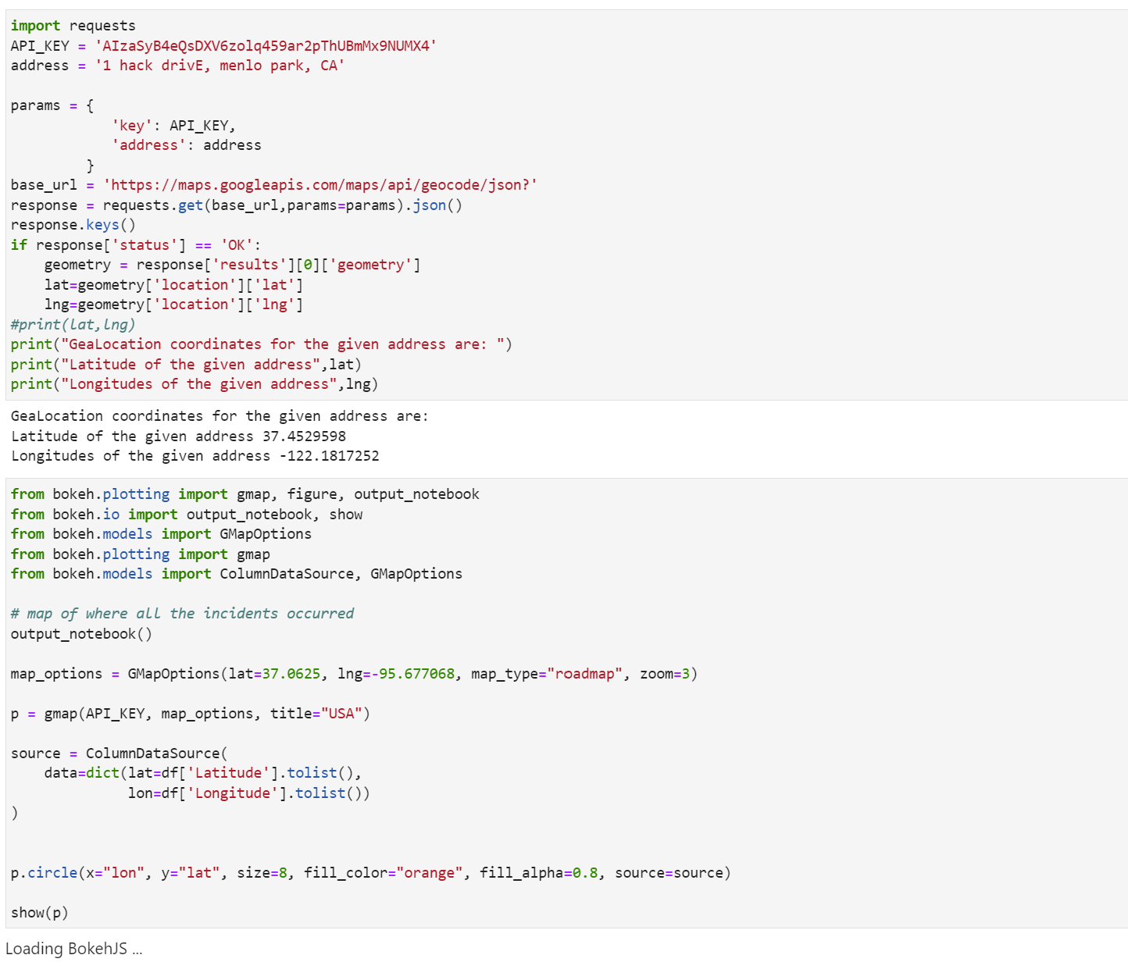

Figure C3. Shows the use of Google API.

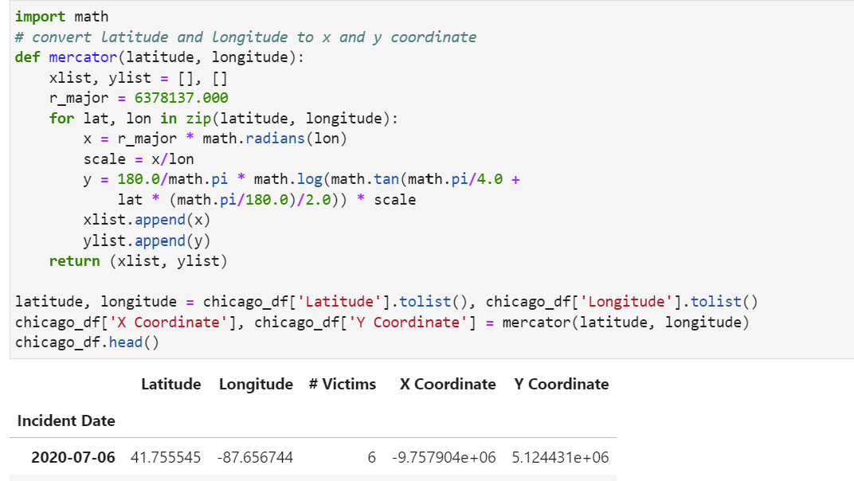

Figure C4. Shows the conversion of latitude and longitude into X and Y coordinates.

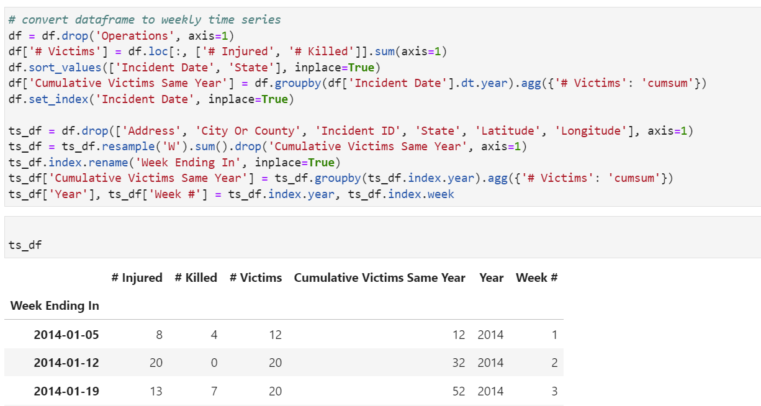

Figure C5. Shows the data transformation step that changes data time series model compatible.

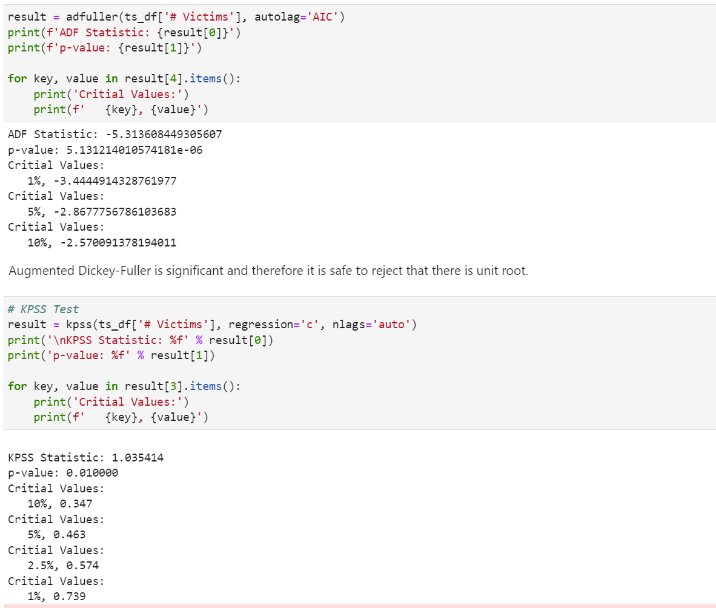

Figure C6. Shows the use of ADF test and KPSS test for testing stationarity of the data.

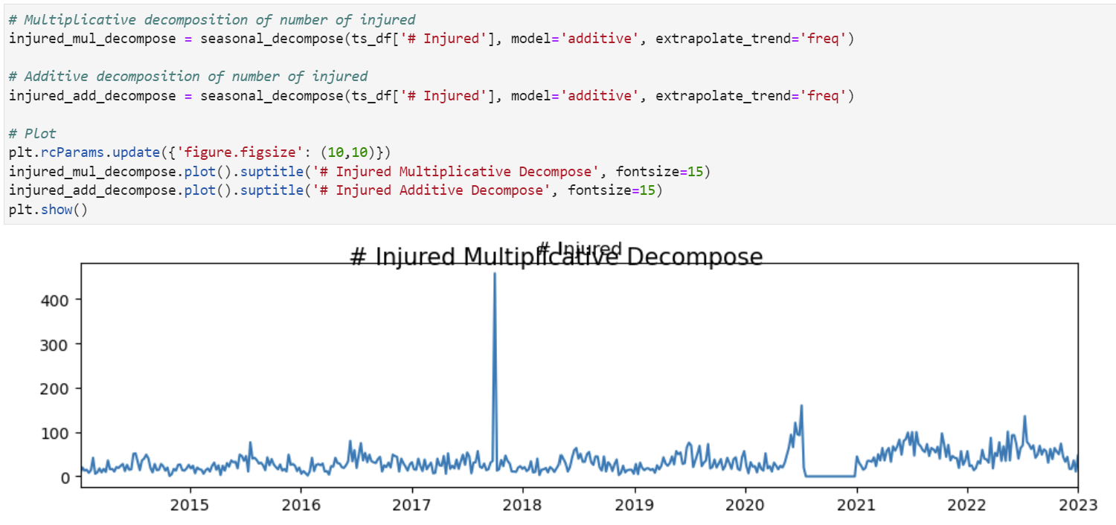

Figure C7. Illustrates the step that finds decomposition of the data.

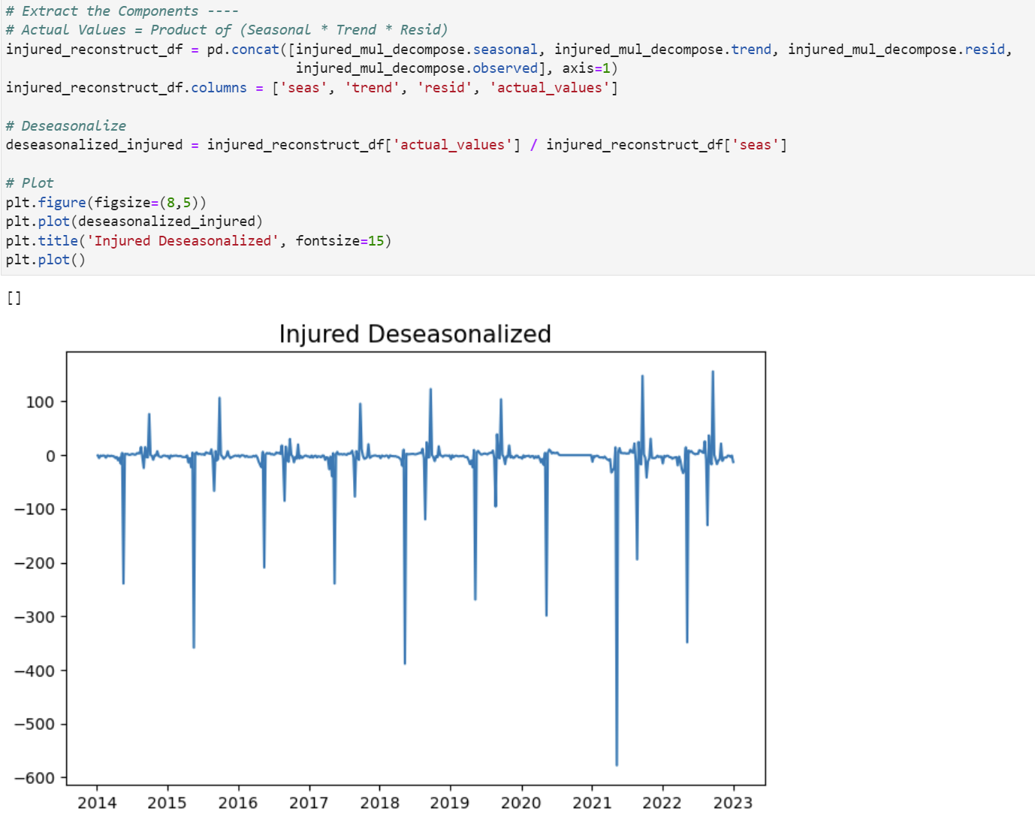

Figure C8. Illustrates the deseasonlizing of the time series data.

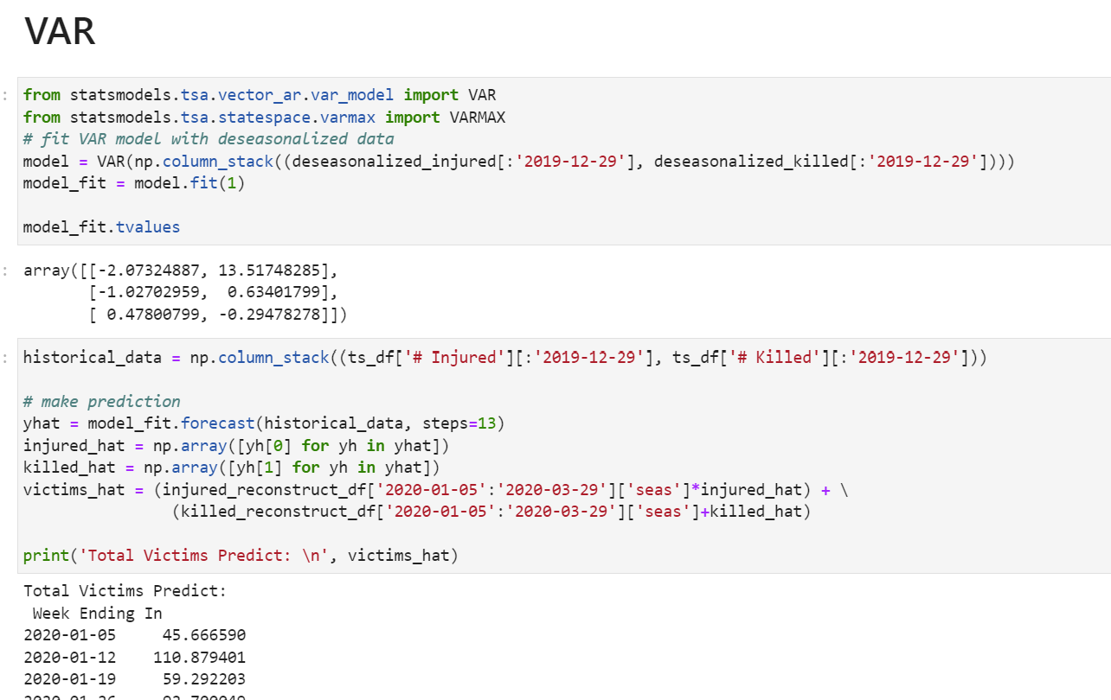

Figure C9. Shows the implementation of VAR on the processed data.

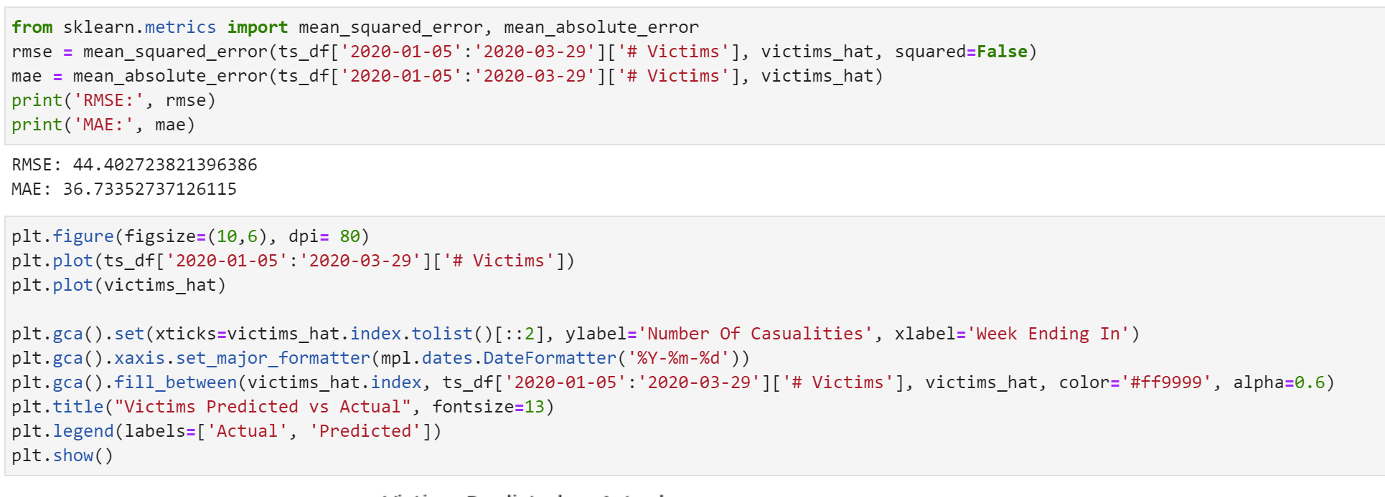

Figure C10. Shows the usage of evaluation metrics for VAR.

**Appendix D**

Implementation of LSTM on Mass Shootings Data

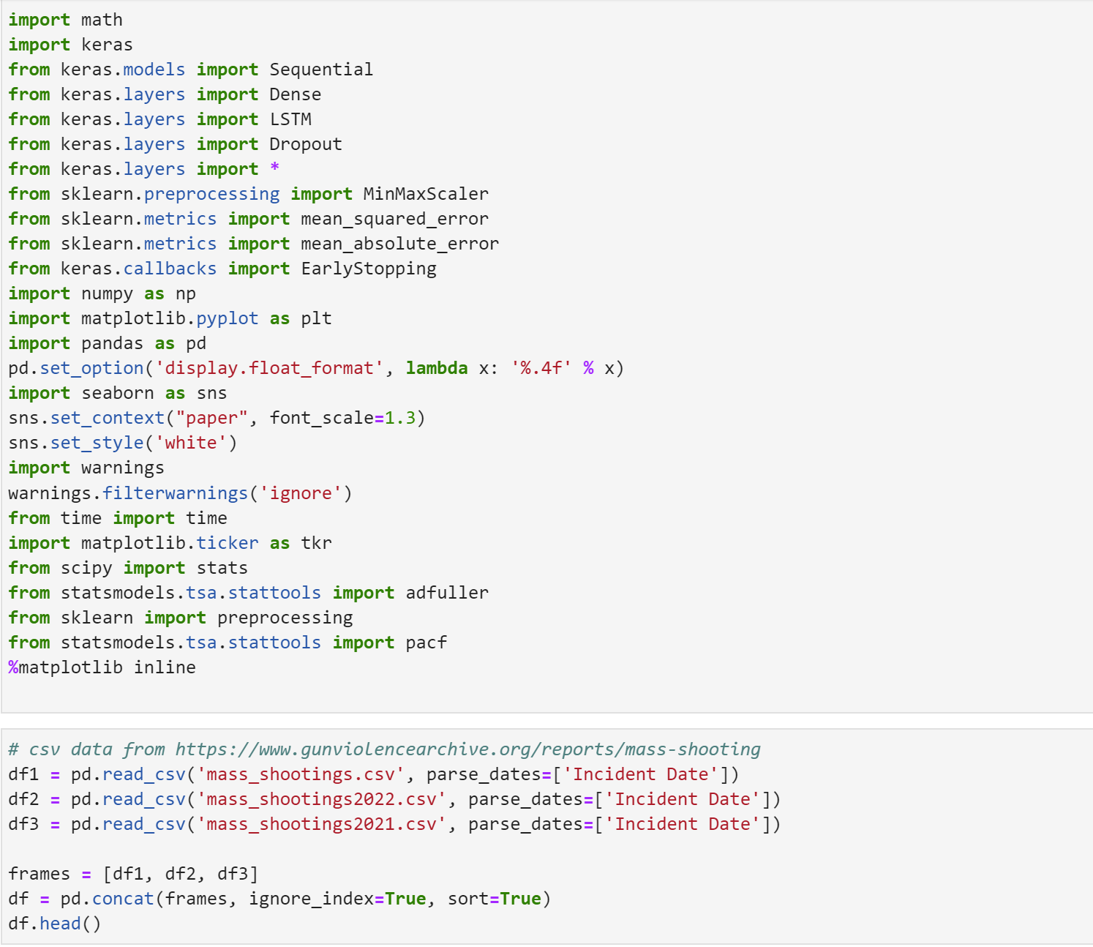

Figure D1. Demonstrates the libraries importing and file reading step.

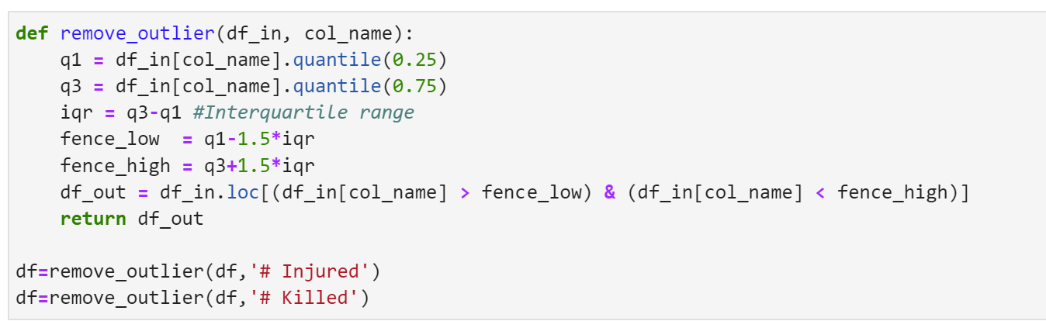

Figure D2. Shows the functions to remove outliers from the data.

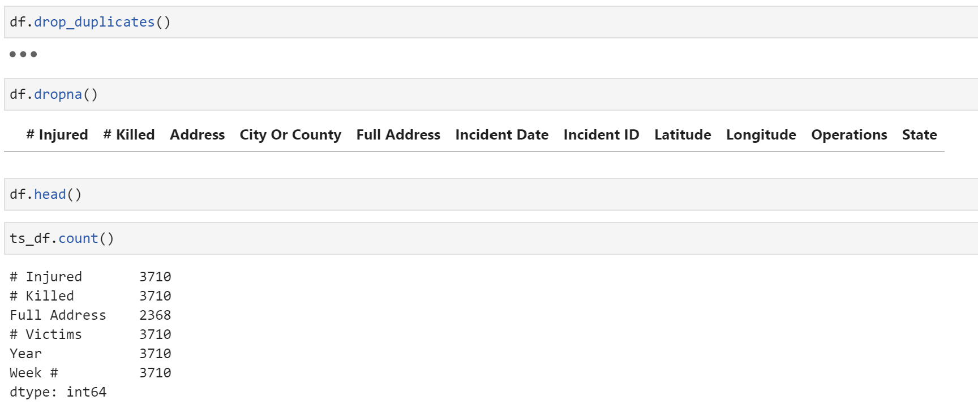

Figure D3. Illustrates the data wrangling step.

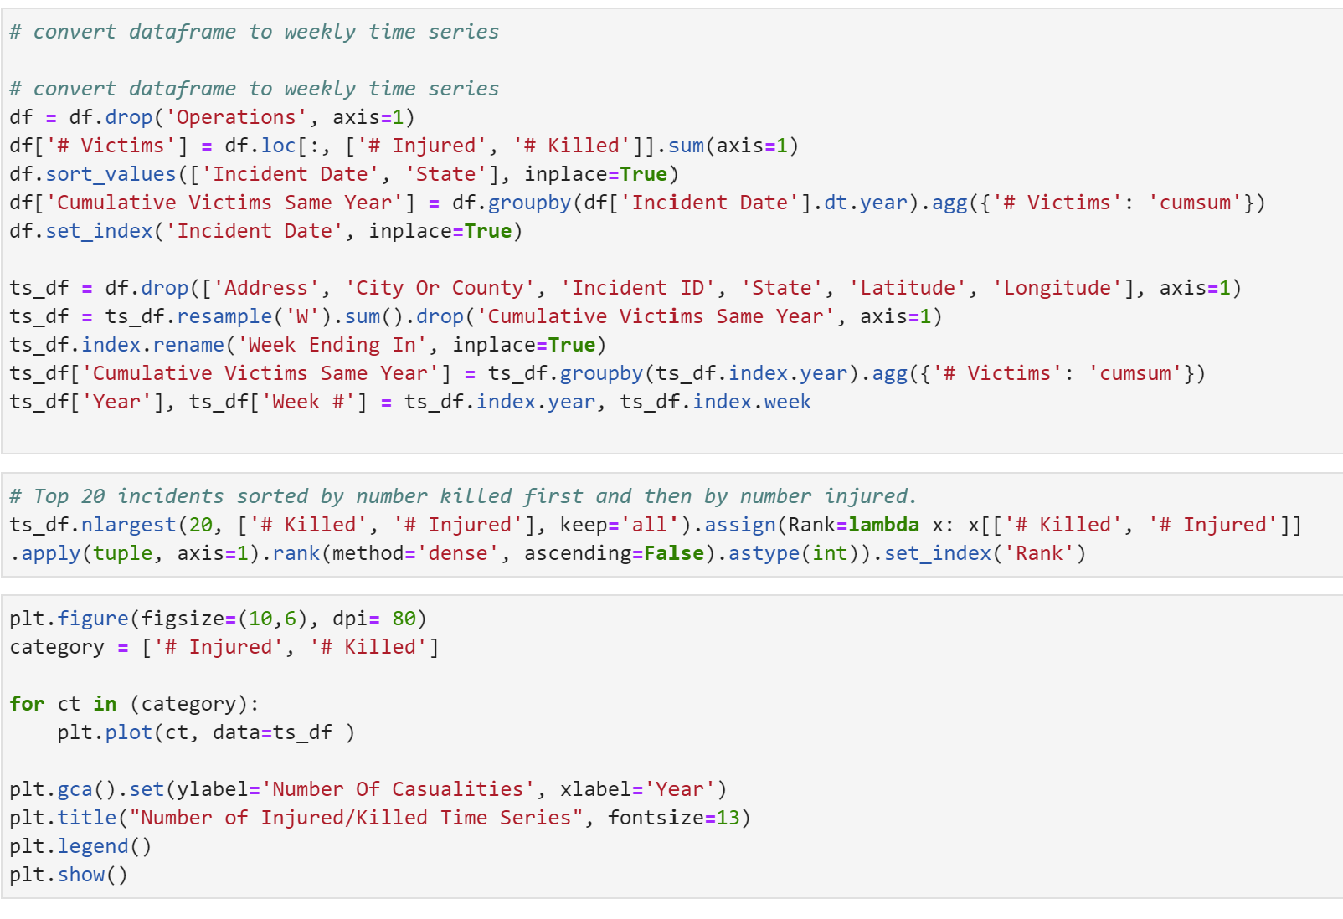

Figure D4. Shows the conversion of concatenated data into a time series data.

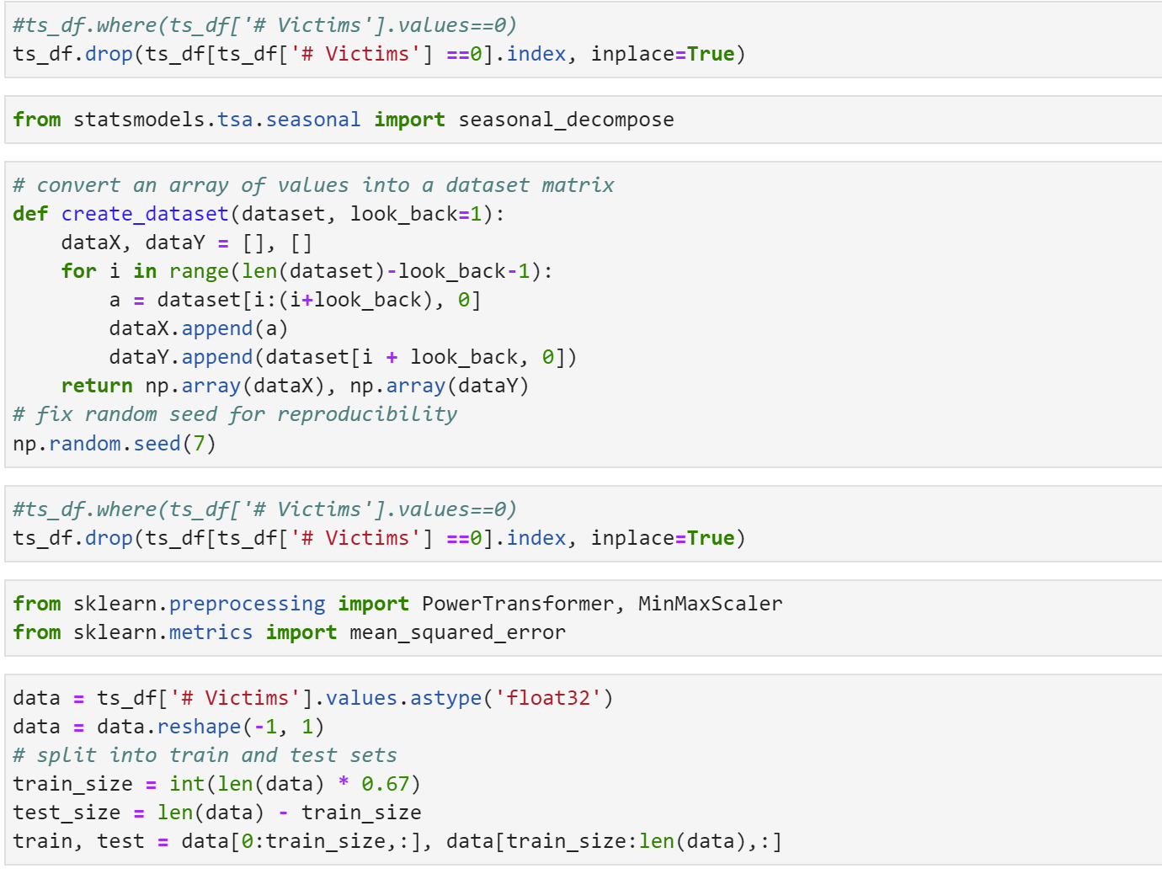

Figure D5. Illustrates use of decompose and data transformation.

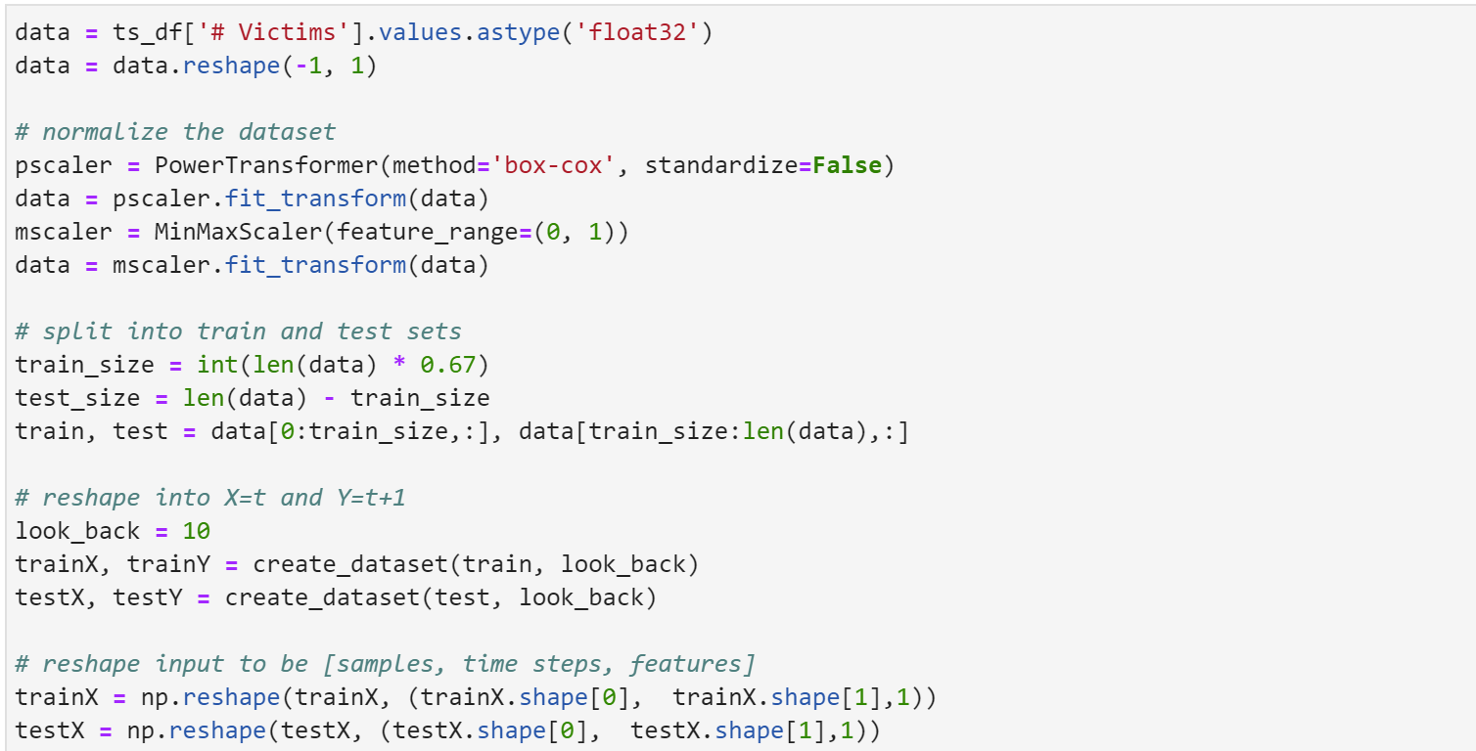

Figure D6. Demonstrates normalization of data and data processing.

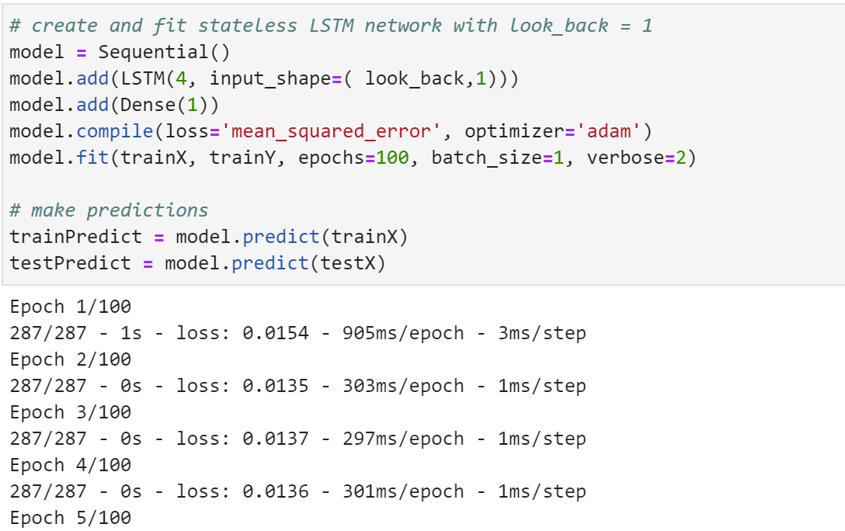

Figure D7. Shows the implementation of LSTM model.

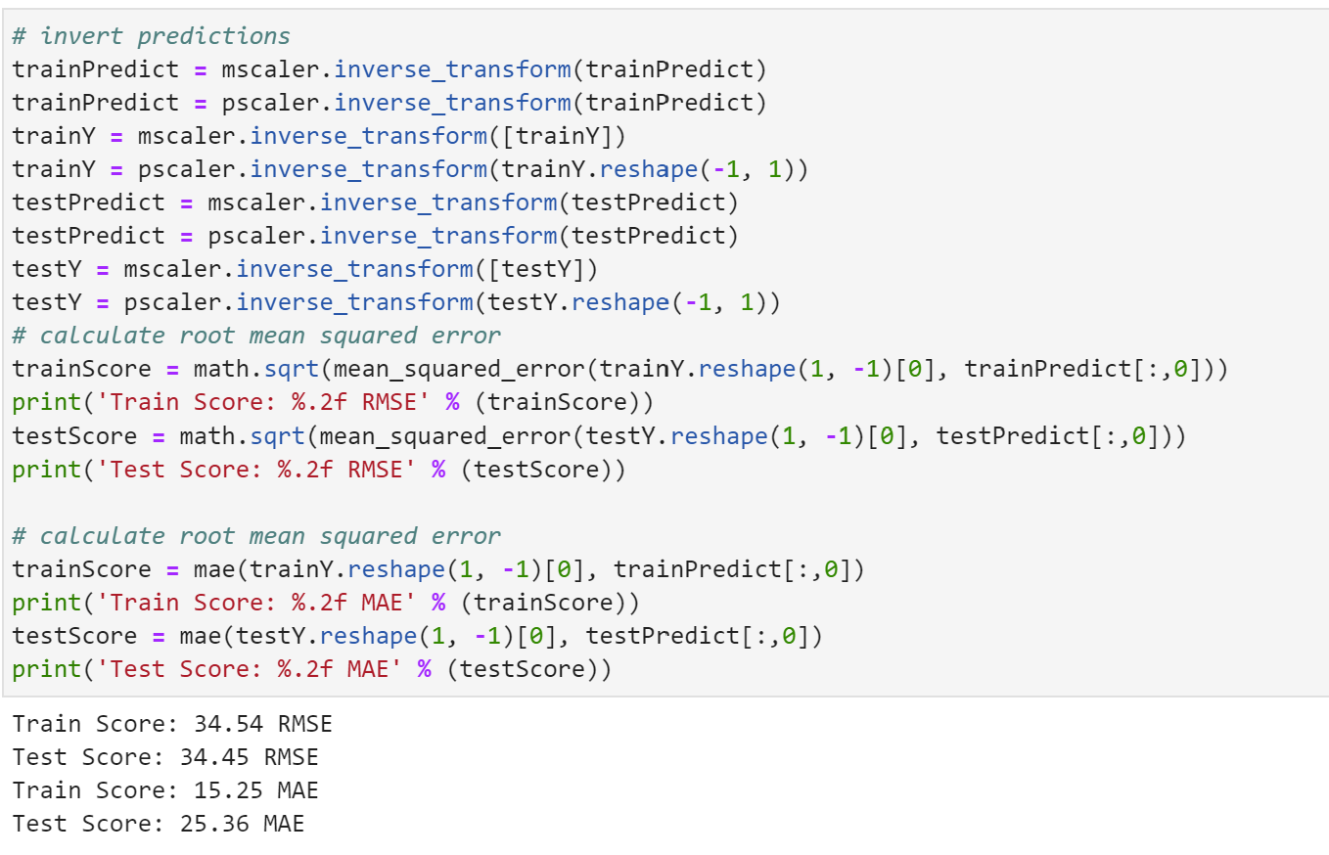

Figure D8. Shows the usage of evaluation metrics on LSTM predections.

**Appendix E**

Implementation of Prophet on Mass Shootings Data

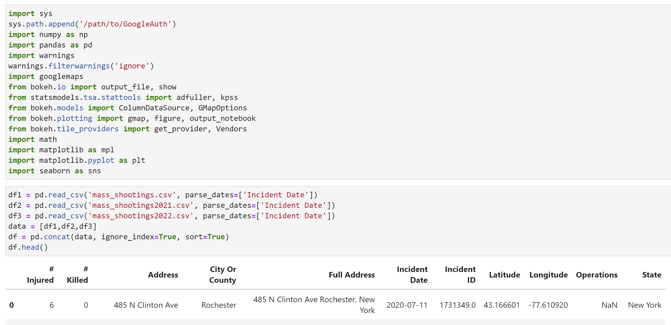

Figure E1. Demonstrates the libraries importing and file reading step.

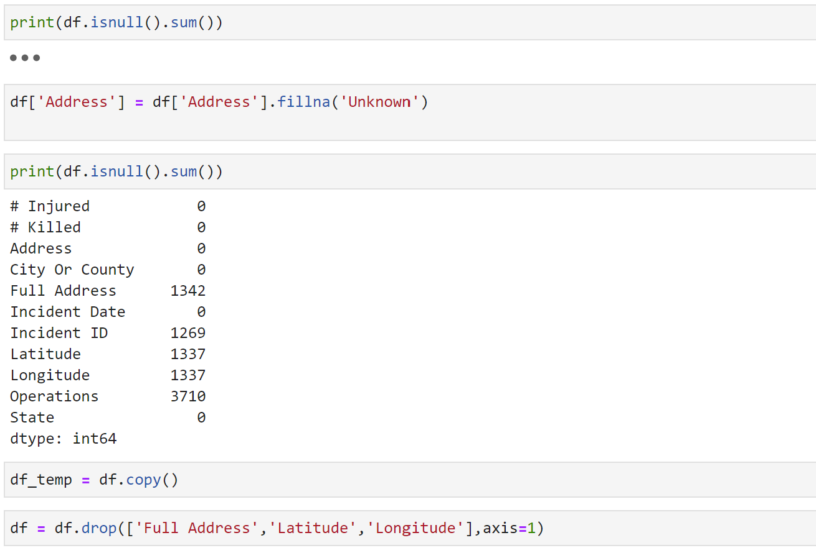

Figure E2. Shows the data wrangling steps.



Figure E3. Shows the use of Google API.



Figure E4. Shows the conversion of latitude and longitude into X and Y coordinates.

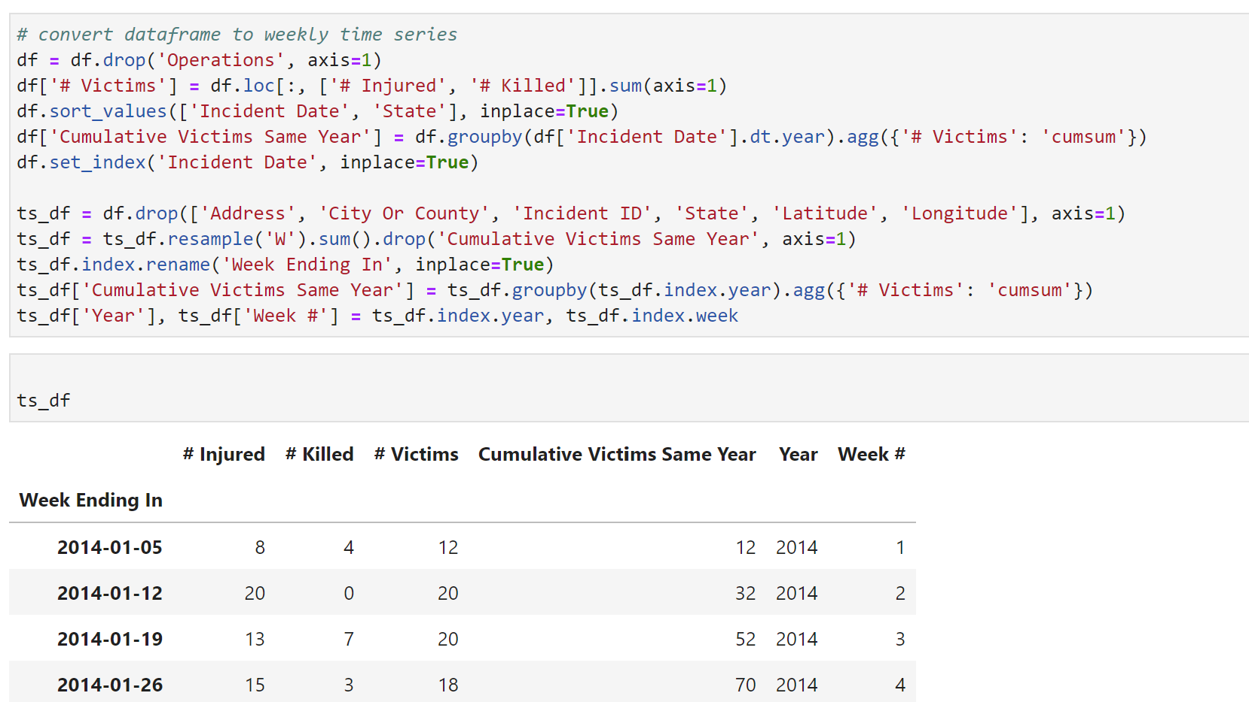

Figure E5. Illustrates the data transformation step where data is transformed into time series.

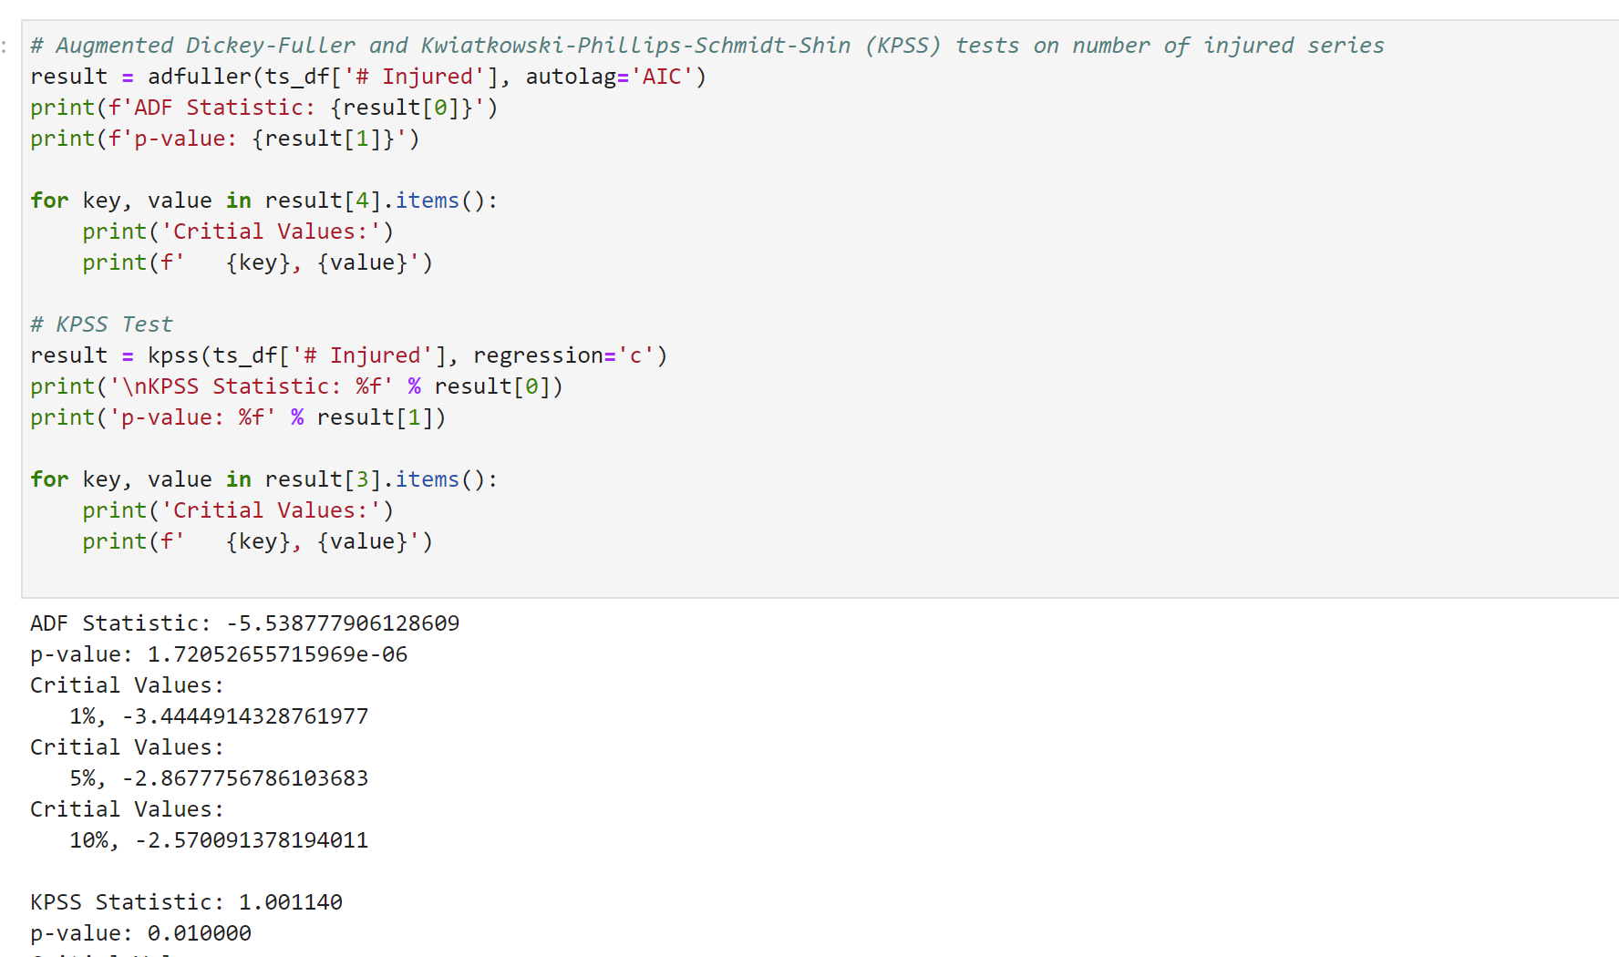

Figure E6. Shows the implementation of ADF and KPSS test.

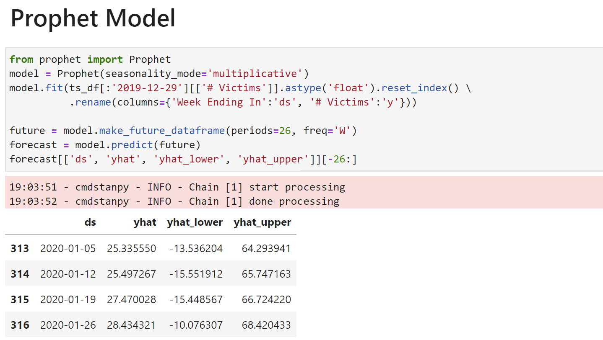

Figure E7. Illustrates the implementation of Prophet model on processed data.

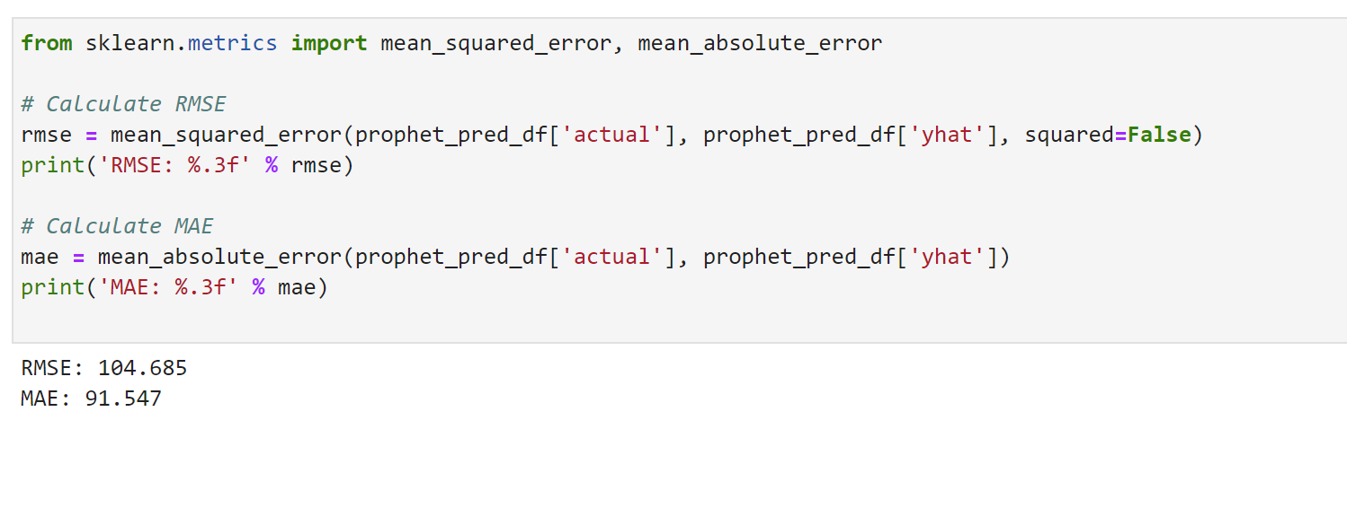

Figure E8. Shows the usage of evaluation metrics.

The above mentioned all the models can be accessed here [GitHub](https://github.com/kishoreruvva/Data270_Group5).